Analysis of Channel Coding Under Impulsive Radio Frequency Interference (RFI)

Submitted To

Goo Jun
Dr. Brian Evans

Prepared By

Navid Aghasadeghi
Peter Erickson
Amir Farahani
Marjo Manalang

EE464 Senior Design Project
Electrical and Computer Engineering Department
The University of Texas at Austin

Spring 2008
CONTENTS

TABLES iv
FIGURES v
EXECUTIVE SUMMARY vi

1.0 INTRODUCTION 1
2.0 DESIGN PROBLEM STATEMENT 1
3.0 DESIGN PROBLEM SOLUTION 3
3.1 HAMMING CODES 3
3.2 REED-SOLOMON CODES 4
3.3 TURBO CODES 4
3.4 HOLE-PUNCHING 4
4.0 DESIGN IMPLEMENTATION 5
4.1 MATLAB IMPLEMENTATION OF NOISY SIGNAL 5
4.1.1 Implementation of Digital Signal Simulation 6
4.1.2 Implementation of Matched-Filtering 6
4.1.3 Adding Impulsive Noise to Our Digital Signal 6
4.2 MATLAB IMPLEMENTATION OF CODING SCHEMES 6
4.2.1 Implementation of Hamming Codes 7
4.2.2 Implementation of Reed-Solomon Codes 7
4.2.3 Implementation of Turbo Codes 7
4.2.4 Implementation of Hole-Punching 7
4.2.5 Combining Reed-Solomon Codes with Hole-Punching 8
4.2.6 Combining Turbo Codes with Hole-Punching 8
4.3 GRAPHICAL USER INTERFACE (GUI) 8
4.3.1 GUI for Automated Testing (GUI AutoTest) 8
4.3.2 GUI for Graphical Data Display and Analysis (GUI Demo) 9
5.0 TEST AND EVALUATION 10
5.1 TESTING CRITERIA AND RESTRICTIONS 10
5.2 ANALYSIS OF TEST RESULTS 11
5.2.1 Alpha = 0.5 Test Results Analysis 11
5.2.2 Alpha = 1.0 Test Results Analysis 12
5.2.3 Alpha = 1.5 Test Results Analysis 13
5.2.4 Alpha = 2.0 Test Results Analysis 14
6.0 TIME AND COST CONSIDERATIONS 15
7.0 SAFETY AND ETHICAL ASPECTS OF DESIGN 16
8.0 CONCLUSIONS AND RECOMMENDATIONS 16
REFERENCES 17
APPENDIX A – SCREENSHOT OF GUI AUTOTEST 18
APPENDIX B – EXAMPLE TEST RESULTS 19
APPENDIX C – SCREENSHOT OF GUI DEMO 20

TABLES

1 Project Costs 1
FIGURES

1 Gaussian Noise vs. Impulsive Noise 2
2 Design Diagram 5
3 Test Results for Alpha = 0.5 11
4 Test Results for Alpha = 1.0 12
5 Test Results for Alpha = 1.5 13
6 Test Results for Alpha = 2.0 14

EXECUTIVE SUMMARY

Wireless data communication transceivers experience radio frequency interference (RFI) when
deployed in computing platforms. This interference must be mitigated to ensure good reception. One of the mathematical models used to simulate RFI is the Alpha-Stable model. This model is particularly useful in characterizing the impulsive nature of RFI. We propose to analyze the performance of different channel-coding algorithms to find out whether they are capable of mitigating the effects of RFI. Under this type of noise, we evaluated the performance of Hamming code, Reed-Solomon code (RS), Turbo code, Hole Punching, RS code in conjunction with Hole Punching, and Turbo code in conjunction with Hole Punching. After analyzing the bit-error rate vs. signal-to-noise ratio plots for each code, we conclude that Turbo code in conjunction with Hole Punching offers the best performance.
1.0 INTRODUCTION

In this final report, we describe the findings of our team’s analysis of channel coding algorithms that will reduce the effects of impulsive radio frequency interference (RFI) in laptops. There are several different designs that could reduce the effects of RFI. In our proposal, we planned to develop an interleaving algorithm that would work in conjunction with a coding algorithm, such as the Hamming algorithm, to reduce the destructive effects of RFI. We then discovered that there are many more powerful coding schemes that already incorporate interleaving; therefore, we decided to analyze these powerful coding schemes that have already integrated interleaving, such as Turbo codes. Previous studies have shown that these codes effectively mitigate the effects of Gaussian noise; however, we were unable to find any information about the codes’ effectiveness under impulsive noise. Therefore, we geared our project towards evaluating how these codes react to impulsive noise and determining which code has the lowest bit-error rate (BER) for each signal-to-noise ratio (SNR) that we test. Dr. Brian Evans, a professor in the Department of Electrical and Computer Engineering, sponsored our project. Our project team is comprised of Amir Farahani, Navid Aghasadeghi, Marjo Manalang, and Peter Erickson.

This report begins with a description of the problem of impulsive noise in modern day laptops, and why current methods have failed to mitigate this impulsive noise. We then describe our strategy for testing various filtering and channel coding schemes under impulsive noise. We also detail the implementation of each coding scheme, as well as our implementation of a Graphical User Interface (GUI) to run simulations and plot our data onto graphs. We also go over the time spent and financial costs of our project. Finally, we provide our recommendations for using our data to help mitigate impulsive noise in modern day laptops.

2.0 DESIGN PROBLEM STATEMENT

One of the current trends in the semiconductor industry is to reduce the size of transistors and other semiconductor devices to help reduce the power consumption as well as shrink the size of laptops and other mobile computing devices. As these devices become smaller in size, their different components will be physically closer to one another. Since all of these electronic components—such as the laptop screen, the bus, and the processors—generate noise, they cause RFI with the wireless communication devices. Therefore, it is necessary to find a solution to minimize the effects of this noise on the received signals in laptops.

INTEL Co. had approached Dr. Evans’ research team with this problem and one of our group members, Navid Aghasadeghi, who takes part in Dr. Evans’ graduate group meetings, proposed that we work on this project. Therefore, our solution will have real-world significance and is being actively investigated by Dr. Evans’ research students. We found many powerful coding schemes that are used to mitigate Gaussian noise; however, we were unable to find any information about the codes’ response to impulsive noise. Because of the lack of information, we decided to focus our project on evaluating how these codes react to impulsive noise and determine which code has the lowest bit-error rate for each signal-to-noise ratio that we test.

We needed to simulate the impulsive noise in order to analyze its effects on the received signals. We used the Alpha-Stable noise model to simulate the impulsive noise [1]. Dr. Evans’ research group provided us with the MATLAB programs implementing the model. Figure 1 below demonstrates the difference between Gaussian noise and Impulsive noise:

(a) Gaussian Noise (b) Impulsive Noise

Figure 1. Gaussian Noise vs. Impulsive Noise

The amplitude of the noise, which is a key factor in the noise power, varies in a relatively narrow range for the Gaussian case. In the impulsive case, however, the amplitude of the noise is very unpredictable in a sense that it has sporadic pulses that have enormous amplitudes. The challenge is to recover the original signal from the signal that has been corrupted by this type of noise.

3.0 DESIGN PROBLEM SOLUTION

Channel coding and filtering are the two approaches that have been developed and studied extensively over the past decades to help communicate information effectively in the presence of noise. Channel coding assists the communication process by intelligently introducing redundancy in the bit sequence. The redundancy is then used by the receiver to correct for bit errors. Filters, on the other hand, perform linear and non-linear operations on the received signal in order to get a cleaner version of the signal.
After careful considerations, we decided to solve the problem of RFI through channel coding. We could not, however, find any information regarding the performance of coding schemes under impulsive noise. Therefore, we decided to dedicate our project to specifically evaluating the performance of different channel-coding algorithms in the presence of impulsive noise. The channel coding strategies that we evaluated include: Hole Punching, Hamming codes, Turbo codes, and Reed-Solomon codes. This evaluation included simulating a specific communication channel (discussed in detail later) and plotting bit-error rate (BER) vs. signal-to-noise ratio (SNR) graphs for each code. We also developed a Graphical User Interface (GUI) to streamline our testing.

3.1 HAMMING CODES
Hamming codes are linear block codes that make use of parity bits to encode and decode information and can also correct errors. Hamming codes are characterized by their block size. A Hamming code of (n, k) has a block length of n, k information bits and n-k parity bits [2]. Hamming codes are easy to implement, perform fast, and have very low complexity. They are, however, unable to recover the original bit sequence when a lot of errors have occurred in the received sequence.
3.2 REED-SOLOMON CODES
Reed-Solomon is a block code used for error correcting in different media and communications applications. The main advantage of Reed-Solomon codes is their easy implementations since they are linear codes [3]. Moreover, they can correct up to half of the number of parity bits added [4]. Therefore, Reed-Solomon codes can correct more errors than Hamming codes of similar lengths. Reed-Solomon codes are also interesting to us because they are used in WiMAX standards along with Turbo codes. However, this class of codes will require buffers of different sizes when implemented on hardware. Moreover, because of the block nature of these codes, decoding cannot be done on individual bits, and blocks of bits have to be processed. Due to their superior performance compared to other block codes, we were interested in investigating their performance under impulsive noise.

3.3 TURBO CODES
Turbo codes are one of the best performing codes developed to date. These codes, along with Low Density Parity Check codes (LDPC) come closest to achieving the Shannon limit for channel capacity among all codes [5]. Moreover, Turbo codes take advantage of a built-in interleaving algorithm which could provide significant communications improvements in the presence of RFI [6]. While Turbo codes are among the best performing codes, the complexity of their encoding and especially decoding process, make them unfeasible in some situations. Moreover, because of their complexities, Turbo codes could introduce a noticeable latency in the system. However, since we are focusing on designs for computer platforms, where enough processing and memory is available, we will be considering Turbo codes as a potential solution. Moreover, the use of Turbo codes in WiMAX, make this class of codes particularly interesting for our project.

3.4 HOLE-PUNCHING
Hole-punching is a non-linear filtering technique which can be applied to a signal corrupted by impulsive noise. In the case of a 2-PAM signal, hole-punching can produce promising results. The advantage of this technique is the very simple implementation and very little computation required. This filtering technique sets the signal to zero when the magnitude exceeds some pre-determined threshold. In the case of impulsive noise, this technique effectively removes the spikes, and makes the impulsive noise more Gaussian. The following equation describes this filtering algorithm. The variable x[n] is the received signal with additive impulsive noise.

$x_{\text{hp}}[n]=\begin{aligned}\left\{x[n]\text{.}\text{.}\text{.}\text{.}\text{.}\text{.}\text{.}\text{.}\text{.}\text{.}\text{.}\text{.}\text{.}\text{.}\text{.}\text{.}\text{.}\text{.}\text{.}\left|x[n]\right|≤T_{\text{hp}} | \right.\end{aligned}$ (1)

4.0 DESIGN IMPLEMENTATION

Our design implementation centered around the use of the MATLAB software package. MATLAB not only allowed us to implement our simulated digital signal, but also let us manipulate the signal with our filtering and channel coding techniques. In the following sections, we describe how we implement our digital signal, filtering, channel coding, and the user interface that brings them all together to run tests and plot data. We used the following the design diagram to implement our communication system:

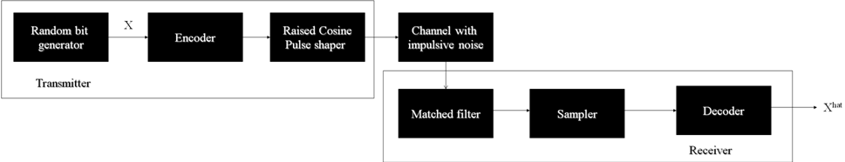
Figure 2. Design Diagram

4.1 MATLAB IMPLEMENTATION OF NOISY SIGNAL
The implementation of our noisy signal in MATLAB involved simulating a digital signal, applying a matched-filter, and adding impulsive noise. The following sections detail this process.

4.1.1 Implementation of Digital Signal Simulation
Using the MATLAB software platform, we implemented a digital signal transmission scheme called Two-Pulse Amplitude Modulation (2PAM) to transmit data. MATLAB has built-in functions that implement 2PAM and we used them to facilitate our work. We needed to use a pulse shape to convert our digital-discrete signals into continuous-analog signals in order to transmit them through the channel. After thorough investigation, we discovered that raised cosine pulse shape is used in the WiMAX standard [7] [8] [9] [10]. We used MATLAB's built-in raised-cosine function to create our pulse shapes. We also used a matched filter in our receiver. The job of a matched filter is to remove as much noise in the signal as possible. It does so by cross-correlating the received signal and the pulse shape.

4.1.2 Implementation of Matched-Filtering
We used a hundred sample raised cosine pulse as the pulse shape in the matched filtering implementation. This pulse shape was convolved with the received signal using the MATLAB convolution function to produce the matched filtered signal. The resulting signal was then sampled at the correct position, which corresponded to an exact match of the pulse shape and the noisy signal, and a hard decision was made about the amplitude of information signal.

4.1.3 Adding Impulsive Noise to Our Digital Signal
In order to add impulsive noise to the information, the information bits were first pulse shaped using the raised cosine pulse shape. The alpha stable noise generating function was then called to produce independent noise samples according to the noise parameters. These independent noise samples were then added to the pulse shaped signal, to produce a noisy version of the signal.

4.2 MATLAB IMPLEMENTATION OF CODING SCHEMES
The following sections describe how we implemented our channel coding and filtering schemes in MATLAB, including implementation of Hamming Codes, Reed-Solomon Codes, Turbo Codes and Hole-Punching. We also detail how we combined Hole-Punching with Reed-Solomon Codes and also Turbo Codes.

4.2.1 Implementation of Hamming Codes
As part of our code in MATLAB, we have two general decoding and encoding functions which will perform a certain type of coding depending on the coding parameter that is passed to the function. The Hamming encoder was designed by using a generating matrix to encode the information bits. These bits are then decoded in the decoder using a parity check matrix. The parity check matrix will produce a syndrome vector which will then help us in identifying the corrupted bits. Hamming encoding/decoding algorithms have been developed completely by our group, and the design was finalized on February 12th, 2008.

4.2.2 Implementation of Reed-Solomon Codes
Reed-Solomon code has been implemented using the built-in MATLAB encoder and decoder. Our group has developed code to use the built-in functions by producing matrices of the correct size, and then evaluating the resulting matrices to get the correct decoding. In order to implement Reed-Solomon coding, we have also used a function to convert variables of type Galoi, which is a mathematical field type, to regular double variables. The Reed-Solomon code was successfully implemented on March 1st, 2008.

4.2.3 Implementation of Turbo Codes
Our group, with Goo Jun’s assistance, was able to find an implementation of Turbo code online. We had to modify a few features of our main program to interface it with the Turbo code. One of the key features we had to modify was the Sampler. The output of the Sampler is binary 1’s and 0’s and is fed into the decoder. The input into the Turbo decoder, however, must be normalized-continuous values between -1 and 1. Therefore, we had to replace our Sampler with a program that takes analog outputs of the Matched Filter and converts them into normalized-continuous values. By doing so, the Turbo decoder would have the correct range of values at its input.

4.2.4 Implementation of Hole-Punching
We implemented the hole-punching filter using the basic functions of MATLAB. This filter was applied to the received signals as the initial operation in the receiver before the matched filtering and decoding operations. One of the difficulties of implementing this filter was that the amplitude of our clean signal in our simulations varied as the SNR value was changed. Therefore, we implemented the threshold amplitude as a function of the signal amplitude at each SNR. Moreover, since the performance of the hole-punching filter was different under noises with different alphas, we found the best threshold value for a number of alpha values. We then performed a quadratic curve fitting. The quadratic equation was then used to produce a proper threshold value under any SNR and alpha value.

4.2.5 Combining Reed-Solomon Codes with Hole-Punching
The coding techniques used in our project are independent of the filtering techniques. Therefore, we were able to independently use Reed-Solomon in conjunction with hole-punching. In order to do this, the signal was first filtered using the hole-punching filter, and then decoded using the Reed-Solomon decoder.

4.2.6 Combining Turbo Codes with Hole-Punching
As mentioned in section 4.2.5 above, hole-punching can be independently used in conjunction with any coding algorithm. Therefore the same procedure applies when combining Turbo coding and hole-punching. Again, the signal was fist filtered using the hole-punching filter, and then decoded using the Turbo decoder.

4.3 GRAPHICAL USER INTERFACE (GUI)
Because of the many channel coding schemes described above, common test methods such as recording test results by hand and graphing data within Microsoft Excel would be daunting; therefore, the implementation of a graphical user interface (GUI) for automated testing and graphing data was an essential part of our project. We quickly discovered that MATLAB has a GUI Development Environment (GUIDE) that enables a novice user to create elegant user interfaces, which allowed our channel coding schemes to work seamlessly with our GUI. We then divided our GUI development into two areas: automated testing and graphical data display.

4.3.1 GUI for Automated Testing (GUI AutoTest)
GUI AutoTest is a user interface that allows the user to run tests under different configurations and automatically stores the results to a spreadsheet. A screenshot of GUI AutoTest has been provided in Appendix A.
We decided that configuration parameters would be encapsulated at the top of the screen; these parameters include choice of channel coding scheme, value of alpha parameter and number of bits to test. The bottom of the screen is divided into two testing modes: Mini Test and Full Test. Mini Test mode is a simulation that tests one signal-to-noise ratio (SNR) and displays the resulting bit-error rate (BER) onto the screen. This test provides a quick and easy way to make sure the code is working. Full Test mode, on the other hand, tests all SNR values for the chosen configuration and writes the resulting data to a Microsoft Excel file titled testData.xls. The newly calculated results are automatically averaged with any existing test results, which allows us to efficiently accumulate test results instead of simply overwriting our progress. An example of one sheet in our testData.xls file has been provided in Appendix B of this report.

We also added a number of features to make our GUI AutoTest more user-friendly. First of all, for each Full Test, the first task done in the background is creating a time-stamped copy of the current testData.xls file. This allows us to keep a record of our test progress and protects us from losing our data in case testData.xls gets corrupted. Full Test mode also gives the user the option of testing up to ten loops with one click so that the user can test large numbers of bits without clogging the memory or repeatedly pressing the “Start Full Test” button. Lastly, since Full Test mode can take hours to complete, we added text fields to the user interface for SNRs completed and Loops completed so that the user can see the simulation progress as it happens.

4.3.2 GUI for Graphical Data Display and Analysis (GUI Demo)
GUI Demo is our other user interface that works in conjunction with GUI AutoTest by displaying the test results collected in testData.xls. A screenshot of our latest GUI Demo can be found in Appendix C.

The goal of GUI Demo was to read from testData.xls and plot a graph of SNR vs. BER. In order to make the user interface more interactive, we added check boxes to the channel coding schemes. This allows the user to select which data plots would be simultaneously plotted on the graph below for comparison. The plotted lines are easily matched to their configuration because the plots are given the same color as the name of the channel coding scheme above. We also allow the user to choose the value of the alpha parameter, so each choice of alpha parameter uses a different set of data, thus redrawing the entire graph.

By plotting our data onto a graph, the user will be able to see which coding schemes have the lowest BER, thus the best performance, for each SNR value. We soon realized that a visual representation of the data was insufficient if the plotted lines are very close together. Therefore, we added an SNR slider on the bottom of the screen. The SNR slider cycles through each SNR value and controls the display of BER values next to each channel coding scheme. This feature gives the user the exact data values being plotted. We also draw a vertical dotted line on the graph to indicate the current value of the SNR slider. This allows the user to visually connect the plotted data lines with the BER values displayed.

5.0 TEST AND EVALUATION

The Test and Evaluation section covers our testing criteria and restrictions when simulating our digital signal. We also provide a detailed analysis of our test results.

5.1 TESTING CRITERIA AND RESTRICTIONS
We evaluated the different channel codes using the GUI AutoTest. We ran each configuration for 1 million bits in order to get results that were as accurate as 10^-4 BER. There were several restrictions to each test when using GUI AutoTest. When running any configuration, we could not run a simulation for more than 100,000 bits because MATLAB would run out of memory. Therefore, when running simulations we tested smaller chunks of bits to add up to 1 million bits. Another restriction we faced was when running Hamming codes, the number of bits had to be a multiple of 4 because hamming codes only encoded blocks of 4. When running any Reed-Solomon codes, the number of bits had to be a multiple of 9 because Reed-Solomon codes encoded blocks of 9.

We originally ran our simulations for SNRs -20 to 20, but we found that we needed to increase the range of SNRs that we test when noise was more impulsive in order to get more detail about when codes distinguished themselves based on their performance. For alphas 0.5 and 1.0, we extended our testing to SNRs from -20 to 62.5.

5.2 ANALYSIS OF TEST RESULTS
The following sections describe our test results.

5.2.1 Alpha = 0.5 Test Results Analysis
An alpha of 0.5 indicates highly impulsive noise. Figure 3 below shows that coding techniques which do not incorporate hole-punching perform poorly under highly impulsive noise. Hole-punching is most effective when combined with another channel coding technique. Out of all the coding techniques we tested, we found that Turbo code with hole-punching has the best performance when under highly impulsive noise.

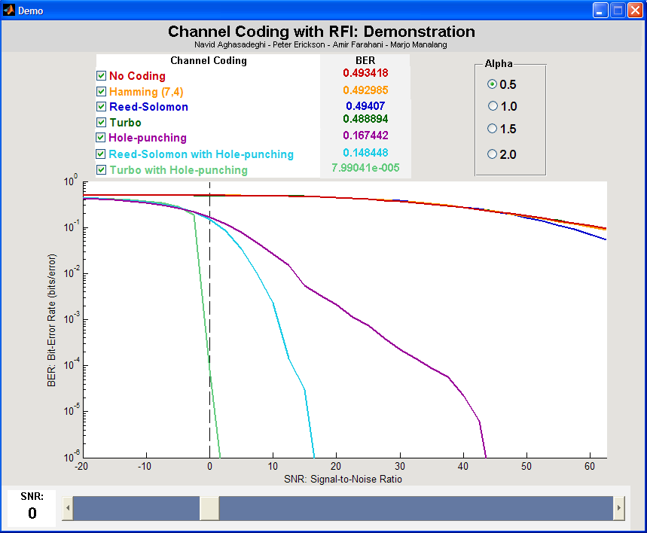
Figure 3. Test Results for Alpha = 0.5

5.2.2 Alpha = 1.0 Test Results Analysis
An Alpha of 1.0 indicates that noise is impulsive. From Figure 4 below, we can see that Turbo Codes and Hamming codes do not perform very well under impulsive noise. Reed-Solomon codes do help decrease the BER. We found that hole-punching performs very well under impulsive noise, but BER is lowest when hole-punching is incorporated with a channel coding technique. We found that Turbo codes with hole-punching had the best performance under impulsive noise.

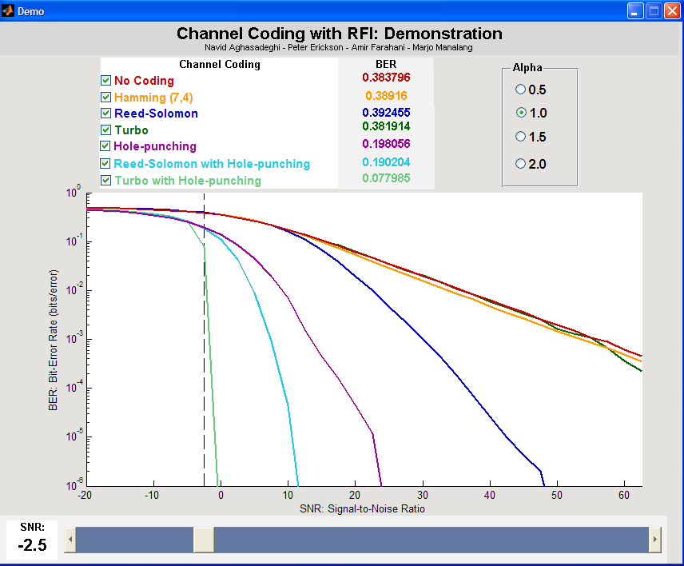
Figure 4. Test Results for Alpha = 1.0

5.2.3 Alpha = 1.5 Test Results Analysis
Alpha of 1.5 indicates slightly impulsive noise. Figure 5 below shows that when hole-punching is incorporated with a channel coding technique there is some improvement. Under slightly impulsive noise, Turbo Codes with hole-punching have the best performance. Hamming codes provided little improvement over no coding and Reed-Solomon has the best performance out of the channel coding techniques.

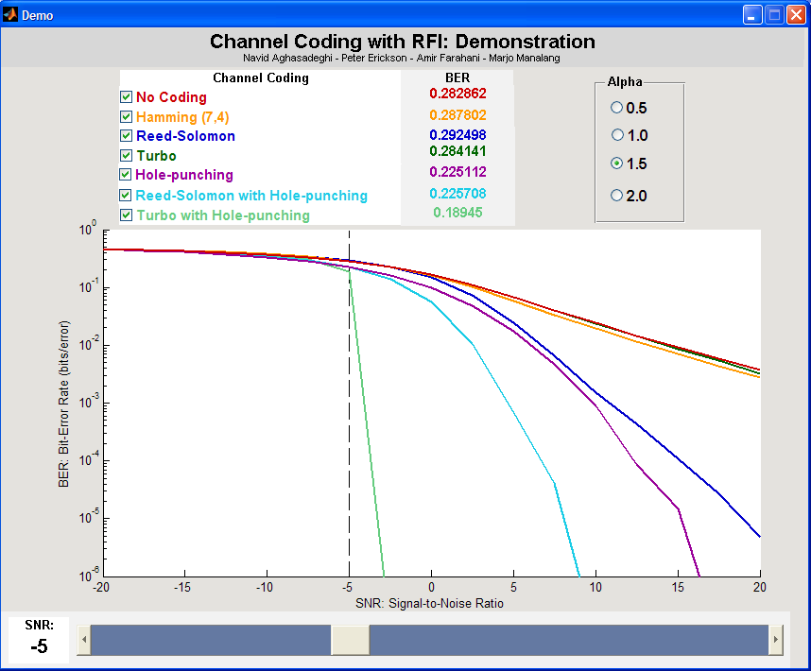
Figure 5. Test Results for Alpha = 1.5

5.2.4 Alpha = 2.0 Test Results Analysis
An alpha of 2.0 indicates Gaussian noise. Figure 6 below shows that turbo codes have the best performance and hamming codes provided little improvement over no coding. We can also see that hole-punching has little effect on BER.

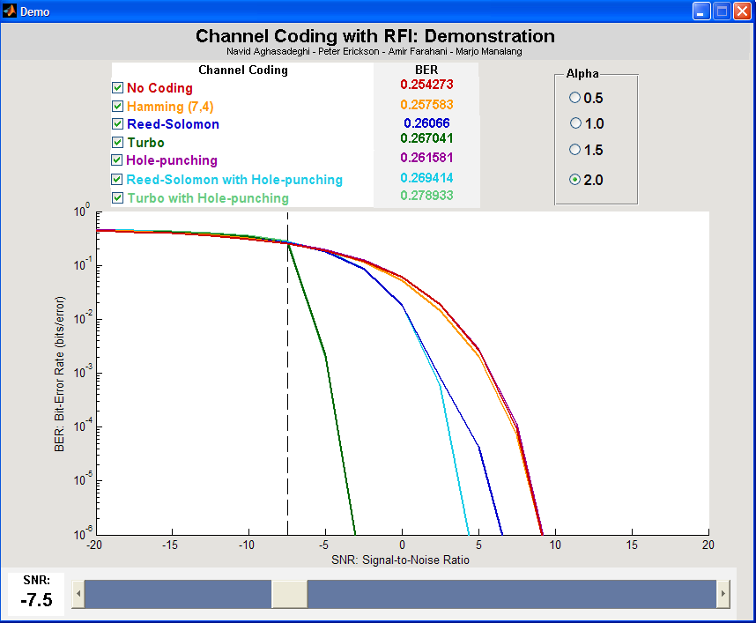
Figure 6. Test Results for Alpha = 2.0

6.0 TIME AND COST CONSIDERATIONS

We were able to keep to the time and cost restrictions that we presented in our proposal.
We were able to obtain the use of MATLAB for $1,900 [11]. The cost of labor for four engineers over eleven weeks totaled $5,280. Including design and prototype overhead costs of $7,180, the total cost of our project was $14,360. We were able to confine ourselves to the free research tools at our disposal to control research and development costs. Below in Table 1 is a detailed table of the costs of this project.

Table 1. Project Costs
Non-Recurring Engineering
(costs incurred during design but not during production)
Design Labor | $5,280
(4 hrs/week @ $30/hr * 11 weeks) * 4 employees
Prototype Materials | $1,900
MATLAB
Overhead | $7,180
(100% of design and prototype)
Total | $14,360
Recurring Engineering and Estimate Selling Price
(costs required to produce product)
Manufacturing Labor | $0
(8 hrs @ 12.50/hr to produce 100 pieces)
Factory Overhead | $0
(200% of Manufacturing Labor)
Expenses | $3,590
(25% Non-Recurring Engineering)
Expenses | $0
(Materials for 100 pieces)
Profit | $3,590
(20% all costs)
Selling Price | $7,180
(per lot)
Selling Price | $72
(per unit)

If we succeed in applying our results toward improving the quality of channel coding in the presence of RFI, we expect a 20% profit on our costs when selling our channel coding scheme to wireless device makers. This high expected profit margin exceeds the minimum attractive rate of return (MARR) of 15% for our company, so we believe this project is a worthwhile endeavor.

7.0 SAFETY AND ETHICAL ASPECTS OF DESIGN

Every project needs to be reviewed for safety and ethical standards, but the nature of our project makes both of these discussions quite brief. Since we are looking to implement new filtering and channel coding schemes in software, there is no imminent danger presented by our project. The main safety concern is that we protect the wireless data being transmitted. Therefore, in order for wireless communication to become more robust, we must strive to create the most efficient channel coding scheme possible. Also, on an ethical standards note, we must ensure that we are not infringing on any current patents if we do sell our channel coding scheme to wireless device manufacturers.

8.0 CONCLUSIONS AND RECOMMENDATIONS

As shown in the above diagrams, Turbo code in conjunction with Hole Punching offers the best performance in each case. Under highly impulsive noise, conventional channel-coding algorithms such as Turbo code and Reed-Solomon code do not perform as well as they do when they are used to mitigate Gaussian noise. Therefore, we needed to make the noisy signal look as though it had been corrupted by Gaussian noise. The technical term for this is Gaussianizing the signal. The Hole Punching technique has been designed specifically to do this. This algorithm works by looking at the amplitudes of the received signals. If the amplitudes are larger than a certain pre-specified threshold, the algorithm will set the amplitude of the signal at that specific time to zero. By doing this, the algorithm gets rid of the large-amplitude pulses in the noisy signal. Once these sporadic pulses are filtered out, the noisy signal is Gaussianized. By feeding this Gaussianized noisy signal into one of our conventional coding schemes, we obtain the best performance out of them. Since Turbo code in general has better performance than Reed-Solomon, Turbo in conjunction with Hole Punching offers the best solution.

We recommend using the hole-punching technique in conjunction with any coding algorithm designed to mitigate Gaussian noise. Since this filtering technique is fairly simple, it can be easily incorporated into the conventional systems.

REFERENCES

[1] K. Gulati, M. Nassar, A. K. Sujeeth, N. Aghasadeghi, B. L. Evans and K. R. Tinsley, "Mitigating Near-Field Interference in Laptop Embedded Wireless Transceivers," Proc. IEEE Int’l Conf. on Acoustics, Speech, and Signal Proc., Las Vegas, NV, 2008.

[2] J. Hall, “Hamming Codes,” http://www.mth.msu.edu/~jhall/classes/
codenotes/Hamming.pdf, (current 29 Jan. 2008).

[3] “Reed-Solomon Codes,” http://www.4i2i.com/reed_solomon_codes.htm, (current 14 Feb. 2008).

[4] “Reed-Solomon error correction,” http://en.wikipedia.org/wiki/Reed-Solomon_error_correction,” (current 14 Feb. 2008).

[5] “Turbo code,” http://en.wikipedia.org/wiki/Turbo_code, (current 14 Feb. 2008).

[6] W. Mo, “An Introduction to Turbo Codes,” http://home.eng.iastate.edu/~mowei/research/
csp_turbo.pdf, (current 14 Feb. 2008).

[7] “WiMAX,” http://en.wikipedia.org/wiki/Wimax, (current 10 Feb. 2008).

[8] S. Shepard, WiMAX Crash Course, McGraw-Hill, New York City, N.Y., 2006.

[9] F. Ohrtman, WiMAX Handbook: Building 802.16 Wireless Networks, McGraw-Hill, New York City, N.Y., 2005.

[10] T. Fisher, “Raised Cosine Filters,” http://www-users.cs.york.ac.uk/~fisher/
mkfilter/racos.html, (current 30 Jan. 2008).

[11] “The MathWorks Products and Prices,” MathWorks, Inc., https://tagteamdbserver.mathworks.com/ttserverroot/Download/
45202_91012v35_NA_INDV.pdf, (current 30 Jan. 2008).
APPENDIX A – SCREENSHOT OF GUI AUTOTEST
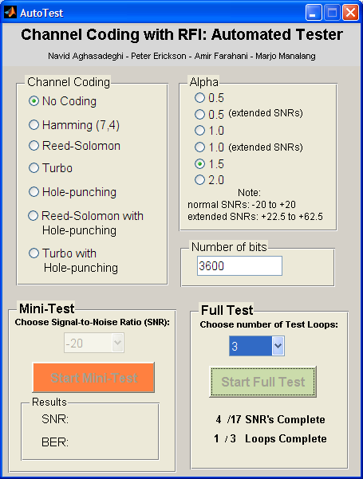

APPENDIX B – EXAMPLE TEST RESULTS
Coding: | SNR | BER | Bits
Hamming (7,4) | -20 | 0.460317 | 1000000
 | -17.5 | 0.448505 | 1000000
Alpha: | -15 | 0.430518 | 1000000
1.5 | -12.5 | 0.4074 | 1000000
 | -10 | 0.377556 | 1000000
 | -7.5 | 0.339161 | 1000000
 | -5 | 0.287802 | 1000000
 | -2.5 | 0.226544 | 1000000
 | 0 | 0.162174 | 1000000
 | 2.5 | 0.102704 | 1000000
 | 5 | 0.059318 | 1000000
 | 7.5 | 0.03362 | 1000000
 | 10 | 0.019321 | 1000000
 | 12.5 | 0.011643 | 1000000
 | 15 | 0.007052 | 1000000
 | 17.5 | 0.004369 | 1000000
 | 20 | 0.002754 | 1000000

APPENDIX C – SCREENSHOT OF GUI DEMO
