Music Database with Song Identification Using Perceptual Audio Hashing

Submitted To

Hamood-ur Rehman
Dr. Brian L. Evans
Dr. Bruce Pennycook

Prepared By

Eric Heinen

EE464H Senior Design Project
Electrical and Computer Engineering Department
University of Texas at Austin

Spring 2006
CONTENTS

LIST OF FIGURES iii
LIST OF TABLES iv
EXECUTIVE SUMMARY v

1.0 INTRODUCTION 1
2.0 DESIGN PROBLEM STATEMENT 1
2.1 MOTIVATION 1
2.2 BACKGROUND 2
2.3 REQUIREMENTS AND GOALS 3
2.4 DESIGN PARAMETERS 4
2.5 CONSTRAINTS 4
3.0 DESIGN PROBLEM SOLUTION 4
3.1 FRAMING 4
3.2 FEATURE EXTRACTION 8
3.3 CLUSTERING 11
4.0 DESIGN IMPLEMENTATION 12
5.0 TEST AND EVALUATION 13
5.1 BEAT DETECTOR CUTOFF FREQUENCY 13
5.2 NUMBER OF FRAMES PER BEAT 14
5.3 SONG DUPLICATION THRESHOLD 14
6.0 TIME AND COST CONSIDERATIONS 15
7.0 SAFETY AND ETHICAL ASPECTS OF DESIGN 15
8.0 CONCLUSIONS AND RECOMMENDATIONS 16
REFERENCES 16
LIST OF FIGURES

1 Three-Stage Perceptual Audio Hashing Framework 3
2 MIT Media Lab Beat Detection Algorithm 5
3 Example Percussion Spectrogram 7
4 YIN Pitch Detection Results 9
5 Auditory Nerve Image (ANI) Pitch Detection Results 10
6 Cross-Correlation Pitch Detection Results 11
7 Graphical User Interface (GUI) Implementation 12
LIST OF TABLES

1 Initial Beat Detection Results 6
2 Improved Beat Detection Results 8
3 Beat Detector Cutoff Frequency Results 14
EXECUTIVE SUMMARY

Digital audio files require relatively large amounts of memory. Therefore, it would be a good idea for a music database’s interface to catch potential song duplications. Without relying on artist and song information in filenames or metadata, this problem becomes a matter signal processing.

The concept of perceptual audio hashing was therefore employed. The idea is to generate a song identifier, upon file addition, that describes its perceptual content in a reduced yet thorough way. Then, catching song duplication is simply a matter of comparing these identifiers. Furthermore, with the right type of search algorithm, database users might be able to find perceptually similar songs.

Perceptual audio hashing generally follows a three-stage framework, but I focused exclusively on the first two stages: framing and feature extraction. For the framing stage, I decided to use beat detection, such that there are a constant number of frames per beat. I had hoped that this would to minimize the complexity of comparing renditions of the same song performed at different tempos. I tested different algorithms, picked the best one, and made improvements by adjusting the limits of the frequency bands it analyzed within the source audio.

For the feature extraction stage, I only implemented pitch detection. I tested three algorithms, and the one I decided to use was of my own design. I used the output of this stage, which I called a note vector, as the database identfier. I then developed an algorithm for comparing these identifiers, and defined song duplication as the event that the match percentage exceeds a threshold.

After implementing all of the aforementioned code in MATLAB, I created a graphical user interface in LabVIEW to implement a music database. With this interface, I then tested the overall solution and made some final design choices. In the end, the database recognized song duplications with high probability, and also recognized my rendition of a song as being very similar to the original. The design had some shortcomings, but the results in general were encouraging and I am interested in extending this project in the future.

1.0 INTRODUCTION

The purpose of this report is basically to discuss an engineering problem that I considered, and how I worked to design, implement, test, and refine a solution. In short, I designed music database software with two key features. First, it reduces the probability of song redundancy without depending on filenames or metadata. Second, it allows the user to search for other renditions of a given song.

Although I completed this project without a team member, I had plenty of resources available. First, I had weekly meetings with my supervising professor, Dr. Brian L. Evans, who helped to guide the project. Also, my Teach Assistant, Hamood, made sure I was keeping up with the schedule and meeting deadlines. Finally, Dr. Bruce Pennycook, from the School of Music, gave some input with regards to audio processing.

The rest of this report is organized as follows. I will begin with a thorough discussion of the design problem, including some motivation and background. Then, I will walk through the results of my design process, implementation, and refinement stages. Finally, I will discuss the impact of time limitations, ethical aspects of the design, and conclude with some suggestions for future work.

2.0 DESIGN PROBLEM STATEMENT

The overall goal of this project was to design a music database interface with two key features. First, it should recognize and alert the user of potentially redundant songs. Second, it should allow the user to search for perceptually similar songs.

2.1 MOTIVATION
Since digital audio files require large amounts of memory, duplicating a song in a music database is an undesirable waste of storage space. It would therefore be desirable for such a database’s interface to assign keys, or unique identifiers, to inserted songs based on auditory content. In this way, data duplication can easily be recognized as key duplication.

The problem is then to devise a way of identifying auditory content. One approach would be to use the artist name and song title, extracted from either the filename or metadata. However, this information is often incomplete, inaccurate, or incorrectly formatted. A signal processing approach has the potential to create a robust solution without requiring human intervention for the sake of verifying filename or metadata accuracy.

2.2 BACKGROUND
Hash functions, which are often called message digest (MD) functions, are commonly used to generate short binary identification strings, or hash values, from digital data sources. Conventional hashing algorithms, such as MD-5, are very sensitive to single bit errors [1]. However, music data often encounters changes that do not affect how a human audience perceives it. For example, bit errors can occur during file transfers, and compression algorithms such as mp3 throw away large amounts of data. Therefore, conventional hashing algorithms are not suitable for auditory content identification.

A more robust approach would be to apply the concept of perceptual audio hashing. In short, the objective is to process a song’s data, recognize its perceptual features, and use this information to form a perceptual hash value. Utilizing these types of identifiers as database keys would reduce the probability of data redundancy, regardless of inaudible differences such as compression. In addition, an additional functionality could be developed for the database interface to allow users to search for perceptually similar songs.

Perceptual audio hashing generally follows a three-stage framework, depicted in Figure 1, on page 3. The source data first goes through a framing process, to divide it into N uniform time chunks. Then, each audio frame is processed by a set of feature extractors, to generate a feature vector. Finally, the feature vector may be reduced to a final hash value by clustering it with other closely related vectors.

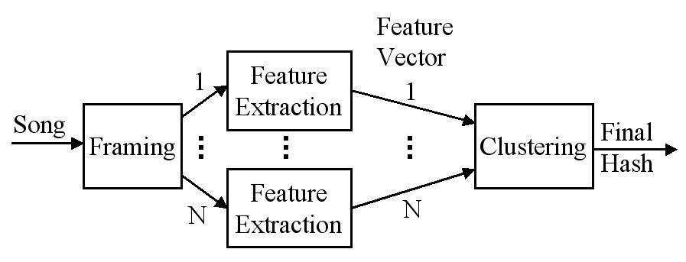
Figure 1. Three-Stage Perceptual Audio Hashing Framework

2.3 REQUIREMENTS AND GOALS
The main requirement for this project was that I design a perceptual audio hashing process in MATLAB that fit into the aforementioned framework. The primary goal of the design was to maximize robustness of song identification, by minimizing both false positive and false negative rates. A false positive occurs when two perceptually dissimilar tracks yield identical hash values. A false negative occurs when two perceptually duplicate tracks yield different hashes. Of lesser concern were the computational complexity of creating the hashes, and memory requirements for storing them.

The second requirement of the project was to develop an algorithm for finding perceptually similar songs. I envisioned using some sort of musical heuristics, but at the very least, I wanted to be able to find different renditions of the same song. Finally, I intended to create a graphical user interface (GUI) in LabVIEW. With this interface I could then automate some of the testing and demo a final solution.

2.4 DESIGN PARAMETERS
For the perceptual hashing process, there were several design parameters to be considered with respect to identification robustness, computational complexity, and memory usage.
- Method of framing: constant frame size or based on beat detection
- Beat detection algorithm, if applicable
- Frame size: if using beat detection, 2^n frames per beat makes most sense
- Feature set extracted: pitches (notes), vibrato, roughness, amplitude onsets, etc.
- Feature extraction algorithms
- Clustering algorithm
- Perceptually similarity search algorithm

2.5 CONSTRAINTS
Due to time limitations, I made some simplifications to the problem from the onset. They are all with respect to the types of audio files I intended to handle.
- 10 second song clips
- Wav or mp3 format
- Single channel (mono)
- 44.1kHz sampling rate
- Starting on a down beat
- Pop genre or generally anything with a simple beat

3.0 DESIGN PROBLEM SOLUTION

In this section, I will step through the stages of the design process and explain the decisions I made for various design parameters.

3.1 FRAMING
Since audio framing is the first stage of the hashing process, it was the first issue I dealt with. The primary choice here was the method of framing. Using a constant frame size is simple, but I chose to use beat detection because it makes the most sense, musically. Also, I thought that this choice would reduce the complexity of recognizing renditions of the same song, which often vary in tempo.

After choosing to use beat detection, I located three different algorithms implemented in MATLAB that I wanted to test. The first, called the IPEM Toolbox Rhythm Analysis Module, did not simply output a tempo estimation. Rather, it gave a best estimate over time, and I couldn’t devise a way of consolidating this data into a single estimation. With the second algorithm, called the Music Analysis Toolbox Periodicity Histogram, I wasn’t able to achieve any accurate results, so I quickly moved on. Finally, I found a beat detection algorithm designed by Eric D. Scheirer at the MIT Media Lab, and implemented in MATLAB by undergraduates at Rice University [2]. Figure 2, below, depicts this algorithm in block diagram form.

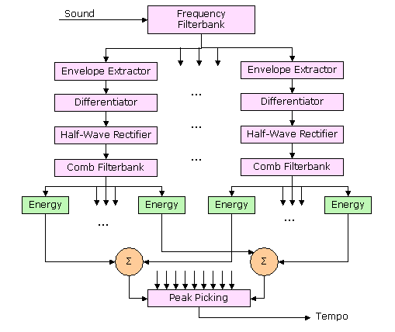

Figure 2. MIT Media Lab Beat Detection Algorithm

This algorithm was easy to use since it output a single tempo estimate. I went ahead and tested it on a pop-compilation CD I had purchased, along with a couple of random songs from my collection. For each song, I compared the detected tempo to what I had estimated by ear with a metronome, and calculated an error percentage. The test results, shown below in Table 1, indicate that the beat detector is often fairly accurate, but errors of approximately 33% are pretty common.

Table 1. Initial Beat Detection Results
Artist - Song | Actual Tempo (bpm) | Detected Tempo (bpm) | Error
The Doors - The End | 110 | 144.5 | 31.36%
3 Doors Down - Let Me Go | 92.5 | 92 | 0.54%
Jimi Hendrix - Hey Joe | 80.5 | 80 | 0.62%
Gorillaz - Feel Good Inc | 138 | 92.5 | 32.97%
Incubus - Pardon Me | 151.5 | 148 | 2.31%
Amerie - 1 Thing | 100 | 66.5 | 33.50%
Baby Bash - Baby Im Back | 99 | 66 | 33.33%
Bobby Valentino - Slow Down | 93.5 | 62 | 33.69%
Brooke Valentine - Girlfight | 99.5 | 136 | 36.68%
Eminem - Mockingbird | 84 | 112 | 33.33%
Keith Urban - Making Memories Of Us | 104 | 102 | 1.92%
Shakira - La Tortura | 99 | 136 | 37.37%

After producing these results, I decided to use this beat detector, but I also wanted to see if I could figure out a way to fix some of the 33% error cases. I soon realized that the melodies in all of the problematic songs had syncopation, which is an accent on a normally weak beat. However, the percussion lines were usually pretty simple. I began to think that I should change the values of the filterbank (see Figure 2 again) to a range where percussion energy was high relative to melody energy. Therefore, I began plotting spectrograms for different songs and isolated percussion tracks to investigate their frequency characterics. See Figure 3, below, for an example percussion spectrogram.

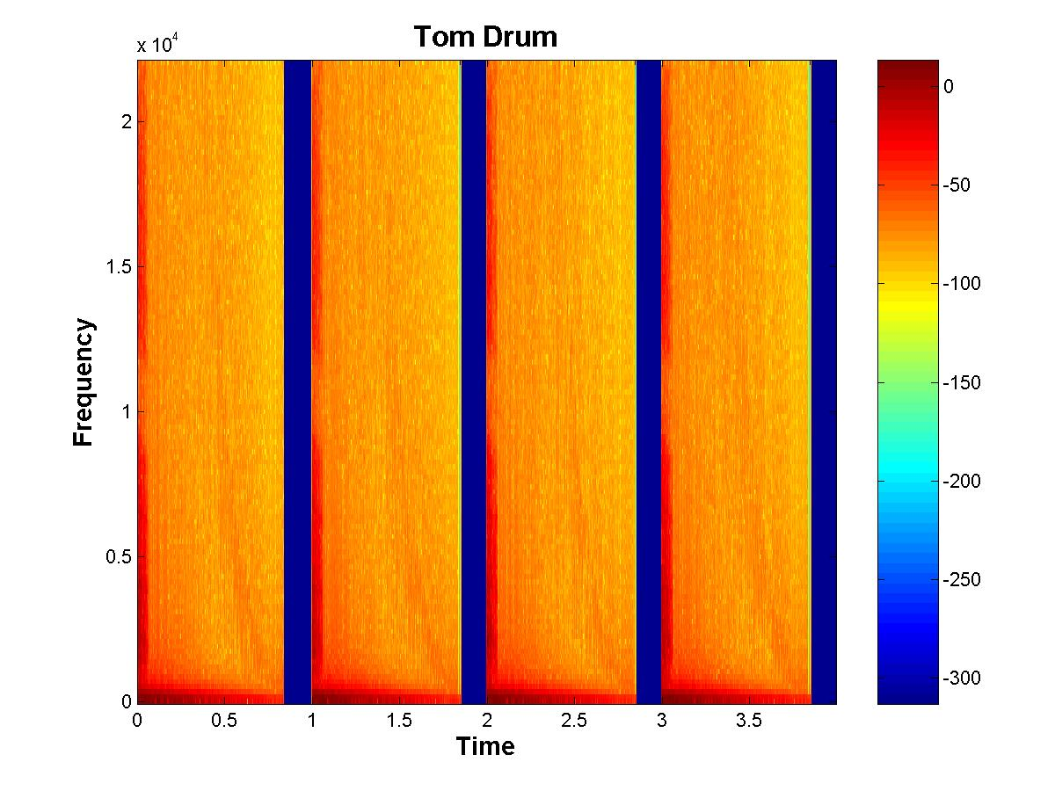
Figure 3. Example Percussion Spectrogram

From these spectrograms, I concluded that percussion is generally wideband. Furthermore, melody pitches are less than 5kHz and the harmonics above 10kHz do not contribute significant energy. Therefore, I made the filterbank highpass, and tried cutoff frequencies of 16kHz, 18kHz, and 20kHz. The 18kHz cutoff case led to the lowest tempo detection errors, and the results are shown in Table 2, on page 8.

Table 2. Improved Beat Detection Results
Artist - Song | Actual Tempo (bpm) | Detected Tempo (bpm) | Error
The Doors - The End | 110 | 109.5 | 0.45%
3 Doors Down - Let Me Go | 92.5 | 92 | 0.54%
Jimi Hendrix - Hey Joe | 80.5 | 81.5 | 1.24%
Gorillaz - Feel Good Inc | 138 | 138.5 | 0.36%
Incubus - Pardon Me | 151.5 | 152 | 0.33%
Amerie - 1 Thing | 100 | 97 | 3.00%
Baby Bash - Baby Im Back | 99 | 100 | 1.01%
Bobby Valentino - Slow Down | 93.5 | 66.5 | 0.00%
Brooke Valentine - Girlfight | 99.5 | 61 | 34.76%
Eminem - Mockingbird | 84 | 66 | 33.67%
Keith Urban - Making Memories Of Us | 104 | 84.5 | 0.60%
Shakira - La Tortura | 99 | 104 | 0.00%

At this point in the design process, I decided that I had spent enough time working on beat detection. There was still a question as to how many frames per beat I should use, but this was left unanswered until the testing and evaluation period.

3.2 FEATURE EXTRACTION
Due to time limitations, I decided to concentrate on extracting only pitches (notes), which are the most important musical features. I tried three algorithms and my test case was an acoustic guitar recording that I made. I played a segment of a song by Joe Satriani, titled “Always With Me, Always With You.” I thought that this recording should be relatively straightforward to analyze, since it has only guitar, there are no chords, and the notes are of uniform length. However, this task proved to be more difficult than expected. The likely cause of confusion for the algorithms was the fact that notes continued to ring while other strings were being plucked, resulting in overlap.

Nevertheless, I began testing with a pitch detector called YIN, which uses a Fast Fourier Transform (FFT). Knowing the tempo of the recording, I then divided the audio such that there was a single note per frame. Next, I ran the YIN algorithm on each frame independently, extracted one pitch each time, and combined the results to form a note/feature vector. To determine the accuracy of this extracted note vector, I compared it to a musical transcription, as seen in Figure 4, below. The blue stem plot is the transcription, and the red plot is what was detected. It is apparent from the graph that this algorithm is not very accurate for this relatively simple recording.

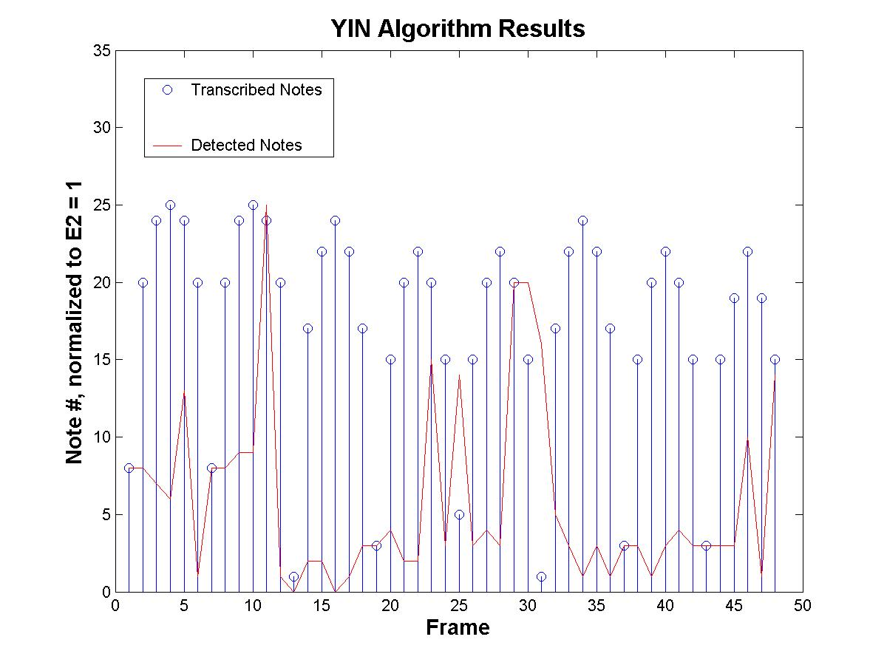
Figure 4. YIN Pitch Detection Results
For the next algorithm, I tried utilizing existing code to create an Auditory Nerve Image (ANI) of the same recording. An ANI is a description of what the inner ear transmits to the brain, and should be insensitive to inaudible transformations including mp3 compression. Basically, the ANI incorporates a filterbank, and outputs a signal for each bandpass channel. I created channels for each note within the ordinary range of a guitar (E2-A5), since this is where the melody usually occurs. Then, for each frame, I detected a pitch by selecting the channel with the most energy. I formed and plotted the note vector, as before, in Figure 5, below. The results show that this algorithm is more accurate, but still intersects few of the points on the actual musical transcription.

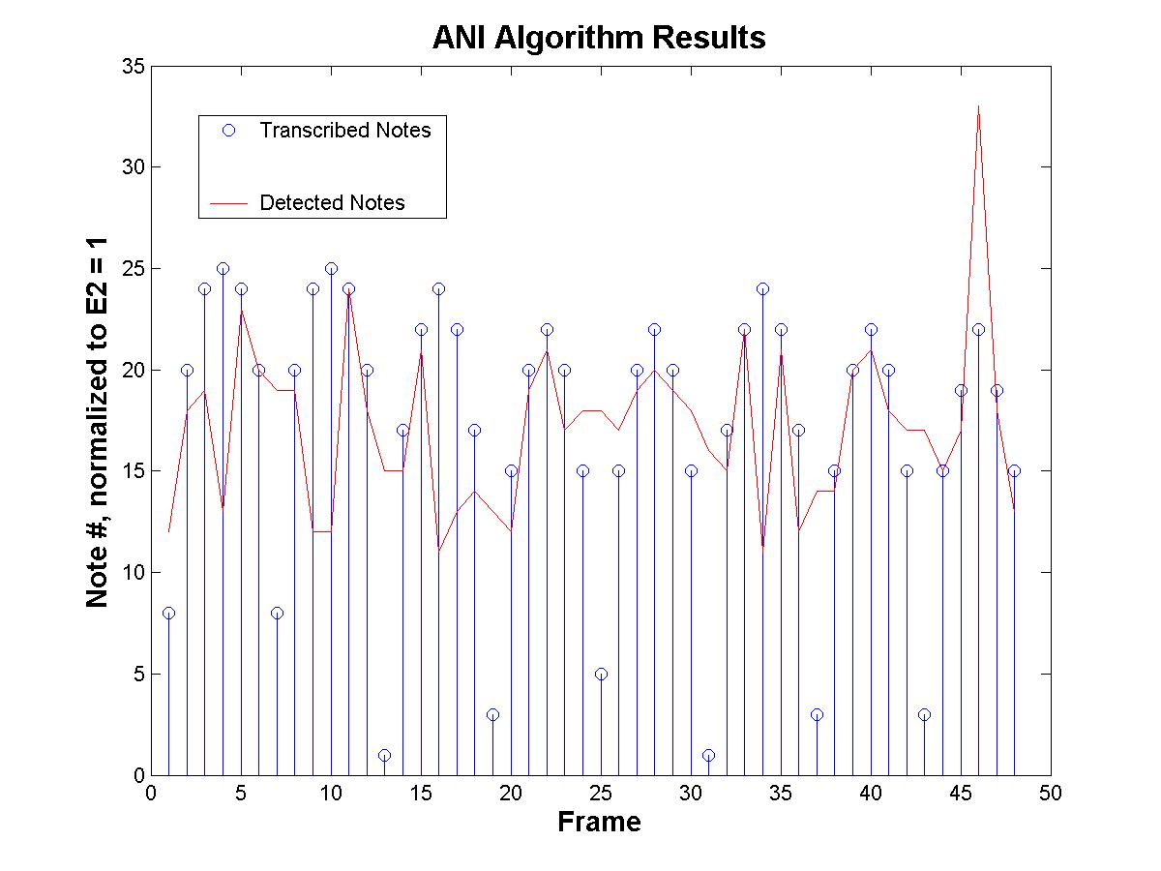
Figure 5. Auditory Nerve Image (ANI) Pitch Detection Results

Finally, I decided to develop a pitch detection algorithm myself. I took the audio frame to be analyzed and computed a cross-correlation between it and pure sinusoids of all note frequencies within the same musical range as before. Then, I selected the three notes with the highest peak cross-correlations. Although this method is brute-force, it actually ran faster than the other two algorithms. In addition, by using three guesses, the resulting two-dimensional note vector intersects almost every point in the musical transcription, as seen in Figure 6, below. Therefore, I decided to use this pitch detection algorithm, and the resulting note/feature vector became the feature vector.

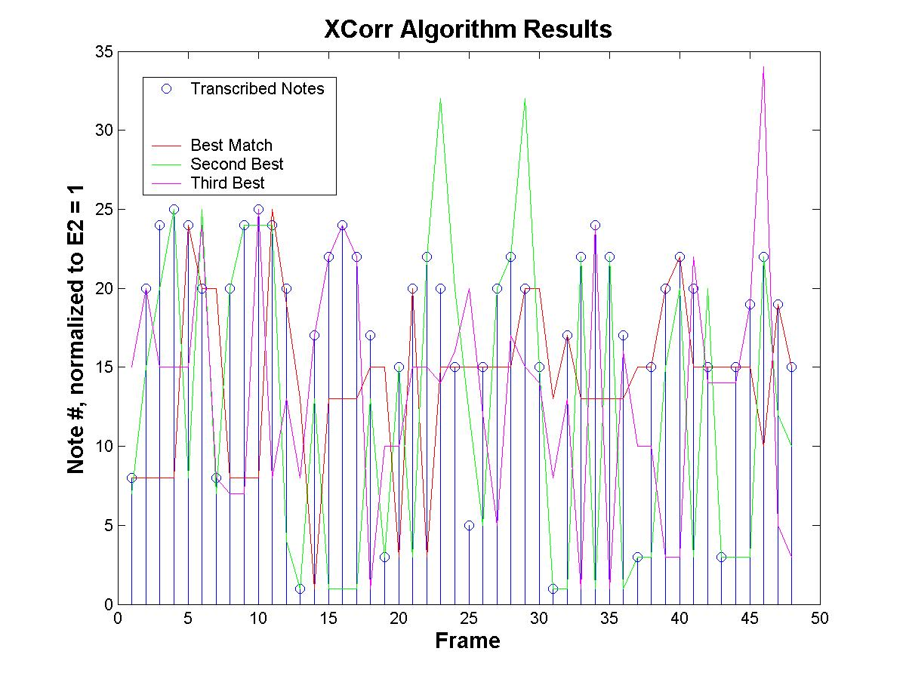
Figure 6. Cross-Correlation Pitch Detection Results

3.3 CLUSTERING
In the end, I decided that clustering note vectors was not necessary, considering how small in size they are compared to the actual song files. However, I needed to develop a method of making comparisons, and at the very least, determining whether two files are duplicates, renditions of the same song, or uncorrelated. What I devised was to calculate the percentage of points intersecting between note vectors. Then, if this match percentage is above one threshold, the two sources are likely duplicates. Otherwise, if the match is relatively high, the sources might be renditions of the same song. I postponed the determination of the threshold value until the testing and evaluation period.

4.0 DESIGN IMPLEMENTATION

After determining the design problem solution, as outlined in the previous section, the actual database implementation was straightforward. First, I combined all of the MATLAB beat detection, framing, and pitch detection code into one function that can be called from a GUI to generate note vector identifiers. Then, I implemented the note vector comparison function in MATLAB. Finally, I implemented the actual music database GUI in LabVIEW, shown in Figure 7, below.

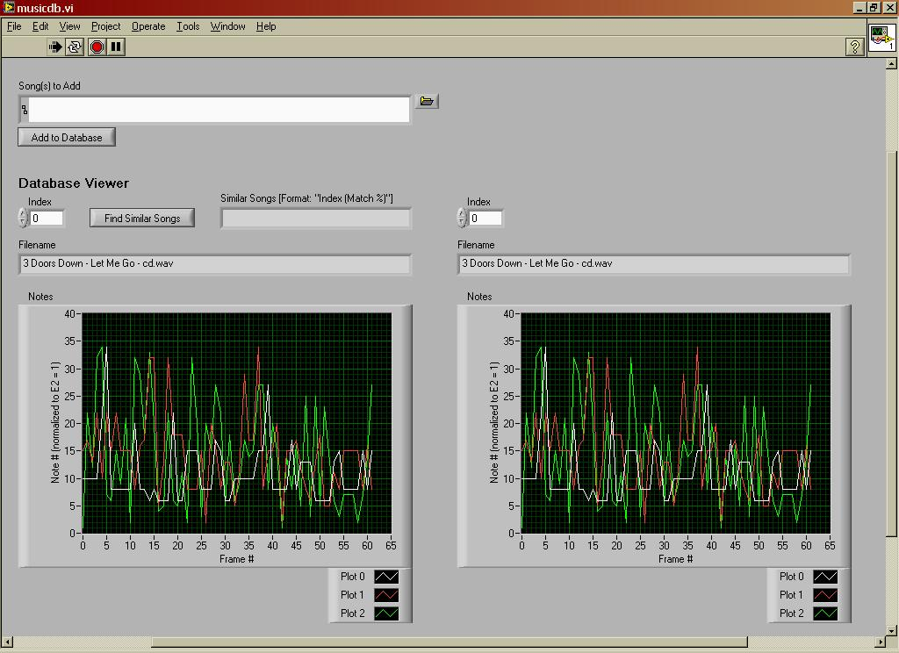
Figure 7. Graphical User Interface (GUI) Implementation

The GUI is simple but effective. At the top, there is a folder button to browse for a song path. Then, by clicking the “Add to Database” button, the GUI calls the MATLAB code to generate a note vector for the source file. If the resultant note vector matches a database entry by a percentage above a threshold, a dialog appears and the user must verify whether or not they actually want to add the song. In addition, the user can browse the note vectors in the database in two separate windows and make visual comparisons. Finally, once a source is selected in the left window, the “Find Similar Songs” button can be clicked to locate possible renditions of the same song.

5.0 TEST AND EVALUATION

During the test and evaluation period, I had to finalize three design parameters. First, although I had previously set the cutoff frequency of the beat detector to 18kHz, testing indicated that this limit did not work well with mp3 files. Therefore, I needed to find a new cutoff for which the beat detector would be consistent, regardless of compression, yet still minimize error. Second, I still had to determine how many frames per beat to use, and third, I needed to find a threshold for the song duplication notifaction function.

5.1 BEAT DETECTOR CUTOFF FREQUENCY
I considered four cutoff frequencies for the beat detector: 16.4kHz, 14.5kHz, 10.8kHz, and 7kHz. For each cutoff, I detected the tempos for the song set from before, and calculated errors with respect to actual tempos. Then, I detected the tempos of the mp3 versions of those songs, and calculated errors with respect to the uncompressed versions. The average errors for each cutoff frequency are listed in Table 3, on page 14. A cutoff of 10.8kHz was selected in the end by trading off between the two types of error.

Table 3. Beat Detector Cutoff Frequency Results
 | 16.4 kHz | 14.5kHz | 10.8kHz | 7kHz
Average Error to  Actual Tempo | 1.44% | 1.20% | 4.79% | 11.51%
Average Error Between  mp3 and uncompressed | 16.39% | 9.65% | 2.58% | 1.30%

5.2 NUMBER OF FRAMES PER BEAT
I started off using two frames per beat, which makes sense for pop music since melodies are rarely more complex than half notes. However, I wanted to test the effect of increasing the number of frames per beat to four. So, I took the same set of songs I had been working with, created note vectors for both frame sizes, and calculated average mp3-to-uncompressed match percentage for the two cases. Two frames per beat resulted in an average match of 84.9%, while four resulted in a 77.67% average match. Furthermore, in both cases, the match percentage to dissimilar songs remained relatively the same. Therefore, increasing the number of frames per beat actually decreased the margin between perceptually duplicate and dissimilar songs. In consideration of this, and the fact that increasing the number of frames per beat results in more computational complexity, I ended up using two frames per beat.

5.3 SONG DUPLICATION THRESHOLD
By setting the threshold to 70%, there were no false positives between the set of mp3 and uncompressed songs I had been working with. In addition, only one false negative occurred, which was due to differences in detected tempos. Finally, my rendition of the Joe Satriani song, which matched the original by 63%, was not identified as duplication, but did appear as matching the original most closely. Given more time, I would have liked to analyze this threshold selection for a more extensive data set.
6.0 TIME AND COST CONSIDERATIONS

Since the design had only a software component, I incurred few costs. Both of the software development tools I used, MATLAB and LabVIEW, were installed on the lab computers and therefore free for me to use. In addition, the toolboxes that I utilized were open-source and free to download. In all, I spent fifteen dollars on the purchase of a pop-music compilation CD, which I used to test beat detectors. Needless to say, I did not overrun my budget.

Time limitations came into consideration often. From the beginning, I had to simplify the problem with the types of song clips I wanted to deal with. During the design process, time pressures forced me to make further sacrifices. First, I had to accept certain limitations of the chosen beat detector and move on to other aspects of the design problem. Second, I only implemented pitch detection in the feature extraction block of the hash value creation process. Finally, I omitted the clustering stage of hash creation. Overall, time limitations influenced the project schedule and design robustness, but did not prevent me from finding a solution.

7.0 SAFETY AND ETHICAL ASPECTS OF DESIGN

Since the design had no hardware component, there were no safety considerations. In addition, there are no real ethical considerations for the software implementation. The database administrator has an ethical consideration of whether to use purchased or pirated music, but the software is essentially a listener and creates perceptual hash identifiers which contain no copyrighted information. In addition, the software simply has no means of identifying copyright infringements and enforcing ethical standards. However, perceptual hashing is certainly applicable to digital watermarking and other copyright protection solutions, which may be investigated as an extension of this project.

8.0 CONCLUSIONS AND RECOMMENDATIONS

In conclusion, my design solution meets most of the requirements and goals I set forth from the beginning, but also has some shortcomings. First of all, the database was able to identify song duplications with high probability by utilizing perceptual hash identifiers, in the form of a note vectors. However, a two-stage process was used to create these identifiers, as the clustering step was omitted. Furthermore, the similar song search functionality was reduced to simply finding other renditions. Although, it worked reasonably well for a recording I made of “Always With Me, Always With You,” I was not able to assess how the database would handle other test cases.

Given the relative success of this semester-long project, it would be interesting to see what kind of results I, or somebody else, could achieve through future work. Besides working on improving beat and pitch detection algorithms, the hash creation and comparison techniques should be expanded to handle full-length songs. This means handling audio files that are not necessarily aligned to a downbeat, and in general have tempo variation. Additionally, a more useful similar song search functionality could be developed, possibly based on characteristics such as musical key and typical note structures.

REFERENCES

[1] V. Monga, Perceptually Based Methods For Robust Image Hashing,
Ph.D. dissertation, Department of Electrical and Computer Engineering,
The University of Texas at Austin, August 2005.
[2] K. Cheng, B. Nazer, J. Uppuluri, R. Verret, “Beat This: A Beat Synchronization Project,” ELEC 301 Signals and Systems Group Projects 2001,
http://www.owlnet.rice.edu/~elec301/Projects01/beat_sync/beatalgo.html
(current 4 May 2006).

