The University of Texas at Austin
Dept. of Electrical and Computer Engineering
Midterm #2

Prof. Brian L. Evans

Date: December 7, 2012 Course: EE 445S

Name:
Last, First

- The exam is scheduled to last 50 minutes.
- Open books and open notes. You may refer to your homework assignments and the homework solution sets. You may not share materials with other students.
- Calculators are allowed.
- You may use any standalone computer system, i.e. one that is not connected to a network. Disable all wireless access from your standalone computer system.
- Please turn off all cell phones and other personal communication devices.
- All work should be performed on the quiz itself. If more space is needed, then use the backs of the pages.
- Fully justify your answers unless instructed otherwise. When justifying your answers, you may refer to the Johnson, Sethares & Klein textbook, the Welch, Wright and Morrow lab book, course reader, and course handouts. Please be sure to reference the page/slide number and quote the particular content you are using in your justification.

Problem | Point Value | Your score | Topic
1 | 30 |  | Quadrature Amplitude Modulation
2 | 23 |  | Channel Equalization
3 | 27 |  | Analog-to-Digital Conversion
4 | 20 |  | Potpourri
Total | 100
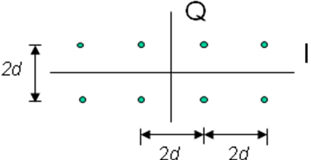
Problem 2.1 Quadrature Amplitude Modulation (QAM). 30 points.
An 8-level QAM constellation is shown on the right.
T_{sym} is the symbol time
Energy in the pulse shape is 1.

- Draw decision regions at the receiver on the above constellation. 6 points.
- Based on the decision regions in (a), give a formula for the probability of symbol error. 6 points.

- When increasing the value of d, does each of the following increase, decrease or stay the same? Why? 9 points.

probability of symbol error?

symbol rate?

implementation complexity/cost in transmitter

- When increasing the value of T_{sym}, does each of the following increase, decrease or stay the same? Why? 9 points.

probability of symbol error?

symbol rate?

implementation complexity/cost in transmitter

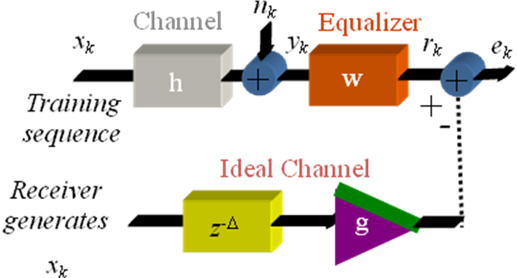
Problem 2.2. Channel Equalization. 23 points.
In the discrete-time system on the right, the
equalizer operates at the sampling rate.
Equalizer has two real-valued coefficients, and the first one is fixed to be one:
w[k] = δ[k] + w₁ δ[k-1]
You may ignore the noise signal n_{k}.

- During training, derive the update
equation for w₁ to implement an
adaptive least mean squares equalizer. 15 points.

- What values of Δ and g would you use? Why? 4 points.

- What value of mu would you advocate? Why? 4 points.

Problem 2.3. Analog-to-Digital Conversion. 27 points.
For an analog-to-digital converter running at sampling rate of f_{s} and quantizing to B bits, here is a block diagram of a sigma-delta modulation implementation of the A/D:
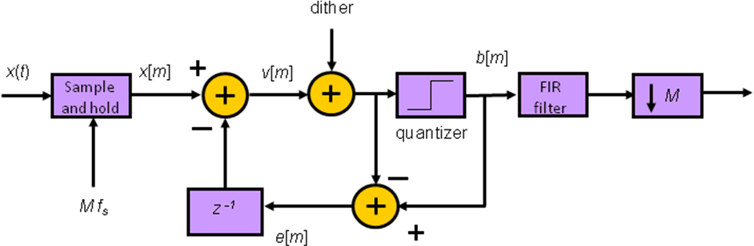
The internal clock runs at M f_{s}.
- How would you efficiently generate an unsigned two-bit dither signal with a triangular probability density function? 6 points.

- For analyzing noise shaping, we can replace the quantizer with an additive noise source n[m]. What is the noise transfer function from n[m] to b[m]? Please set the dither signal and x[m] to zero. 9 points.

- The output stage contains a finite impulse response (FIR) filter and a downsampler by M. If the internal quantizer gives 5 bits (signed) and if the A/D converter output is 12 bits (signed), how many 4-bit FIR coefficients (signed) are there for the following cases so that there is no loss of precision? 12 points.

Direct implementation of the FIR filter (without inclusion of downsampler effects)

Polyphase filter bank implementation of cascade of FIR filter and downsampler
Problem 2.4. Potpourri. 20 points.
Shown below are five common impairments in communication systems. For each impairment:
- Give the name of the receiver block or subsystem that would attempt to compensate it.
- Give the name of a design method for each block or subsystem and any assumptions made in the design method

- Additive noise. 4 points.

- Linear time-invariant distortion. 4 points.

- Fading. 4 points.

- Carrier mismatch. 4 points.

- Symbol timing mismatch. 4 points.

