% In-Lecture Assignment #4 Related to Homework #6
% Consider performing an iterative maximization of
% $J\left(x\right)=8-x^{2}+6 cos⁡(6x)$
% via the steepest descent (ascent) algorithm (JSK equation (6.5) on page 116)
% with the sign on the update reversed from negative to positive so that
% the algorithm will maximize rather than minimize; i.e.
% $x\left[k+1\right]=x\left[k\right]+μ{\left.\frac{dJ(x)}{dx}\right]}_{x=x[k]}$
% a. Visualize and analyze the shape of the objective function J(x).
% 1) Plot J(x) for -5 < x < 5. Give the Matlab code for your answer.
x = [-5 : 0.01 : 5];
J = 8 - x .^ 2 + 6 * cos(6*x);
plot(x, J); %% At end of document

% 2) Describe the plot.
% Sum of concave down parabola and cosine creates many local maxima -OR-
% Headband-like rainbow shape composed in a parabolic wavy pattern -OR-
% Comic (graphical novel) sketch of a head with hair or crown
% 3) How many local maxima do you see?
% 11, which are the 9 peaks with valleys plus the two end points.
% 4) Of these local maxima, how many are global maxima?
% Only one, located at x = 0.

% b. Derive the steepest descent (ascent) update equation
% dJ(x)/dx = -2x - 36*sin(6*x)
% and modify the code below to include the derivative of dJ(x)/dx
% Code below modified from a solution by a Spring 2019 student
% polyconverge.m find the maximum of J(x)=x via steepest descent
N=50; % number of iterations
mu=0.001; % algorithm stepsize
x=zeros(1,N); % initialize sequence of x values to zero
x(1)=0.7; % starting point x(1)
for k=1:N-1
x(k+1)= x(k) + (-36*sin(6*x(k)) - 2*x(k))*mu; % update equation
end
figure();
stem(x); % to visualize approximation of x
x(N)

% c. Implement the steepest descent (ascent) algorithm in Matlab with x[0] = 0.7.
% 1) To what value does the steepest descent algorithm converge?
% x = 1.0376
% 2) Is the convergent value of x in the global maximum of J(x)? Why or why not?
% No. The only global maximum of J(x) occurs at x = 0. The initial guess
% of x = 0.7 is on an upward slope of J(x) towards a local maximum at
% x = 1.0376 and the iterates of x[k] go towards the local maximum.
% The objective function J(x) is plotted below vs. x
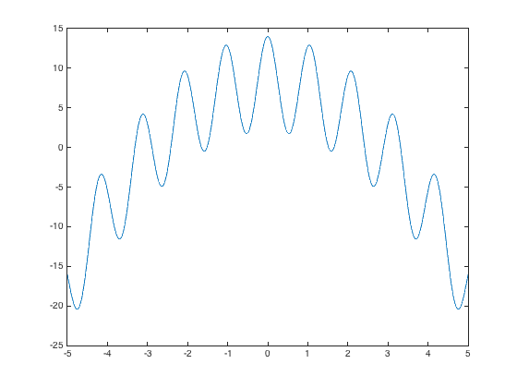
% The plot below shows the trajectory of x[k] values vs. k
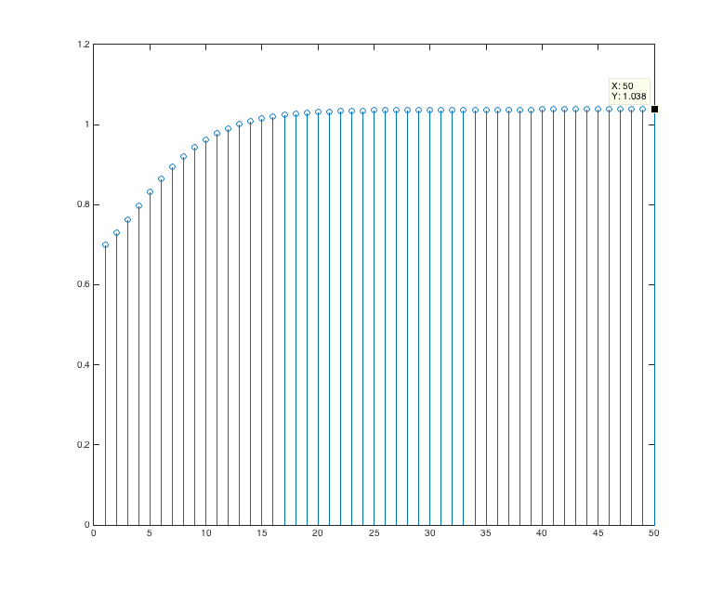
% Below, the objective function J(x) is highlighted with the global maximum at x = 0,
% the starting point of the steepest descent (ascent) algorithm at x = 0.7, and
% the point where the steepest descent (ascent) algorithm converges at x = 1.0376.
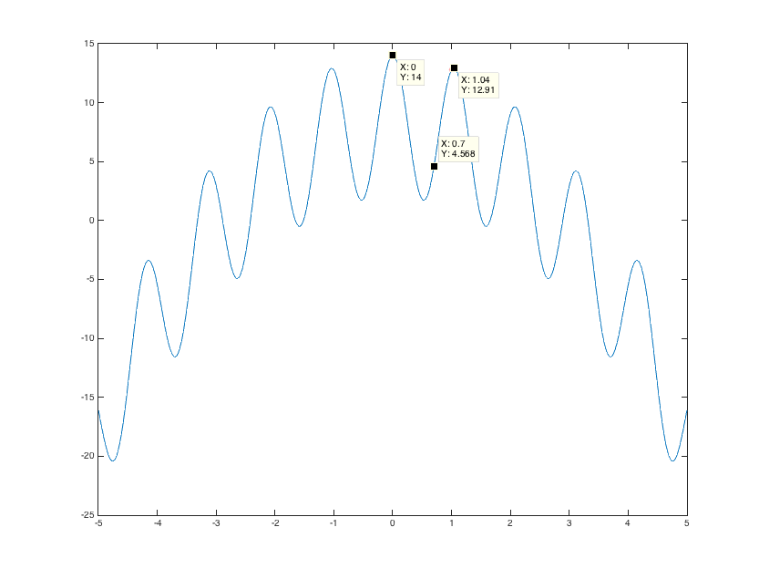
% Debugging hint: What happens if one makes a mistake computing
% the derivative? How I can tell that there’s a mistake? The steepest
% descent (ascent) will not correctly find the minimum (maximum).

