Spring 2014 EE 445S Real-Time Digital Signal Processing Laboratory Prof. Evans

Homework #0

Review of Linear Systems and Signals Material
Assigned on Friday, January 17, 2014
Due on Friday, January 24, 2014, by 11:00am sharp in class
Late homework is subject to a penalty of two points per minute late.
Reading: Johnson, Sethares and Klein, chapters 1-2 and Appendices A and F

This assignment is intended to review key concepts from Linear Systems and Signals. Moreover, all of the problems on homework #0 directly relate to lab #2. This homework will be graded and be counted towards the overall homework grade for the course.

Here are key sections from Lathi’s Linear Systems and Signals book (2nd ed) and Oppenheim & Willsky’s Signals and Systems book (2nd ed) with respect to material in EE 445S:
O&W | Lathi | Topic
1.6 | 1.7 | System properties
1.3 – 1.4 | 1.4 | Basic continuous-time signals
3.2 ## | 2.4-4 | Fundamental theorem for continuous-time linear systems **
1.3 – 1.4 | 3.3 | Basic discrete-time signals
3.2 ## | 3.8-3 | Fundamental theorem for discrete-time linear systems **
9.7.2 | 2.6 | Stability of continuous-time filters
10.7.2 | 3.10 | Stability of discrete-time filters
10.1 – 10.3 | 5.1 | Z transforms
10.5 | 5.2 | Properties of the z-transform
10.7.3 – 10.7.4 | 5.3 | Transfer functions
10.8 | 5.4 | Realizations of transfer functions
4.3 – 4.4 | 7.3 | Fourier transform properties
7.1 | 8.1 | Sampling theorem
** Please see Appendix F and slide 5-13 in the course reader for the fundamental theorem.
## O&W covers a slightly different version of the fundamental theorem in which a complex exponential is the input to a linear time-invariant system. Lathi also has that version as well.

Other signals and systems textbooks should contain equivalent material.

The MATLAB code in Johnson, Sethares & Klein also runs in LabVIEW Mathscript and GNU Octave (see footnote on JSK page viii about Octave). Feel free to use these environments. Please submit any MATLAB code that you have written with the homework solution. In the course reader, Appendix D gives a brief introduction to MATLAB. For quick review of commands in MATLAB for generating and plotting signals, please see
http://www.ece.utexas.edu/~bevans/courses/ee313/lectures/02_Signals/lecture2.ppt

As stated on the course descriptor, “Discussion of homework questions is encouraged. Please be sure to submit your own independent homework solution.”

Office hours for the teaching assistants and Prof. Evans; bold indicates a 30-minute timeslot.
Time Slot | Monday | Tuesday | Wednesday | Thursday | Friday
9:30 am |  |  |  |  | Jia  (ENS 137)
10:00 am |  |  |  |  | Jia  (ENS 137)
10:30 am

11:00 am | MLK  Holiday |  | Evans  (ETC 5.148) |  | Evans  (ETC 5.148)
12:00 pm | MLK Holiday |  | Evans  (ENS 433B) |  | Evans  (cafe)
12:30 pm |  |  |  | Evans  (ENS 433B) | Evans  (cafe)
1:00 pm |  |  |  | Evans  (ENS 433B) | Evans  (cafe)
2:00 pm |  |  |  | Evans  (ENS 433B)
2:30 pm
3:00 pm |  |  | Sinno  (ENS 137)
3:30 pm |  |  | Sinno  (ENS 137) | Jia  (ENS 137)
4:00 pm |  |  | Sinno  (ENS 137) | Jia  (ENS 137)
4:30 pm |  |  |  | Jia  (ENS 137)
5:00 pm |  |  |  | Jia  (ENS 137)
5:30 pm |  |  |  | Sinno  (ENS 137)
6:00 pm |  |  |  | Sinno  (ENS 137)

1. Continuous-Time Sinusoidal Generation. 27 points.

In practice, we cannot generate a two-sided sinusoid cos(2 π f_{c} t), nor can we wait until the end of time to observe a one-sided sinusoid cos(2 π f_{c} t) u(t).
In the lab, we can turn on a signal generator for a short time and observe the output in the time domain on an oscilloscope or in the frequency domain using a spectrum analyzer.
Consider a finite-duration cosine that is on from 0 sec to 1 sec given by the equation
c(t) = cos(2 π f_{c} t) rect(t – ½)
where f_{c} is the carrier frequency (in Hz).
- Using MATLAB, LabVIEW Mathscript or GNU Octave, plot c(t) for -0.5 < t < 1.5 for f_{c} = 10 Hz. Turn in your code and plot. You may find the rectpuls command useful. 6 points.
Give a formula for the Fourier transform of c(t) for a general value of f_{c}. 6 points.
- Sketch by hand the magnitude of the Fourier transform of c(t) for a general value of f_{c}. Using MATLAB, LabVIEW Mathscript or GNU Octave, plot the magnitude of the Fourier transform of c(t) for f_{c} = 8 Hz. Turn in your code and plot. 9 points.
- Describe the differences between the magnitude of the Fourier transforms of c(t) and a two-sided cosine of the same frequency. What is the bandwidth of each signal? 6 points.

2. Downconversion. 19 points.

A signal x(t) is input to a mixer to produce the output y(t) where
y(t) = x(t) cos(ω₀ t)
where ω₀ = 2 π f₀ and f₀ = 2 kHz. A block diagram of the mixer is shown below on the left. The Fourier transform of x(t) is shown below on the right.
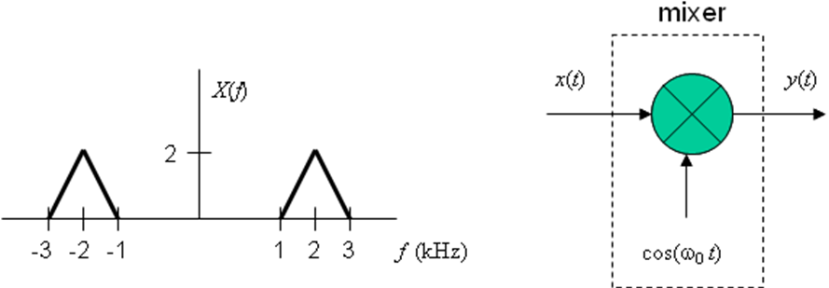

- Using Fourier transform properties, derive an expression for Y(f) in terms of X(f). 6 points.

- Sketch Y(f) vs. f. Label all important points on the horizontal and vertical axes. 6 points.

- What operation would you apply to the signal y(t) in part (b) to obtain a baseband signal? The process of extracting the baseband signal from a bandpass signal is known as downconversion. 7 points.

3. Sampling in Continuous Time. 24 points.

Sampling the amplitude of an analog, continuous-time signal f(t) every T_{s} seconds can be modeled in continuous time as
y(t) = f(t) p(t)
where p(t) is the impulse train defined by
$$p(t)=\sum_{n=−∞}^{∞}{δ\left(t−{\text{nT}}_{s}\right)}$$
$p(t)=\frac{1}{T_{s}}\left(1+2\text{cos}(ω_{s}t)+2\text{cos}(\text{2 }ω_{s}t)+\text{.}\text{.}\text{.}\right)$T_{s} is known as the sampling duration. The Fourier series expansion of the impulse train is
where ω_{s} = 2 π / T_{s} is the sampling rate in units of radians per second.
- Plot the impulse train$p(t)=\sum_{n=−∞}^{∞}{δ\left(t−{\text{nT}}_{s}\right)}$. 6 points.
- Note that in part (a), p(t) is periodic. What is the period? 6 points.
- Using the Fourier series representation of p(t) given above, please give a formula for P(ω), which is the Fourier transform of p(t). Express your answer for P(ω) as an impulse train in the Fourier domain. 6 points.
- What is the spacing of adjacent impulses in the impulse train in P(ω) with respect to frequency ω in rad/s? 6 points.

4. Discrete-Time Sinusoidal Generation. 30 points.
Consider a causal discrete-time linear time-invariant system with input x[n] and output y[n] being governed by the following difference equation:
y[n] = (2 cos ω₀) y[n-1] - y[n-2] + (sin ω₀) x[n-1]
The impulse response of the above system is a causal sinusoid with discrete-time frequency ω₀ in units of rad/sample. The value of ω₀ would normally be in the interval [-π, π). You will be implementing the above difference equation in C in lab #2 on a programmable digital signal processor for real-time sinusoidal generation.
- Draw the block diagram for this system using add (or summation), multiplication (or gain), and delay blocks. Please label delay blocks with the text z^{-M} to denote a delay of M samples. Use arrowheads to indicate direction of the flow of signals. 6 points.
(b) Please state all initial conditions. Please give values for the initial conditions to satisfy the stated system properties. 6 points.
(c) Find the equation for the transfer function in the z-domain, including the region of convergence. 6 points.
(d) Compute the inverse z-transform of the transfer function in part (c) to find the impulse response of the system. 6 points.
(e) Using MATLAB, LabVIEW Mathscript or GNU Octave, plot the impulse response obtained in part (d) for ω₀ equal to 0, π, and a value in the interval (0, π) of your choosing. Turn in your code and plots. 6 points.

