Tune-Up Tuesday for October 5, 2021
% Create a MATLAB simulation for fall 2021 midterm problem 1.2
% The problem involves analysis of the output of a squaring system y(t) = x²(t).
% Let input x(t) = cos(2 π f₁ t) + cos(2 π f₂ t) where f₁ = 110 Hz and f₂ = 220 Hz.

% (a) Using a sampling rate of 8000 Hz and time from 0 to 3 seconds, write
% the code to generate a sampled version of the signal x(t).
fs = 8000;
Ts = 1/ fs;
tmax = 3;
t = 0 : Ts : tmax;
f1 = 110;
f2 = 220;
x = cos(2*pi*f1*t) + cos(2*pi*f2*t);

% (b) Play sampled version of x(t). Describe what you hear.
% Answer: The signal x(t) is composed of A note in the second octave (110 Hz)
% and A note in the third octave (220 Hz).
% On a laptop. On many laptop speakers, the 110 Hz tone may not be audible
% due to limitations in playing back low audible frequencies. On a laptop, the
% playback sounded like a single note with hum in the background.
% Audio system with a sub-woofer. A sub-woofer plays low audible frequencies
% down to 20 Hz. The sub-woofer is often a separate large speaker (due to the
% longer acoustic wavelengths λ for low frequencies, i.e. λ = c / f) in an audio
% system. On an audio system with a sub-woofer, the playback sounded like a
% beat frequency with hum in the background. Both notes were audible.
soundsc(x, fs);
pause(tmax+1);

% (c) Plot the spectrum of the sampled version of x(t). Principal frequencies
% are 110 Hz and 220 Hz.
% Using the spectrogram. See the second page for the plot.
figure;
spectrogram(x, 512, 256, 512, fs, 'yaxis');

% Using the fast Fourier transform approach from mini-project #1.
fourierSeriesCoeffs = fft(x);
N = length(x);
freqResolution = fs / N;
ff = (-fs/2) : freqResolution : (fs/2)-freqResolution;
figure;
plot(ff, abs(fftshift(fourierSeriesCoeffs)));
xlabel('f');
xlim( [-1000, 1000] );
ylim( [-10, 15000] );

% (d) Using a sampling rate of 8000 Hz and time from 0 to 3 seconds,
% write the code to generate the sampled version of the signal y(t).
y = x.^2;

% (e) Play sampled version of y(t). Describe what you hear.
% Answer: The signal y(t) is composed of ‘A’ note in the second octave (110 Hz)
% ‘A’ note in the third octave (220 Hz), ‘E’ note in the fourth octave (330 Hz),
% and ‘A’ note in the fourth octave (440 Hz). When played back, the signal
% y(t) has a higher pitch than x(t) but it was difficult to distinguish more than
% two notes. The 0 Hz term is not audible. Please see the answer in part (b).
soundsc(y, fs);
pause(tmax+1);

% (f) Plot the spectrum of the sampled version of x(t). Principal frequencies
% are 0, 110, 220, 330, and 440 Hz. Principal frequencies at 0, 330, 440 Hz aren’t
% in x(t) and are called intermodulation distortion caused by the squaring system.
% Using the spectrogram. See below for the plot.
figure;
spectrogram(y, 512, 256, 512, fs, 'yaxis');

% Using the fast Fourier transform approach from mini-project #1. See below.
fourierSeriesCoeffs = fft(y);
N = length(y);
freqResolution = fs / N;
ff = (-fs/2) : freqResolution : (fs/2)-freqResolution;
figure;
plot(ff, abs(fftshift(fourierSeriesCoeffs)));
xlabel('f');
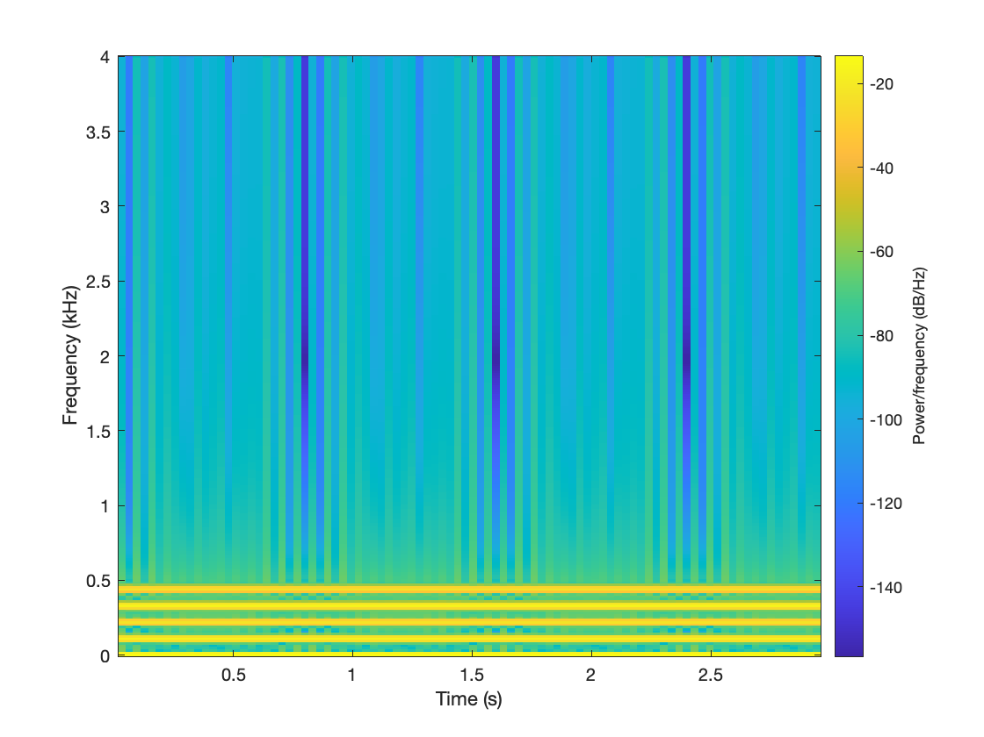
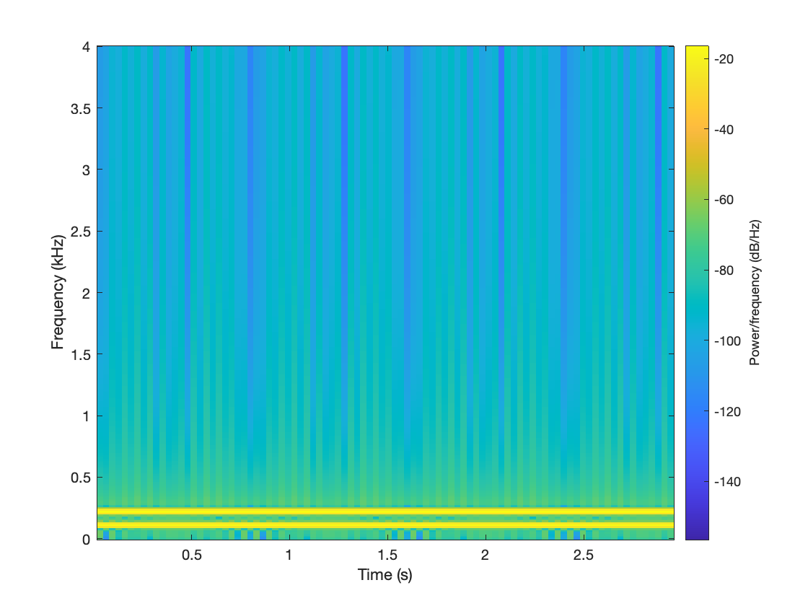
xlim( [-1000, 1000] );
Spectrogram for sampled x(t)
Spectrogram for sampled y(t)

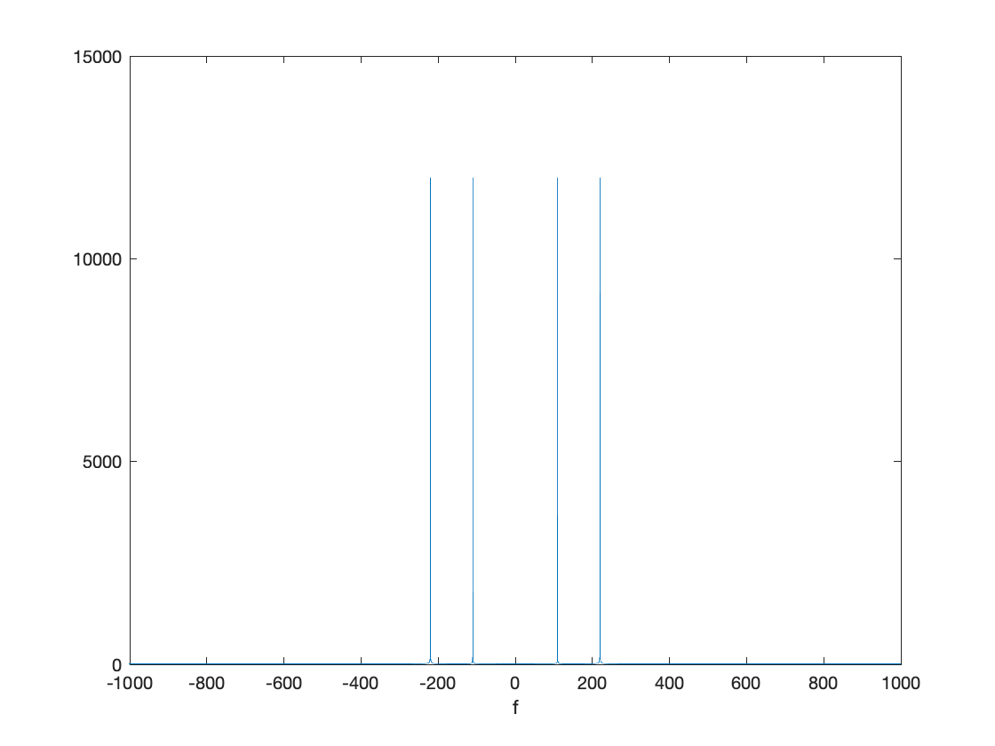
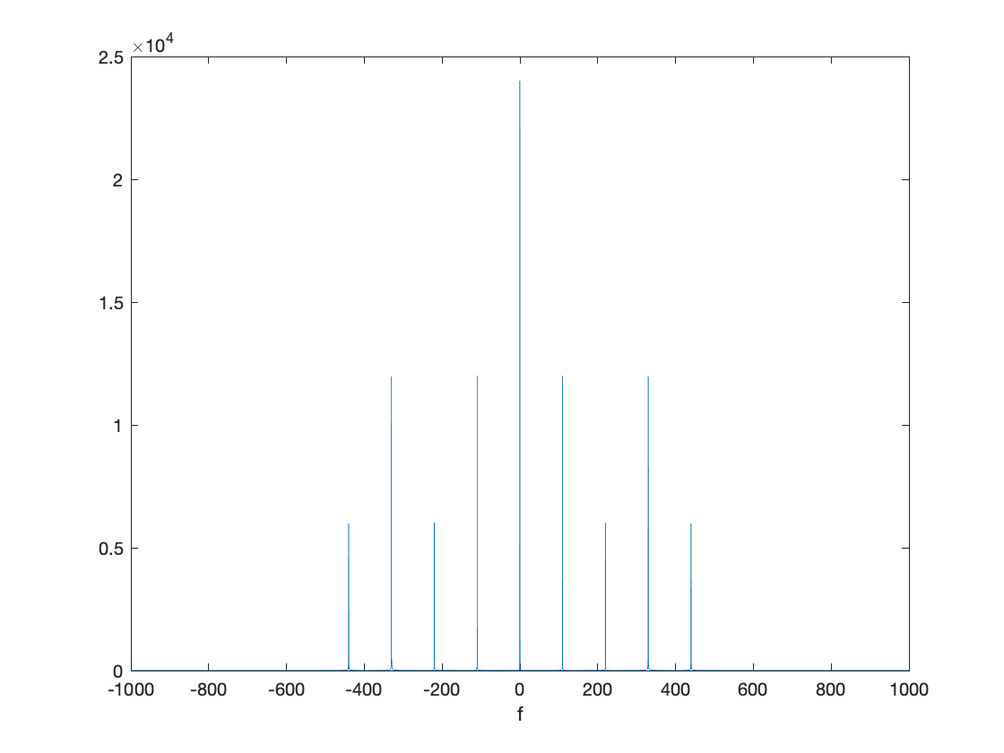
Spectrum for sampled y(t)
Spectrum for sampled x(t)

