**Tune-Up Tuesday #5 for October 14, 2021**

The tuneup is to solve homework problem 5.3(b) and verify the solution.

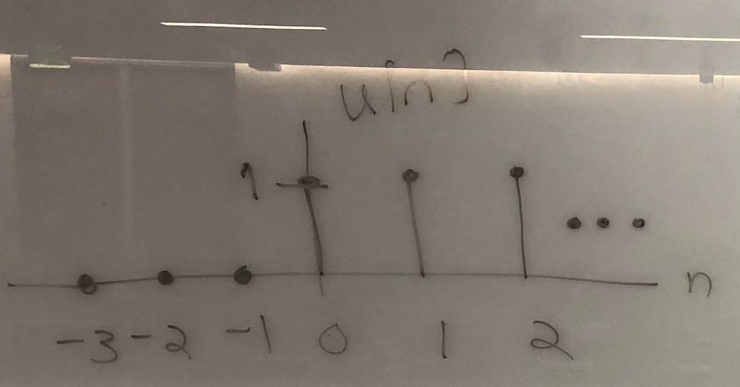**Intro.** A step function *u*[*n*] is a function that turns “on” at the origin and stays on, as plotted on the right. Mathematically,

$$u\left[n\right]=\left[\begin{matrix}1 & n≥0 \\ 0 & n<0\end{matrix}\right.$$

**Problem.** A linear time-invariant (LTI) system gives the output plotted on the right when the input is $x_{1}\left[n\right]=u[n]$. The output, also called the step response, is

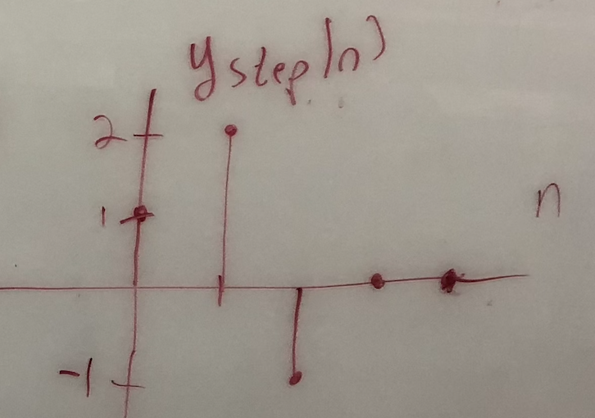

We’ll model the unknown LTI system as a finite impulse response (FIR) filter with input signal $x\left[n\right]$ and output signal

$$y\left[n\right]=h\left[0\right] x\left[n\right]+h\left[1\right] x\left[n-1\right]+h\left[2\right] x\left[n-2\right]+h\left[N-1\right] x[n-\left(N-1\right)]$$

From this information, compute the filter coefficients $h\left[n\right]$ for $n=0, 1, …, N-1$ and manually verify that the step response of the FIR filter is $y_{1}[n]$.

**Deconvolution.** We’ll use deconvolution to compute the filter coefficients. We derive the time-domain deconvolution algorithm by evaluating the output at $n=0$:

$$y\left[0\right]= b_{0} x\left[0\right]+b_{1} x\left[-1\right]+b_{2} x\left[-2\right]+⋯+b_{N-1} x\left[-(N-1)\right]$$

For LTI systems, it is a necessary (but not sufficient) condition for the system to be “at rest”, which means that all initial conditions $x\left[-1\right], x\left[-2\right], …, x\left[-\left(N-1\right)\right]$ must be zero. Since we know *x*[*n*] and *y*[*n*], we have one equation and one unknown at *n* = 0:

$$y\left[0\right]=b_{0} x\left[0\right]$$

and we can compute $$b_{0}=\frac{y[0]}{x[0]}$$

For this calculation to be valid, the first value of the test signal, *x*[0], cannot be zero.

The second output value is: $y\left[1\right]= b_{0} x\left[1\right]+b_{1} x\left[0\right]$, and therefore, $b_{1}=\frac{y\left[1\right]- b_{0}x[1]}{x[0]}$.

The third output value is: $y\left[2\right]= b_{0} x\left[2\right]+b_{1} x\left[1\right]+b_{2} x\left[0\right]$ and $b_{2}=\frac{y\left[2\right]- b_{0}x\left[2\right]- b_{1}x[1]}{x[0]}.$

In general, $b_{N}=\frac{y\left[N\right]-\sum_{i=0}^{N-1}{b_{i}x[N-i]}}{x[0]}$.

The MATLAB script [utdeconvolve.m](http://users.ece.utexas.edu/~bevans/courses/signals/tuneups/fall2021/utdeconvolve.m) implements this algorithm.

**Part (a).** Give the vectors for x and y that you used when running [utdeconvolve.m](http://users.ece.utexas.edu/~bevans/courses/signals/tuneups/fall2021/utdeconvolve.m) and the filter coefficients in vector b that the code computes.

|  |  |  |
| --- | --- | --- |
| **x** | **y** | **b** |
| [ 1 1 1 ] | [ 1 2 -1 ] | [ 1 1 -3 ] |
| [ 1 1 1 1 ] | [ 1 2 -1 0 ] | [ 1 1 -3 1] |
| [ 1 1 1 1 1 ] | [ 1 2 -1 0 0 ] | [ 1 1 -3 1 0 ] |
| [ 1 1 1 1 1 1 ] | [ 1 2 -1 0 0 0 ] | [ 1 1 -3 1 0 0 ] |

**Part (b).** Verify that the filter coefficients by using them in the difference equation for the LTI FIR filter

$$y\left[n\right]=h\left[0\right] x\left[n\right]+h\left[1\right] x\left[n-1\right]+h\left[2\right] x\left[n-2\right]+h\left[N-1\right] x[n-\left(N-1\right)]$$

given that the input signal is $u[n]$ and the output signal is $y_{1}[n]$

$$y_{1}\left[n\right]=u\left[n\right]+u\left[n-1\right]-3 u\left[n-2\right]+ u\left[n-3\right]$$

This is a closed-form solution for $y_{1}\left[n\right]$ which gives the correct output values for $y_{1}[n]$ for all *n*. For $n≥0$, the values are [ 1 2 -1 0 0 0 …. ].

**Alternate solution for part (b)**. One could simply compute several values of $y[n]$:

$$y\left[n\right]=x\left[n\right]+ x\left[n-1\right]-3 x\left[n-2\right]+x\left[n-3\right]$$

$$y\left[0\right]=x\left[0\right]+ x\left[-1\right]-3 x\left[-2\right]+x\left[-3\right]=1+0+3∙0+0=1$$

$$y\left[1\right]=x\left[1\right]+ x\left[0\right]-3 x\left[-1\right]+x\left[-2\right]=1+1-3∙0+0=2$$

$$y\left[2\right]=x\left[2\right]+ x\left[1\right]-3 x\left[0\right]+x\left[-1\right]=1+1-3∙1+0=-1$$

$$y\left[3\right]=x\left[3\right]+ x\left[2\right]-3 x\left[1\right]+x\left[0\right]=1+1-3∙1+1=0$$

$$y\left[4\right]=x\left[4\right]+ x\left[3\right]-3 x\left[2\right]+x\left[1\right]=1+1-3∙1+1=0$$

and so forth.