% Tune-Up #6 on October 19, 2021
% Homework problem 6.1(a) parts 1 and 2.
% For the first-order unnormalized averaging filter (lowpass filter)
% y[n] = x[n] + x[n-1] for n >= 0
% and the initial condition x[-1] = 0 to satisfy LTI properties,
% determine the formulas for, and plot in MATLAB, the
% (a) impulse response h[n]
% Input the discrete-time impulse d[n]
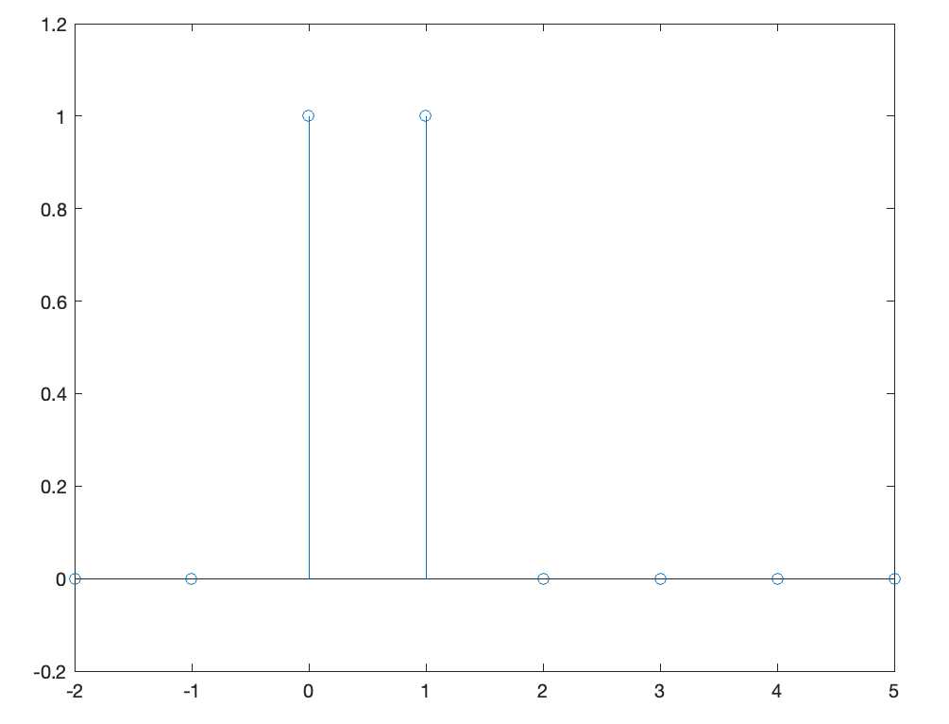
% Discrete-time impulse: d[n] = 1 when n = 0 and 0 otherwise.
% Let x[n] = d[n]. Output h[n] = d[n] + d[n-1].
% h[-2] = d[-2] + d[-3] = 0 + 0 = 0
% h[-1] = d[-1] + d[-2] = 0 + 0 = 0
% h[0] = d[0] + d[-1] = 1 + 0 = 1 etc.
n = -2 : 5;
h = [ 0 0 1 1 0 0 0 0 ];
stem(n, h)
ylim( [ -0.2 1.2] );
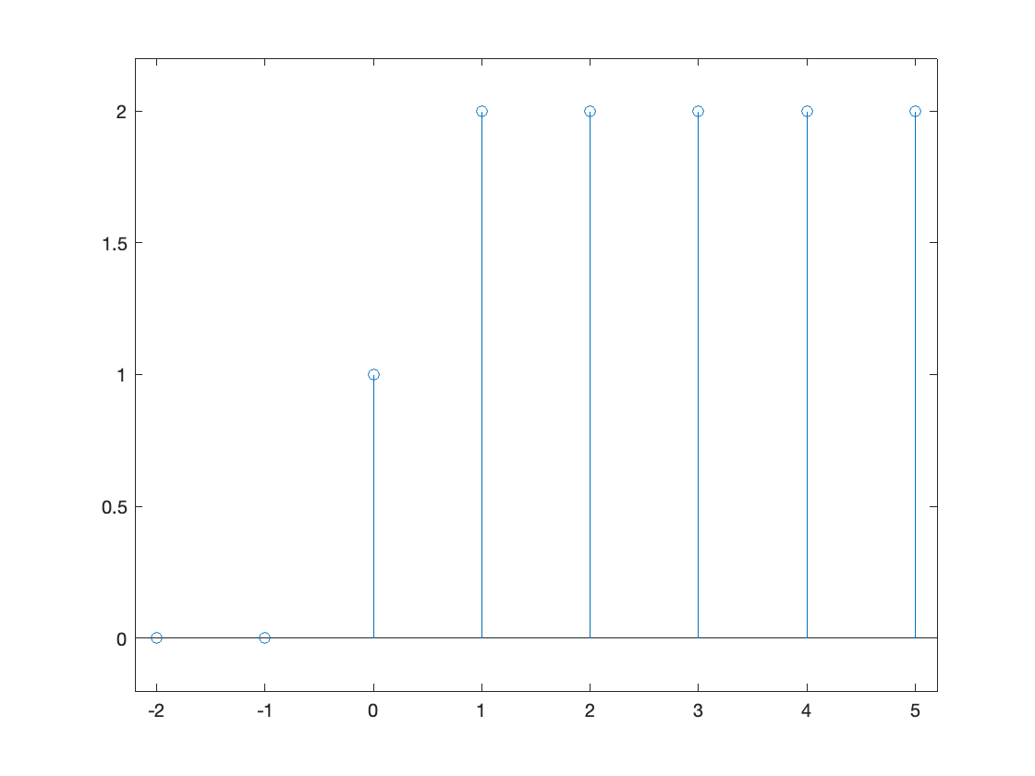
% (b) step response ystep[n]
% Input the unit step function u[n]:
% u[n] = 1 for n >= 0 and 0 otherwise
% Let x[n] = u[n]. Output h[n] = u[n] + u[n-1].
n = -2 : 5;
unitstep = ( n >= 0 );
% Output: 0 0 1 1 1 1 1 1
unitstepdelayed = ( (n-1) >= 0 );
ystep = unitstep + unitstepdelayed;
stem(n, ystep);
ylim( [ -0.2 2.2 ] );
xlim( [ -2.2 5.2 ] );

