% Tune-Up #7
% Working part of Exercise 1.1 of Mini-Project #2. Mini-Project #2 assignment,
% hints, and code are available on the homework page.
% The exercises for Mini-Project #2 are from Chapter 10 of the book
% Computer-Based Exercises for Signal Processing in Matlab, 1994.

% Wireless Localization
% The project involves estimating distance to an object in the environment.
% using wireless signals. This problem simulates a radar system that sends a
% signal and then listens for the return signal that bounced off the object.
% Using the round-trip time T_{d} and speed of propagation in the environment c,
% the distance can be determined as d = (1/2) T_{d} c.
% Methods for finding the direction (angle) to the object include
% (a) Directional beams
% (b) Triangulation
% For an overview of radar signals, please see
% https://en.wikipedia.org/wiki/Radar_signal_characteristics

% Complex-Valued Chirp Signals
% In a chirp signal, the principal frequency increases or decreases over time.
% When chirp signals propagate in an environment, they are resistant to
% frequency distortion and thermal noise. You'll evaluate this in Mini-Project #2.

% Part (a) Write Matlab code to generate and plot a complex-valued chirp
% pulse that sweeps frequencies from -W/2 to W/2:
% s(t) = exp(j pi (W t^2) / T) for -T/2 <= t <= T/2.
% Parameters from Table 10.1 in the excerpt of Chapter 10:
% T pulse length 25 us
% W swept bandwidth 2 MHz
% fs sampling frequency 20 MHz
% TW time-bandwidth product 50 [dimensionless]
% The oversampling factor is p where fs = p W.
T = 25E-6;
W = 2E6;
fs = 20E6;
Ts = 1/fs;
t = (-T/2) : Ts : (T/2);
s = exp(j*pi*W*(t.^2)/T);

% Time-domain plot. We have to be careful at plotting s(t)
% because it is complex-valued. We'll plot the real part.
figure;
plot(t, real(s));
xlabel( 't' );

% Question: Describe the chirp signal.
% Answer: The chirp signal is a finite-length signal that last from -T/2 to T/2 seconds.
% The principal frequency decreases from -T/2 to 0 seconds and increases
% from 0 to T/2 seconds.

% (b) Write a Matlab function to generate a discrete-time version of the
% complex-valued chirp following the Mini-Project #2 guidance:
% s[n] = exp(j 2 pi alpha (n - N/2)²) for for 0 ≤ n ≤ N-1
% We'll need to connect s(t) for -T/2 ≤ t ≤ T/2 via s[n] = s(n T_{s}) where
% T_{s} is the sampling time. N samples would correspond to T seconds of
% continuous time i.e. T = N T_{s}. The Matlab function will take two parameters
% TW time-bandwidth product
% p oversampling factor
% The sampling rate fs is p W. Using the hints for Mini-Project #2, we can
% express the parameters alpha and N in terms of p and TW:
% N = p TW
% alpha = TW / (2 N²)

% Question: Verify the formulas for N and alpha using the code from part (a).
% Answer: The formulas for N and alpha can be obtained by equating the first
% value of the complex-valued chirp s(-T/2) and the first sample of the
% discrete-time chirp s[0].
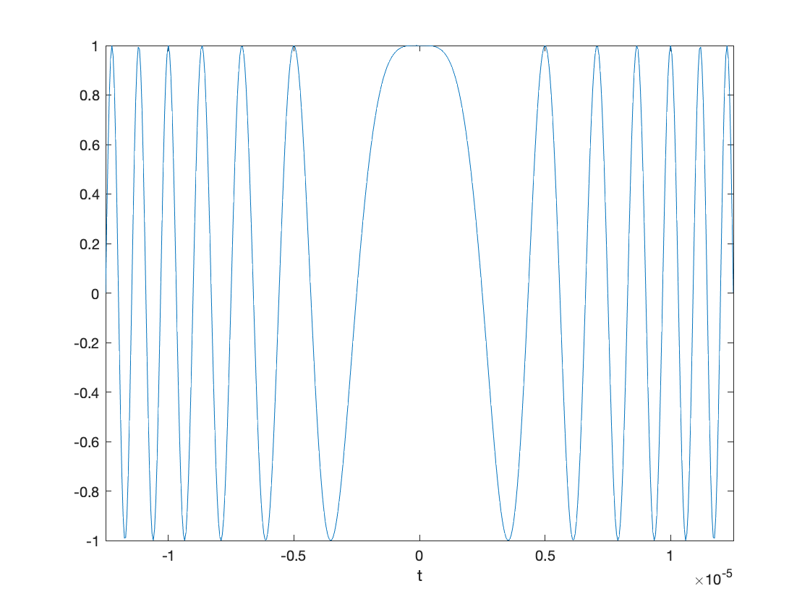
% For this Tune-Up, we’ll plot s(t) and
% s[n] to see if s[n] are samples of s(t).
%% Plot real part of s(t)
T = 25E-6;
W = 2E6;
fs = 20E6;
Ts = 1/fs;
t = (-T/2) : Ts : (T/2);
soft = exp(j*pi*W*(t.^2)/T);
figure;
plot(t, real(soft));
xlabel( 't' );
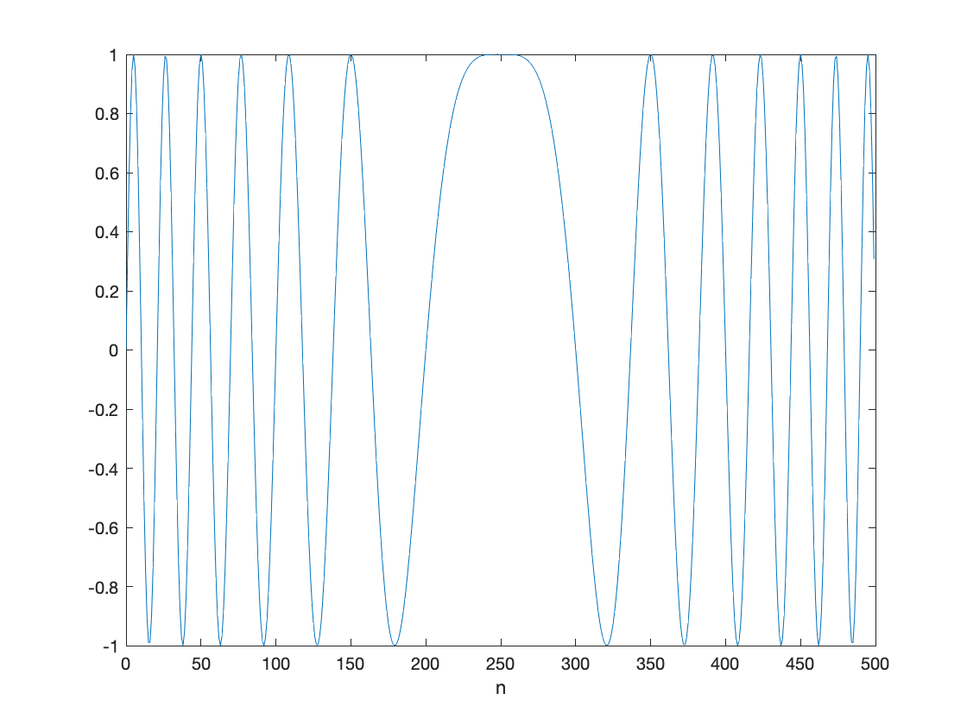
xlim( [-T/2 T/2] );

%% Plot real part of s[n]
TW = T*W;
p = fs / W;
N = p * TW;
alpha = TW / (2*N^2);
n = 0 : N-1;
sofn = exp(j*2*pi*alpha*(n - N/2).^2);
figure;
plot(n, real(sofn));
xlabel( 'n' );

% Yes, as seen on the right, s[n] are samples of s(t).

% Question: Write a MATLAB function to generate the discrete-time chirp
% called dchirp and place it in a file called dchirp.m.
% Answer: See the code below.

function s = dchirp( TW, p )
% DCHIRP generate a sampled chirp signal
% usage s = dchirp( TW, p )
% s : samples of a discrete-time "chirp" signal
% exp(j pi (W/T) t^2 ) for -T/2 <= t <= T/2
% TW : time-bandwidth product
% p : sample at p times the Nyquist rate (W)
N = p*TW;
alpha = TW / (2*N^2);
n = 0 : N-1;
s = exp(j*2*pi*alpha*(n - N/2).^2);

