% Tune-Up #6 - Fall 2023 - ECE 313 Linear Systems & Signals - Evans

% Copy this file into a Matlab script window, add your code and
% answers to the questions as Matlab comments, hit "Publish", and
% upload the resulting PDF file to this page for the tune-up
% assignment. Please do not submit a link to a file but instead
% upload the file itself. Late penalty: 2 points per minute late.

% Homework problem 6.1(a).

% For the first-order unnormalized averaging filter (lowpass filter)
% y[n] = x[n] + x[n-1]
% and the initial condition x[-1] = 0
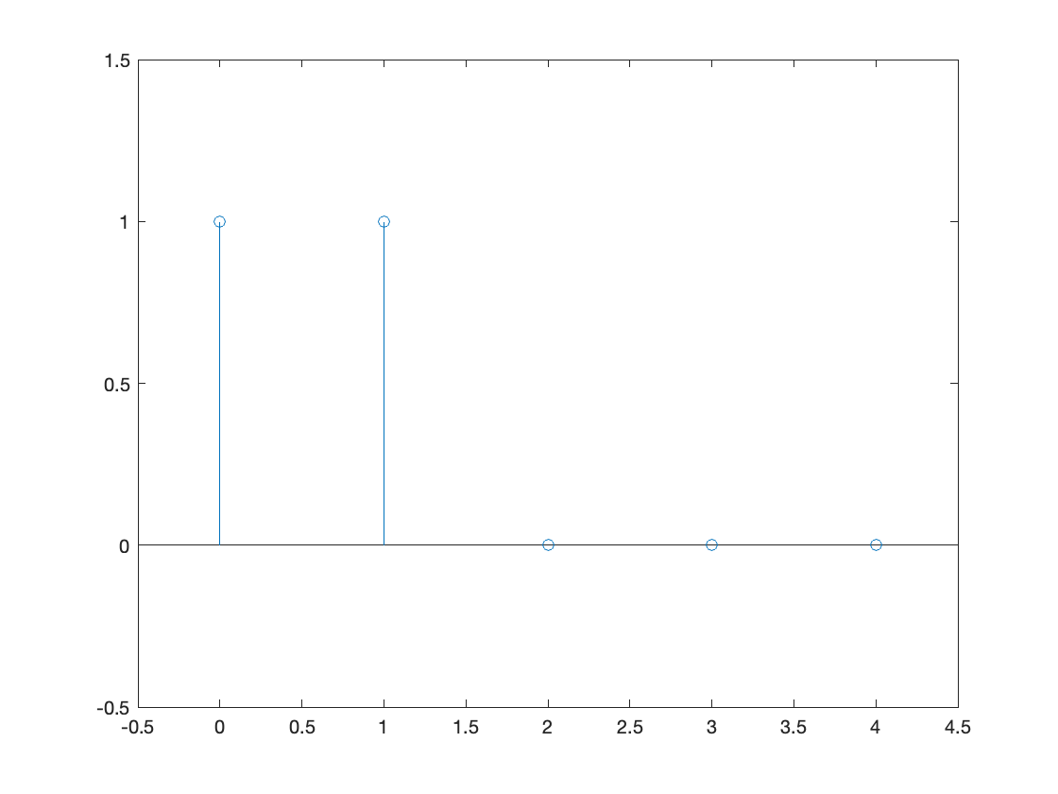
% as a necessary condition for LTI
% system properties to hold.
% Determine the formulas for, and
% plot in MATLAB, the following:

% i. impulse response
% h[n] = d[n] + d[n-1] where d[n]
% is the discrete-time delta signal
h = [ 1 1 0 0 0 ];
n = [ 0 1 2 3 4 ];
stem(n, h);
ylim( [-0.5 1.5] );
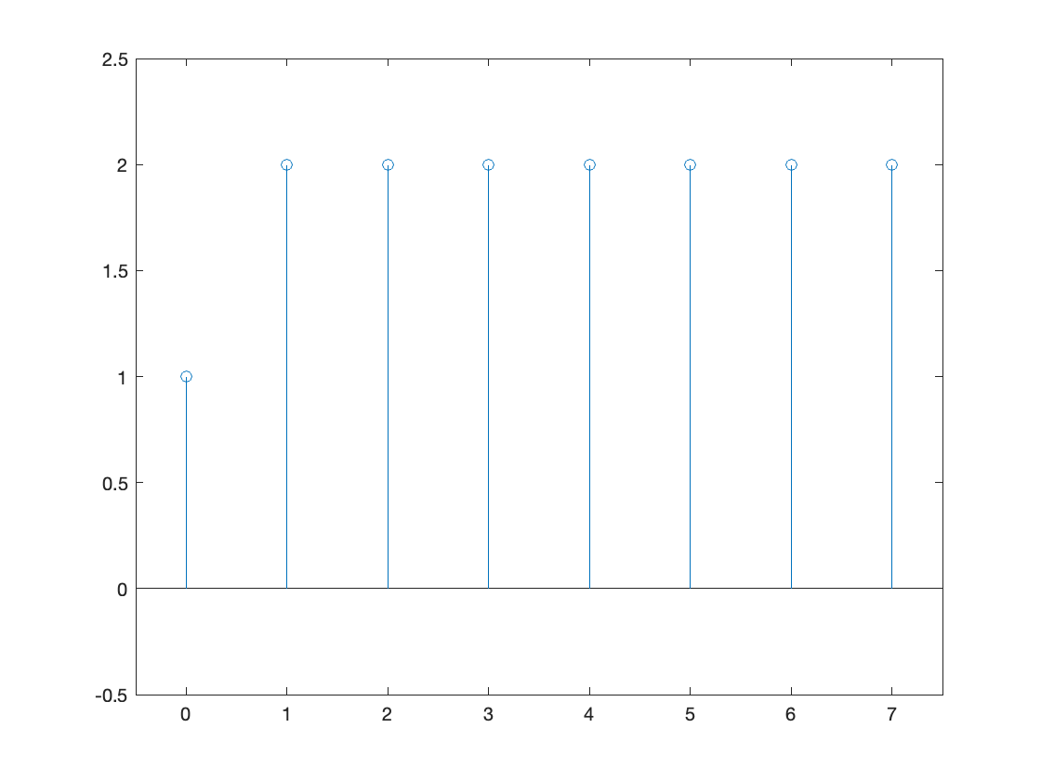
xlim( [-0.5 4.5 ] );

% ii. step response
% ystep[n] = u[n] + u[n-1]
stepsignal = [ 1 1 1 1 1 1 1 1 ];
ystep = filter( [1 1], 1, stepsignal );
n = [ 0 1 2 3 4 5 6 7 ];
figure;
stem(n, ystep);
ylim( [-0.5 2.5] );
xlim( [-0.5 7.5 ] );
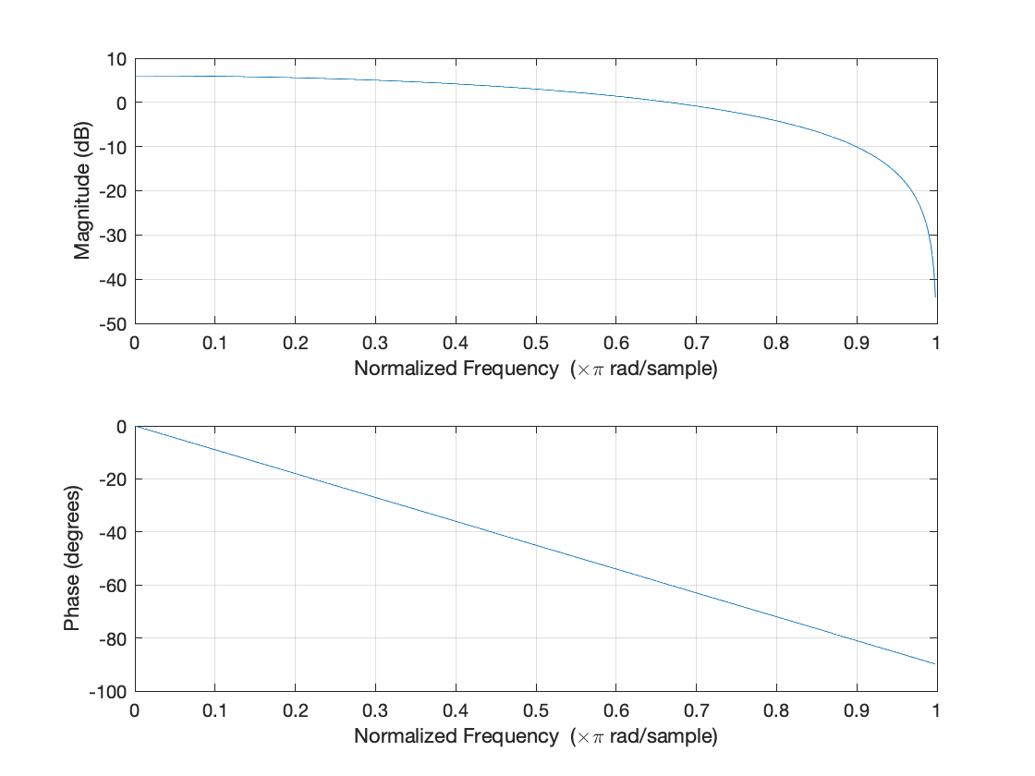
% iii. Plot the magnitude and phase of
% the frequency response using freqz.
% H( exp(j w) ) = 1 + exp(-j w)
figure;
freqz( [ 1 1 ] );
% Magnitude response: Low frequencies pass
% through with gain (at or above 0 dB)
% and very high frequencies (close to pi)
% are attenuated. Lowpass filter.
% Phase response: A line with a slope of
% -1/2 if the phase were plotted in rad.

