Tune-Up Tuesday for September 10, 2024
% Copy this file into a Matlab script window, add your code and answers to the
% questions as Matlab comments, hit "Publish", and upload the resulting PDF file
% to this page for the tune-up assignment. Please do not submit a link to a file
% but instead upload the file itself. Late penalty: 2 points per minute late.
% (a) Copy, paste and run the Matlab code from lecture slide 1-18 to generate
% the cosine signal x(t) = cos(2 π f₀ t) with f₀ = 440 Hz and play it as an audio
% signal for 3s at a sampling rate of f_{s} = 8000 Hz. (Using a higher standard
% audio sampling rate such as 96000 Hz would give a smoother plot in part (d)).
% (a) ‘A’ note on Western scale in 4th octave (A4) at 440 Hz
f0 = 440; % note ‘A4’
fs = 8000; % sampling rate
Ts = 1/fs; % sampling time
t = 0 : Ts : 3; % 3 seconds
x = cos(2*pi*f0*t);
sound(x, fs);
pause(3);
% (b) Add to the code in (a) to generate a new signal y(t) = cos(2 π f₀ t) cos(2 π f₁ t)
% with f₁ = 110 Hz by using the same sampling rate of f_{s} = 8000 Hz.
% (b) Multiply cosine at 440 Hz and cosine at 110 Hz
% Modified code from left side of lecture slide 3-3.
f1 = 110; % ‘A’ in the second octave
x1 = cos(2*pi*f1*t);
y = x .* x1;
% (c) Add to the code in (b) to playing y(t) as an audio signal.
% Describe what you hear.
% Express y(t) as a sum of two sinusoids.
% (c) Play y(t) at a sampling (playback) rate of 8000 Hz.
% I hear two notes/tones at a lower pitch than 440 Hz.
% The product can be written as a sum of two cosines.
% Using lecture slide 3-2,
% y(t) = 0.5 cos(2 pi 330 t) + 0.5 cos(2 pi 550 t)
% Tones at 330 Hz (E 4th octave) and 550 Hz (C# 5th octave)
% are harmonics of 110 Hz. See Piano frequencies.
sound(y, fs);

% Note: The product cos(2*pi*f0*t) cos(2*pi*f1*t) will have
% amplitudes on [-1, 1] because each cosine has amplitudes
% on [-1, 1]. Hence, the sound command can be used without
% clipping amplitude values.

% Note: Playing a tone at 110 Hz may not be audible when
% played back on a laptop. Many laptop playback systems
% have very low volume outputs for frequencies below 200 Hz.

% (d) Plot one period of y(t). We'll need to find the periodicity of y(t).
% The product of two sinusoids at frequencies f0 and f1 produces
% frequencies at f0+f1 and f0-f1. You could modify the code from the
% bottom right side of lecture slide 3-3.
ffund = gcd(f0+f1, f0-f1); % 440 Hz +/- 110 Hz
Tfund = 1/ffund;
n = round(Tfund / Ts); % Tfund / Ts isn’t an integer.
plot( t(1:n), y(1:n) );
% See below for the plot. The plot has several artifacts as noted below.
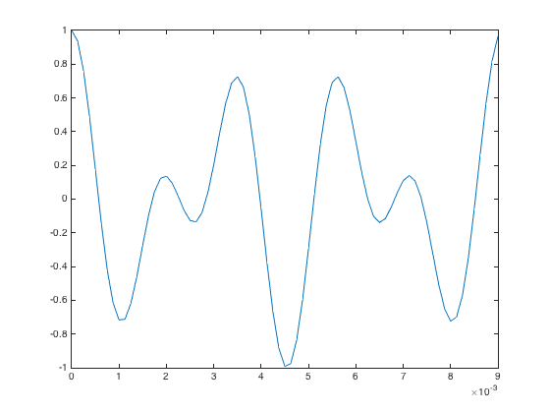
Non-smooth troughs

