% In-Lecture Assignment #1 on Sep. 18, 2024. Based on homework problem 1.2.
% Key takeaways: (1) Chirp signals are useful in localization, testing and training
% because they linearly sweep a range of frequencies, and (2) Spectrograms analyze
% a signal in the time and frequency domains simultaneously so that frequencies can
% be localized in time. Spectrogram trades off frequency resolution for time resolution.
% Chirp Signals: Please see slides 1-14 to 1-16 of CommonSignalsInMatlab.pptx.
% Spectrograms: Please see slides 1-17 to 1-20 of CommonSignalsInMatlab.pptx.
% Introduction: A chirp signal is a sinusoid whose principal frequency
% increases (or decreases) over time. A chirp signal has the form
% c(t) = cos( θ(t) ) where θ(t) = 2 π ( f₀ + 0.5 f_{step} t ) t = 2 π f₀ t + π f_{step} t²
% The principal frequency in Hz is f₀ when t = 0 and then changes over time at a
% rate of f_{step} in units of Hz/s. The principal frequency of a sinusoid at a given
% point in time is called the instantaneous frequency, and it is defined as
% dθ (t) / dt in units of rad/s. dθ (t) / dt = 2 π f₀ + 2 π f_{step} t = 2 π (f₀ + f_{step} t).
% We divide dθ (t) / dt by 2π to obtain instantaneous frequency in Hz of f₀ + f_{step} t.
% (a) Generate a chirp signal that lasts 10s with f₀ = 20 Hz and f_{step} = 420 Hz/s.
% Use sampling rate f_{s} of 44100 Hz. The chirp will sweep through the principal
% frequencies of the keys on an 88-key piano. Here’s Matlab code to get started.
%%% Generate a chirp signal with frequency increasing
%%% from f0 to (f0 + fstep time) over time seconds
time = 10;
f0 = 20;
fstep = 420;
fs = 44100;
Ts = 1 / fs;
t = 0 : Ts : time;
%%% Add code here to define the chirp signal y = cos( angle(t) )
angle = 2*pi*f0*t + pi*fstep*t.^2;
y = cos(angle);
% (b) Play the chirp signal as an audio signal. Describe what you hear.
% I hear a rising pitch over time. Sounds like a slide whistle or a tsunami warning siren
% (rb.gy/18exl). Note: Some laptop playback systems cannot play frequencies below 200 Hz.
sound(y, fs);
pause(time+1);
% (c) Plot the spectrogram of the chirp signal and describe the visual representation.
% Spectrogram shows a yellow line that represents the principal frequency in the chirp
% signal. The line goes from 20 Hz at time 0s to 4220 Hz at time 10s. The spectrogram
% plot is on the next page. See Appendix A for explanation of spectrogram arguments.
figure;
blockSize = 256; overlap = 128;
spectrogram(y, hamming(blockSize), overlap, blockSize, fs, 'yaxis');
title('(c) Spectrogram with block size 256 and overlap 128');
% (d) Give the code for the spectrogram that would improve the
% frequency resolution by a factor of two vs. part (c).
% The frequency resolution is what is possible from observing a signal for a block of
% N samples which lasts for N Ts seconds. From homework problem 0.1, the frequency
% frequency resolution in Hz is the inverse of the observation time or 1 / (N Ts) = fs / N.
% Increase N to decrease (improve) frequency resolution.
% The yellow line in the spectrogram with N doubled is half the width vs. part (c).
% Please see the derivation of frequency resolution in Appendix B.
figure;
blockSize = 2*256; overlap = 128;
spectrogram(y, hamming(blockSize), overlap, blockSize, fs, 'yaxis');
title('(d) Spectrogram with block size 512 and overlap 256');
% (e) Give the code for the spectrogram that would improve the time resolution,
% i.e. localizing frequency components in time, by a factor of two vs. part (c).
% The time resolution means the ability to identify when a frequency component occurs
% in time. In a block of N samples, we do not know when frequency components occur, and
% hence, our time resolution in seconds is N Ts. We improve time resolution by reducing N.
figure;
blockSize = 256/2; overlap = blockSize/2;
spectrogram(y, hamming(blockSize), overlap, blockSize, fs, 'yaxis');
title('(e) Spectrogram with block size 128 and overlap 64');
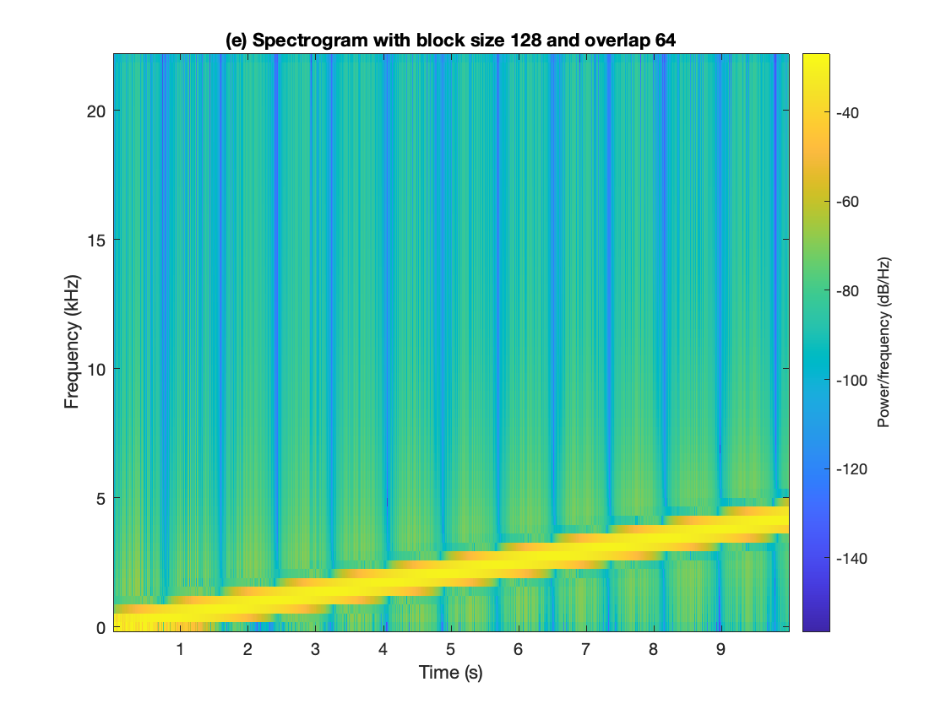
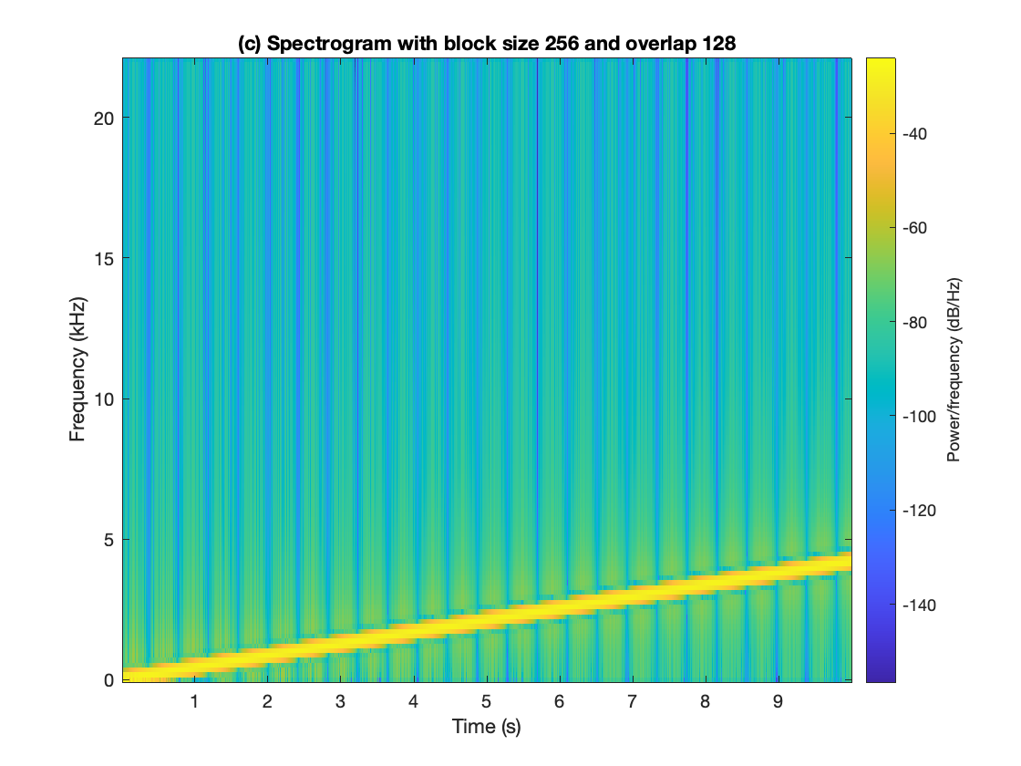
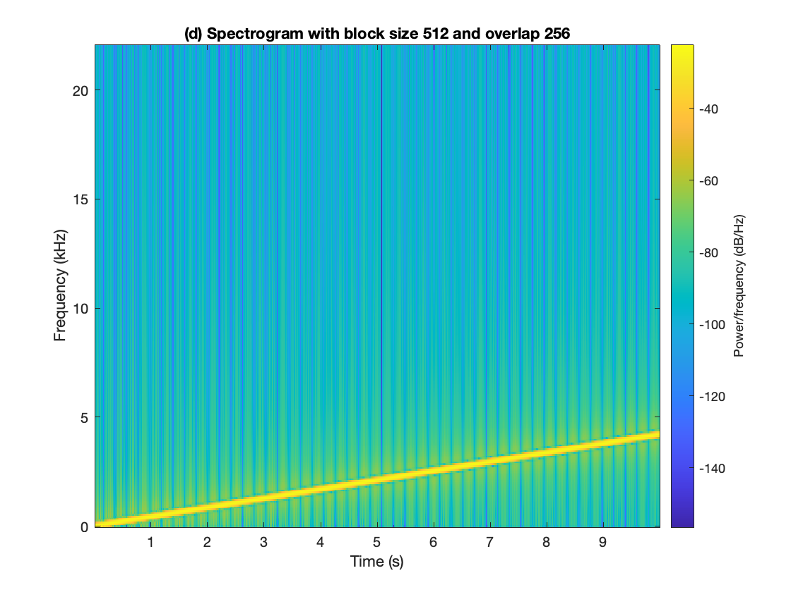
(e)
(d)
In all three spectrogram plots, the extent of the horizontal time axis is the same (from 0 to 10s) and the extent of the vertical frequency axis is the same (from 0 to ½ f_{s} where f_{s} = 44100 Hz). We have chosen f_{s} to satisfy the sampling theorem f_{s} > 2 f_{max} where f_{max} is the maximum frequency of interest (4220 Hz) and to be a standard audio sampling rate.
(c)

Appendix A: Arguments to the MATLAB spectrogram function by Dan Jacobellis
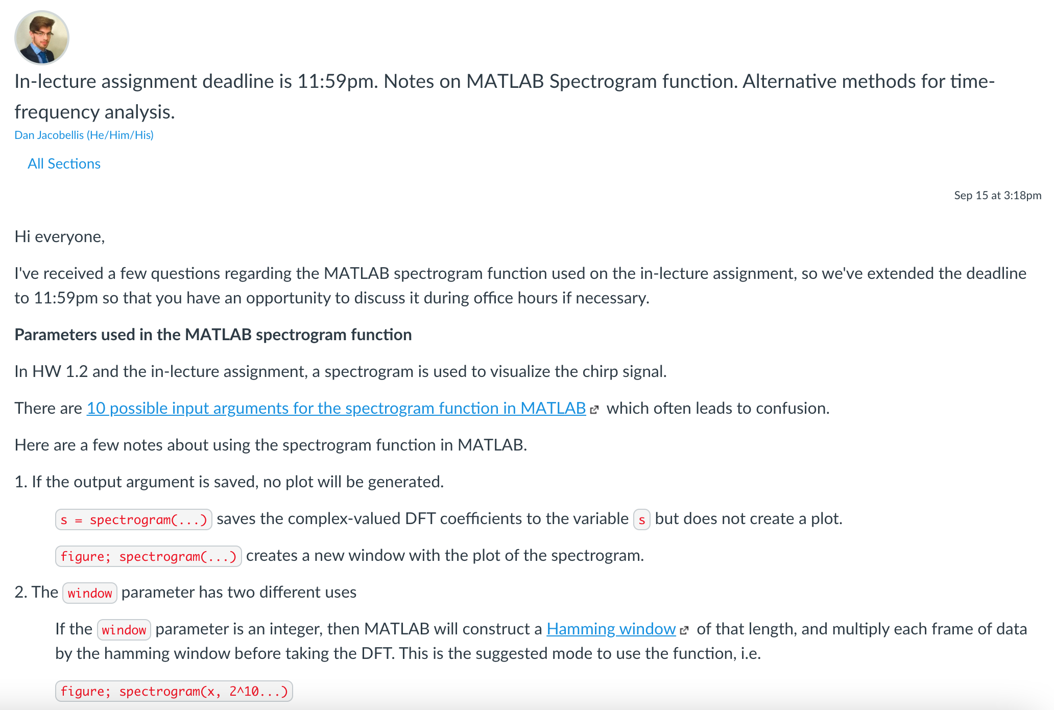
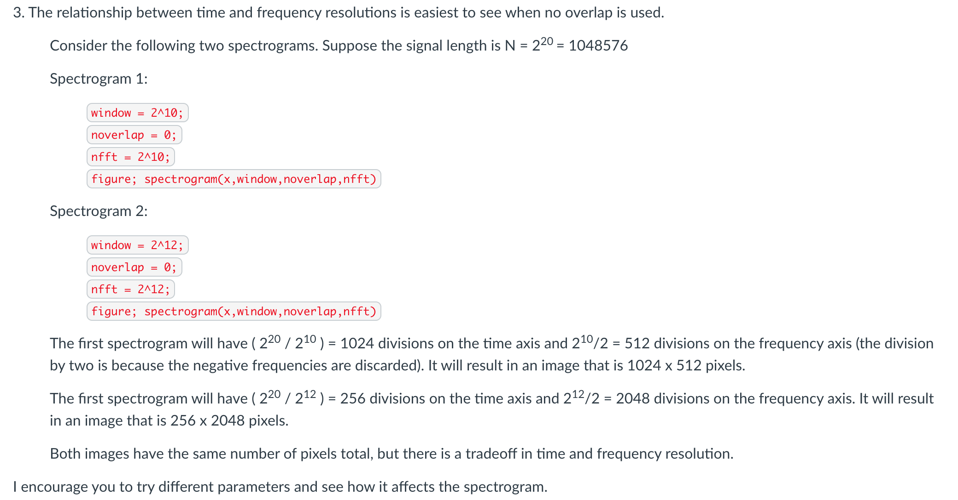

Appendix B: Derivation of Frequency Resolution
Frequency resolution of $Δf$ Hz means two frequency components spaced $Δf$ Hz apart can each be clearly identified by an algorithm, e.g. well separated in a plot of the frequency domain.
We’ll illustrate the concept of frequency resolution by revisiting homework problem 0.1.
Homework 0.1 concerned a sine signal c(t) lasting from 0s to 1s. The mathematical expression is a two-sided sine signal multiplied by a rectangular pulse that lasts from 0s to 1s:
c(t) = sin(2 π f_{c} t) rect(t – ½)
The continuous-time Fourier transform of r(t) = rect(t – ½) is a sinc function times a phase shift
$R\left(f\right)=F\left\{ rect\left(t-\frac{1}{2}\right) \right\}=sinc\left(f\right) e^{-jπf}$ where $sinc\left(x\right)=\frac{sin⁡(πx)}{πx}$ and
$C\left(f\right)=\frac{j}{2}e^{-jπ(f+f_{c})}sinc\left(f+f_{c}\right)-\frac{j}{2}e^{-jπ(f-f_{c})}sinc\left(f-f_{c}\right)$ due to the modulation property.
Below are the plots of $|R\left(f\right)|$ on the left and $|C\left(f\right)|$ for $f_{c}=4$ Hz on the right:
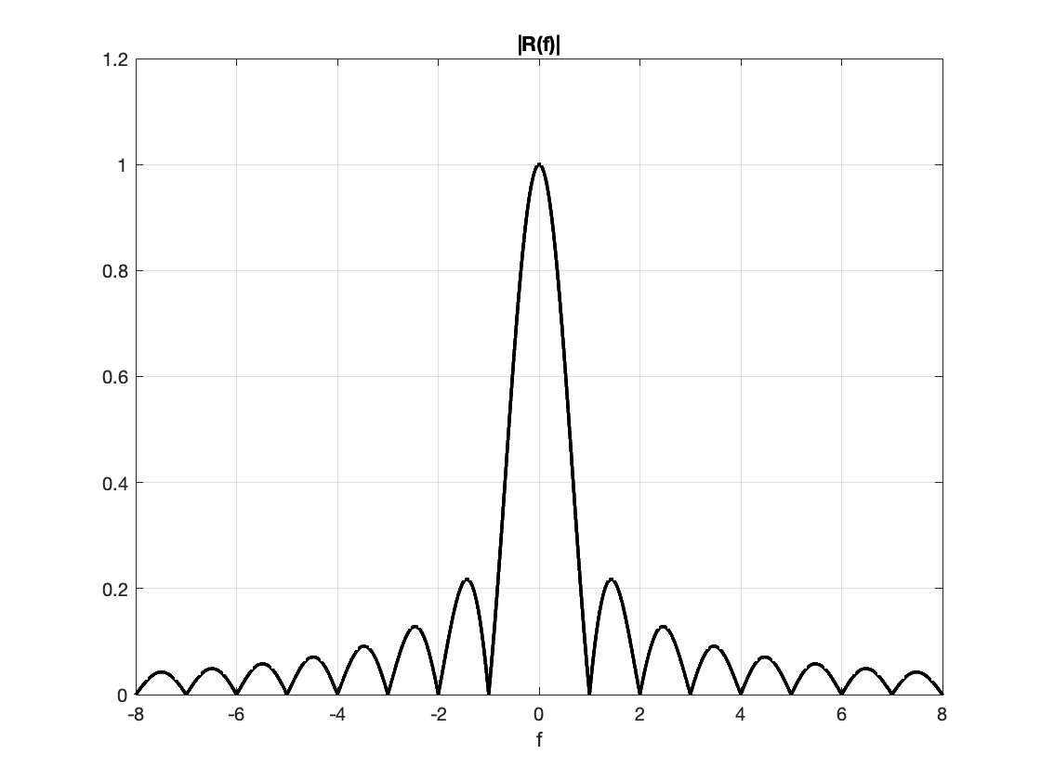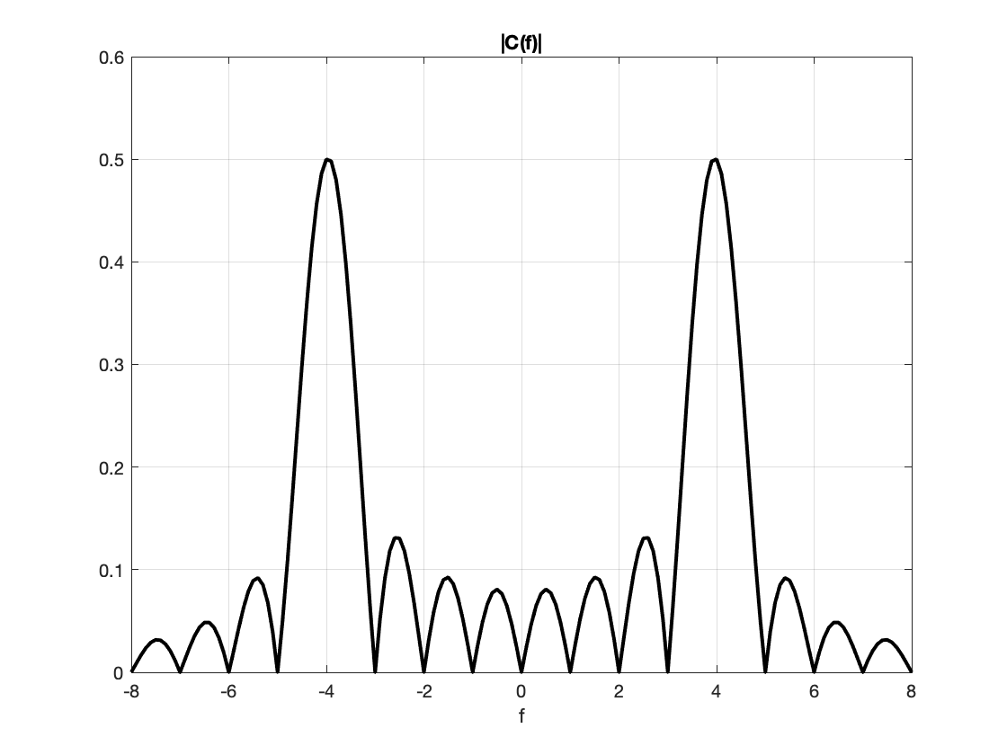
$$Δf$$
For a signal lasting 0s to 1s and containing sinusoids at frequencies 3 Hz and 4 Hz,
c₂(t) = sin(2 π f₀ t) rect(t – ½) + sin(2 π f₁ t) rect(t – ½)
let’s see if we can resolve the two frequencies. We’re looking for two peaks in the frequency domain plot that are well separated at 3 Hz and 4 Hz. Between the peaks, the magnitude response should not be higher than the “sidelobes” at frequencies higher than 1 Hz in $\left|R\left(f\right)\right|$.
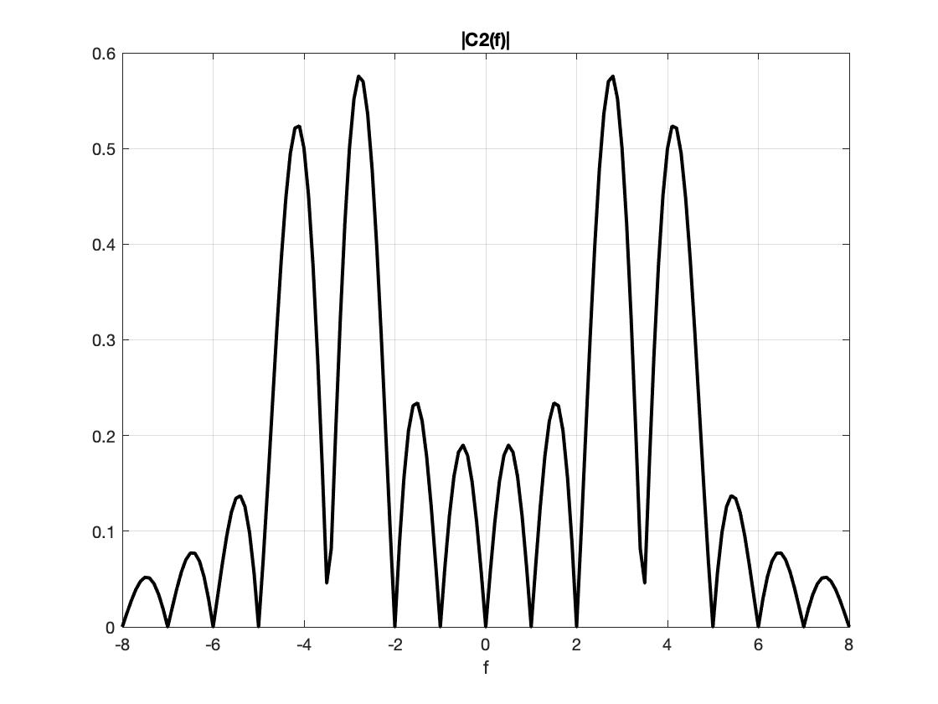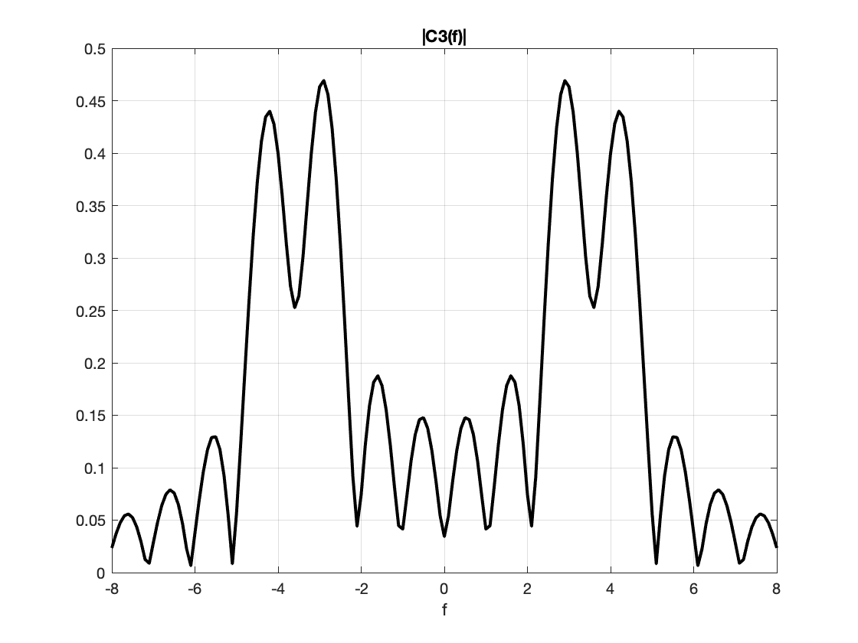
Clean separation of 3 Hz and
4 Hz frequency components
Difficulty separating 3.2 Hz and 4 Hz frequency components

More generally, for a rectangular pulse of duration T seconds, the frequency resolution is 1/T. The value of 1/T is also the null bandwidth.

In the course of computing the spectrogram, we apply a rectangular pulse to the discrete-time signal to extract a block of samples to compute their Fourier series coefficients using the fast Fourier transform. Consider a discrete-time signal that is a two-sided sine signal and the first N samples are kept:
c[n] = sin(ω_{c} n) rect((n – N/2)/N)
Here, r[n] = rect((n – N/2)/N) which has amplitude 1 for $n ϵ \{0, 1, …., N-1\}$ and 0 elsewhere. We can also write r[n] = u[n] – u[n-N] where u[n] is the unit step function. The discrete-time Fourier transform of r[n] is a periodic sinc function times a phase shift :
$$R\left(ω\right)=\underset{\begin{aligned}periodic sinc \\ function\end{aligned}}{\underbrace{\frac{sin⁡\left(\frac{Nω}{2}\right)}{sin\left(\frac{ω}{2}\right)}}}e^{-jω\left(N-1\right)/2}$$
where ω is in units of rad/sample. The periodic sinc function is periodic in ω with period 2π. Here’s one period of $|R(ω)|$ for N = 8 :
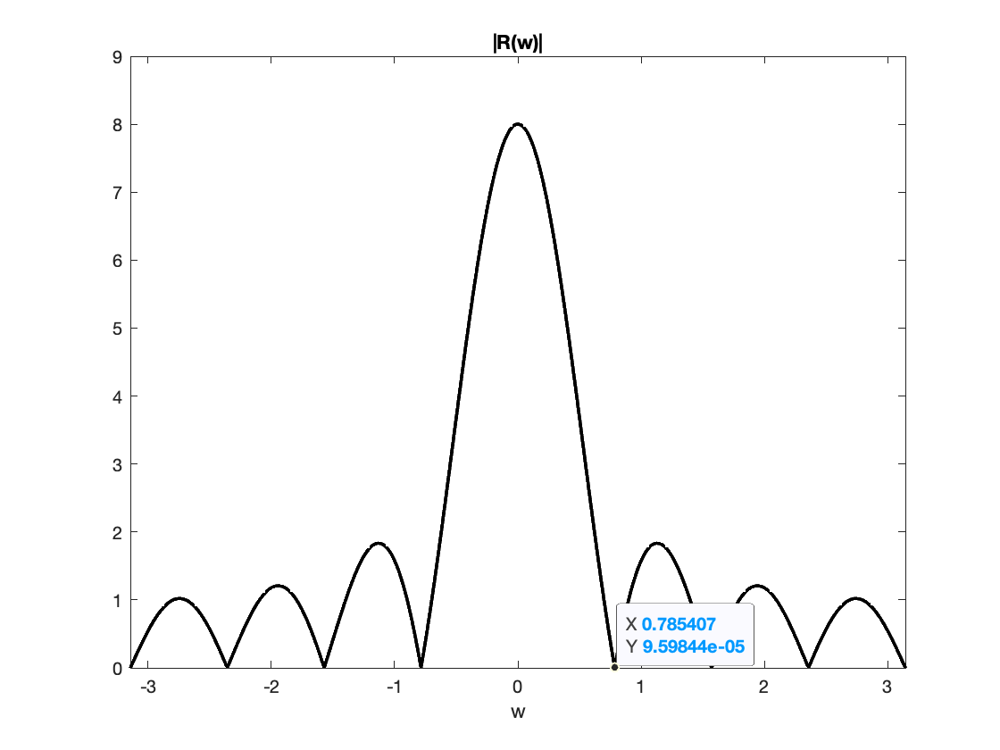
$$Δω$$
w = -pi : 0.001 : pi;
N = 8;
Rw = sin(N*w/2) ./ sin(w/2);
figure;
plot(w, abs(Rw), 'k','LineWidth',2 );
title( '|R(w)|' );
xlabel( 'w' );
ylim( [0, 9] );

This is the magnitude response of an averaging filter with 8 coefficients. Please see the Designing Averaging Filters handout.

The first zero for the magnitude response in positive frequencies occurs at 2π / N. This is the null bandwidth and also the frequency resolution $Δω$.

Let’s connect the frequency resolution in the discrete-time frequency domain to the continuous-time frequency domain:

$Δω=\frac{2π}{N}=2π\frac{Δf}{f_{s}}$ means that $Δf=\frac{f_{s}}{N}$

