In-Class Matlab Assignment #2
Bandstop selectivity
IIR filter
Elliptic design of pole and zero locations
Minimum order design
Sampling rate 44100 Hz
fpass1 = 1800 Hz
fstop1 = 2000 Hz
fstop2 = 4000 Hz
fpass2 = 4200 Hz
Apass1 = 1 dB
Astop = 80 dB
Apass2 = 1 dB
Design a bandstop IIR filter to apply to audio signals before they are
played to relieve symptoms of tinnitus (“ringing of the ears”).
Assignment relates to parts (a) and (b) of homework problem 3.3.
Here are the bandstop filter specifications for your design:
- From 0 Hz to 0.6 f_{c}, passband ripple is not greater than 1 dB.
- From (2/3) f_{c} to (4/3) f_{c}, stopband attenuation is at least 80 dB.
- Above 1.4 f_{c}, passband ripple is not greater than 1 dB
Use tinnitus frequency f_{c} of 3000 Hz & sampling rate f_{s} of 44100 Hz.
Use filterDesigner in Matlab. This tool was formerly called fdatool.
- Use elliptic method to design an IIR filter to meet specification.
- Give the filter order. 20 How many biquads? 10 in cascade.
- Are all of the poles inside the unit circle for bound-input bounded-output (BIBO) stability? Yes. Filter designer indicates that the design is BIBO stable. Also, one can plot the poles and zeros to show that the poles are inside the unit circle. (see next page)
- Describe the pole-zero plot and connect poles/zeros to filter passbands/stopbands. Angles of poles near but inside unit circle indicate passband frequencies and angles of zeros on/near unit circle indicate stopband frequencies when poles/zeros separated in angle.
- Give the minimum and maximum value of group delay over 0-1 kHz. 11 & 21 samples. Many fewer than the 282 samples of group delay for the linear phase FIR filter designed using the Parks-McClellan design algorithm in homework 2.3.
- At what frequency does the peak group delay value occur? Maximum values of group delay are at the edges of the passbands, i.e. at 1.8 kHz and 4.2 kHz
- Convert the IIR filter structure to be a single direct form section. In fdatool, this accomplished via the “Convert to a Single Section” under the Edit menu.
- Are any poles outside the unit circle? Yes. If so, how many? 4 Why? Poly expansion
$$H\left(z\right)=C\frac{(1-z_{0}z^{-1})(1-z_{1}z^{-1})}{(1-p_{0}z^{-1})(1-p_{1}z^{-1})}=C\frac{1-{\left(z_{0}+z_{1}\right)z}^{-1}+{z_{0}z}_{1}z^{-2}}{1-{\left(p_{0}+p_{1}\right)z}^{-1}+{p_{0}p}_{1}z^{-2}}$$
per lecture slide 6-22. Elliptic filter design algorithm returns poles, zeros and gains. When converting the transfer function in factored form to feedforward and feedback coefficients, each two-argument multiplication and addition is truncated to the original precision, which can lose accuracy and perturb zero and pole locations. Four poles moved outside the unit circle to indicate BIBO instability. (see next page)
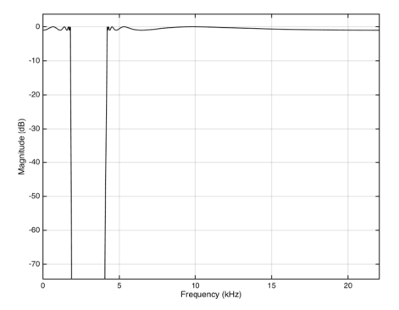
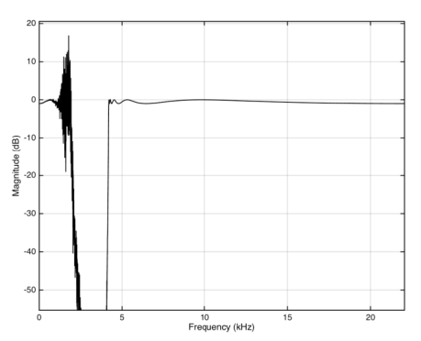
- Describe any differences in the magnitude response vs. part (a). As shown on right, the single section implementation does not meet specification in the passband.
Oscillator at 1.78 kHz

IIR Bandstop Filter as
Single Section (Direct Form)
IIR Bandstop Filter as Cascade of Biquads

Pole-zero plot for the IIR bandstop filter implemented as cascade of biquads:
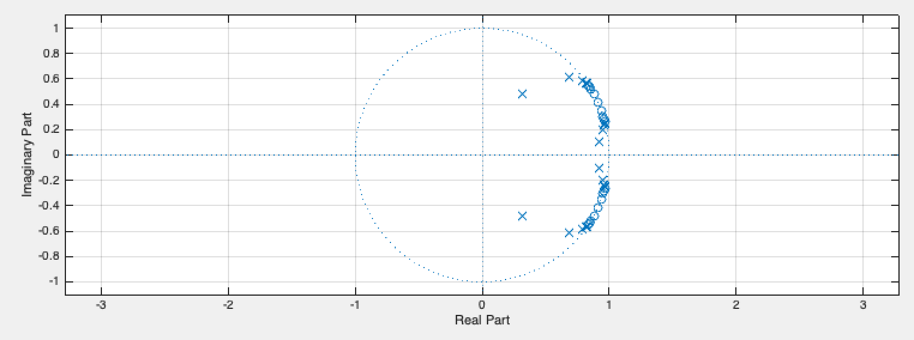
Pole-zero plot for the IIR bandstop filter implemented as a single IIR section – notice the disturbance in the pole-zero locations. Four poles have moved outside of the unit circle to indicate BIBO instability. The zeros have moved off of the unit circle.
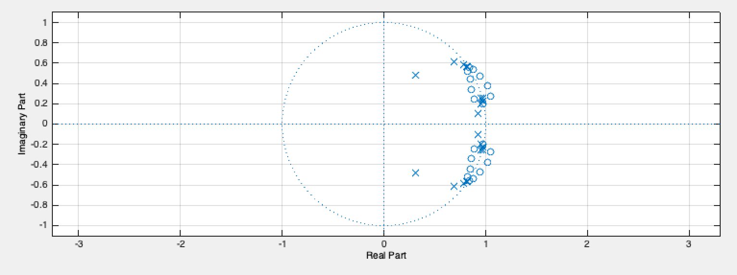
IIR filter design algorithms return a list of poles, zeros, and gains. Consider the transfer function for the 20th-order IIR filter with 20 zeros and 20 poles. We expand from factored form to a single polynomial in the numerator to find the feedforward coefficients and in the denominator to find the feedback coefficients. By default, MATLAB uses 64-bit IEEE floating point data and arithmetic. During polynomial expansion, there is loss of precision in each feedback coefficient of one bit (worst case) for every addition and 53 bits worst case for every multiplication. When refactoring the denominator polynomial, the pole locations would have changed.
