**% In-Lecture Assignment #4 Related to Homework #6**

% Consider performing an iterative ***maximization*** of

% $J\left(x\right)=8-x^{2}+6 cos⁡(6x)$

% via the steepest descent (***ascent***) algorithm (JSK equation (6.5) on page 116)

% with the sign on the update reversed from negative to positive so that

% the algorithm will ***maximize*** rather than minimize; i.e.

% $x\left[k+1\right]=x\left[k\right]+μ{\left.\frac{dJ(x)}{dx}\right]}_{x=x[k]}$

% a. Visualize and analyze the shape of the objective function *J*(*x*).

% 1) Plot *J*(*x*) for -5 < *x* < 5. Give the Matlab code for your answer.

x = [-5 : 0.01 : 5];

J = 8 - x .^ 2 + 6 * cos(6*x);

plot(x, J); %% At end of document

% 2) Describe the plot.

**% Sum of concave down parabola and cosine creates many local maxima -OR-**

**% Headband-like rainbow shape composed in a parabolic wavy pattern -OR-**

**% Comic (graphical novel) sketch of a head with hair or crown**

% 3) How many local maxima do you see?

**% 11, which are the 9 peaks with valleys plus the two end points.**

% 4) Of these local maxima, how many are global maxima?

**% Only one, located at *x* = 0.**

% b. Derive the steepest descent (***ascent***) update equation

% dJ(x)/dx = -2x - 36*sin(6*x)

% and modify the code below to include the derivative of dJ(x)/dx

% Code below modified from a solution by a Spring 2019 student

% polyconverge.m find the maximum of J(x)=x via steepest descent

N=50;                      % number of iterations

mu=0.001;                % algorithm stepsize

x=zeros(1,N);              % initialize sequence of x values to zero

x(1)=0.7;                 % starting point x(1)

for k=1:N-1

  x(k+1)= x(k) + (-36*sin(6*x(k)) - 2*x(k))*mu;    % update equation

end

figure();

stem(x);          % to visualize approximation of x

x(N)

% c. Implement the steepest descent (***ascent***) algorithm in Matlab with *x*[0] = 0.7.

% 1) To what value does the steepest descent algorithm converge?

**% x = 1.0376**

% 2) Is the convergent value of x in the global maximum of *J*(*x*)? Why or why not?

**% No. The only global maximum of *J*(*x*) occurs at *x* = 0. The initial guess**

**% of *x* = 0.7 is on an upward slope of *J*(*x*) towards a local maximum at**

**% *x* = 1.0376 and the iterates of *x*[*k*] go towards the local maximum.**

**% The objective function *J*(*x*) is plotted below vs. *x***

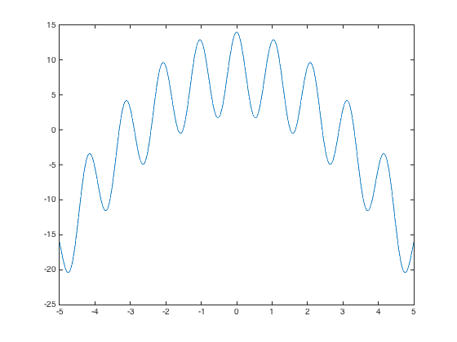

**% The plot below shows the trajectory of *x*[*k*] values vs. *k***

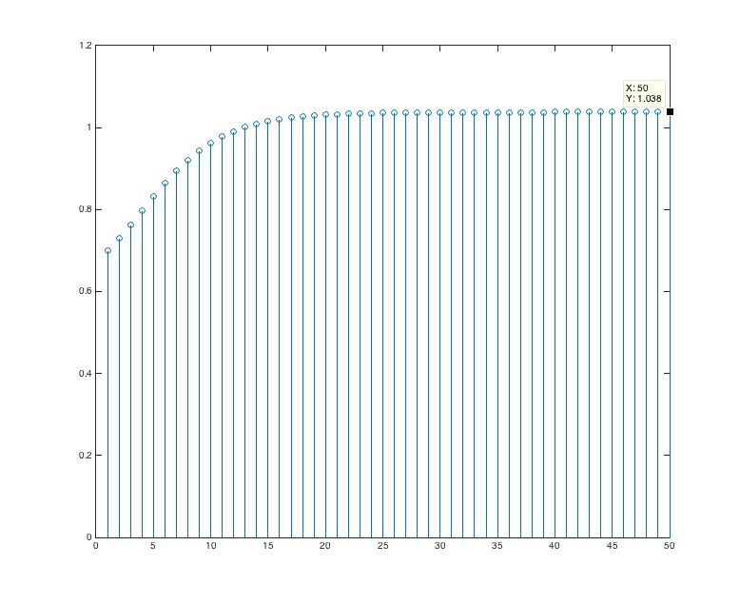

**% Below, the objective function *J*(*x*) is highlighted with the global maximum at *x* = 0,**

**% the starting point of the steepest descent (ascent) algorithm at *x* = 0.7, and**

**% the point where the steepest descent (ascent) algorithm converges at *x* = 1.0376**.

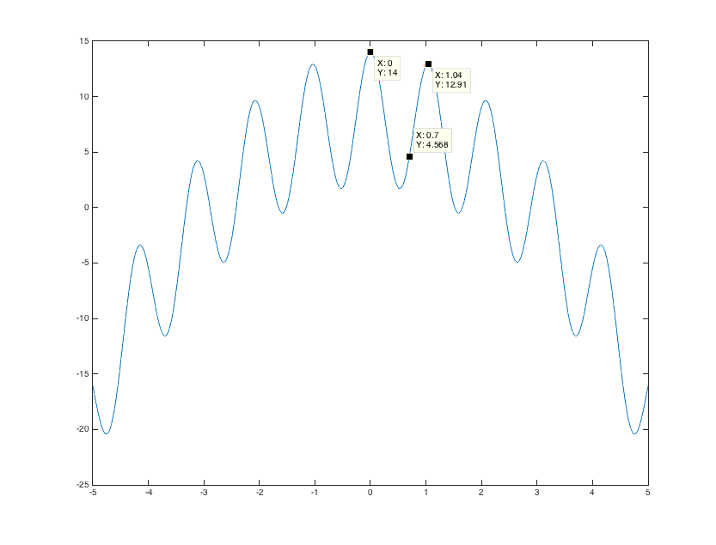

**% *Debugging hint:* What happens if one makes a mistake computing**

**% the derivative? How I can tell that there’s a mistake? The steepest**

**% descent (ascent) will not correctly find the minimum (maximum).**