% In-Lecture #3 Assignment related to Homework 5.1 Steepest Descent
% Copy this file into a Matlab script window, add your code and answers to the
% questions as Matlab comments, hit "Publish", and upload the resulting PDF file
% to this page for the tune-up assignment. Please do not submit a link to a file
% but instead upload the file itself. Late penalty: 2 points per minute late.
% This assignment introduces steepest descent algorithms.
% Please see Fig. 6.15 on page 116 in JSK’s Software Receiver Design book.
% See steepest descent slides and Midterm Problem 2.1 in Spring 2016.
% Consider performing an iterative minimization of objective function
% J(x) = x^2 – 14x + 49 = (x - 7)^2
% via the steepest descent algorithm (JSK equation (6.5) on page 116).
% $x\left[k+1\right]=x\left[k\right]-μ{\left.\frac{dJ(x)}{dx}\right]}_{x=x[k]}$
% a. Visualize and analyze the shape of the objective function J(x).
% 1) Plot J(x) for 5 < x < 9. Give the Matlab code for your answer.
x = [5 : 0.01 : 9];
J = x.^2 - 14*x + 49;
figure;
plot(x, J); %% At end of document
% 2) Describe the plot.
% Answer: It’s a concave up parabola (bowl)
% 3) How many local minima do you see?
% Answer: 1 at x = 7
% 4) Of the local minima, how many are global minima?
% Answer: The local minimum is also a global minimum.

% b. As first step in deriving steepest descent update equation,
% compute the first derivative of J(x) with respect to x.
% Answer: dJ(x)/dx = 2x - 14
% c. Implement the steepest descent algorithm in Matlab with x[0] = 5.
% 1) What value of x did steepest descent reach in 50 iterations with mu=0.01?
% Answer: x = 6.2568
% 2) What value of x did steepest descent reach in 50 iterations with mu=0.1?
% Answer: x = 7.0
% 3) Is the above value the global minimum of J(x)? Why or why not?
% Answer: Yes, the objective function has only one minimum.
% polyconverge.m find the minimum of J(x) via steepest descent
N=50; % number of iterations
mu=0.01; % algorithm stepsize
x=zeros(1,N); % initialize sequence of x values to zero
x(1)=5.0; % starting point x(1)
for k=1:N-1
x(k+1)= x(k) - (2*x(k)-14)*mu; % update equation
end
figure;
stem(x); % to visualize approximation
x(N)
See plots and comments on the next page…
Plots for mu = 0.01
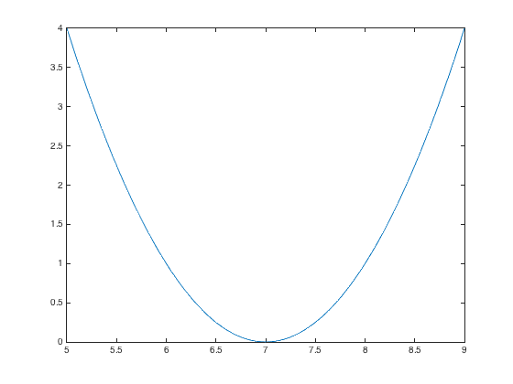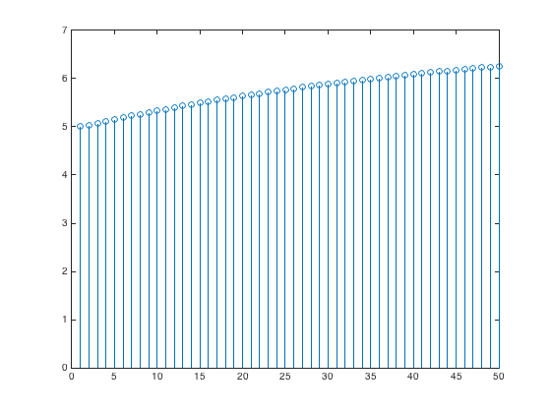
iterations
Plot of J(x) vs. x Plot of x vs. iterations
Plots for mu = 0.1
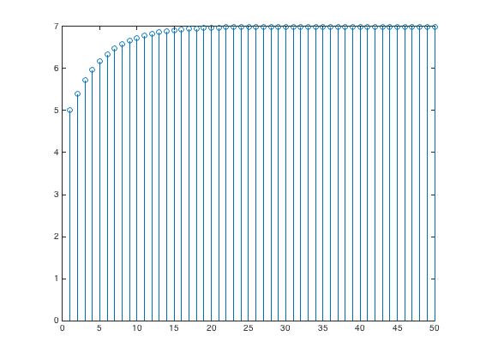
iterations
Plot of J(x) vs. x Plot of x vs. iterations

Convergence. In general, the convergence of the steepest descent algorithm depends on the initial guess and the value of the step size mu.
In this problem, the steepest descent algorithm is a first-order IIR filter with a pole at $1-2μ$:
$$x\left[k+1\right]=\left(1-2μ\right)x\left[k\right]+14μ u[k]$$
The current output is $x\left[k+1\right]$, previous output is $x\left[k\right]$, and current input is $14μ u[k]$ where $u[k]$ is the unit step function. For the first-order IIR filter to be BIBO stable, the pole has to be inside the unit circle, i.e. $-1<1-2μ<1$ or equivalently $0<μ<1$. We choose a small positive value for the step size so that the steepest descent algorithm converges. See additional analysis next.
The first derivative acts like a highpass filter: As an LTI system, the first derivative is a highpass FIR filter. Recall that the first-order FIR difference filter from homework 1.1(b) and 2.1(b) is a discrete-time approximation of the first derivative and is a highpass filter.
Often in practice, the first derivative is calculated by formula or estimated numerically using measured data, e.g. using a continuous-time analog signal that has been converted to a discrete-time digital signal. The first derivative, as a highpass filter, will amplify high-frequency components of noise and measurement error.
In this problem, steepest descent acts like a lowpass filter if the step size is small enough. For a lowpass filter, we want the pole location to be at say 0.9 which would mean a $μ$ = 0.05. By choosing an appropriate $μ$ value, we can equalize the highpass response of the first derivative.

