**Sine Wave Generation (Polling)**

**Please check out a DSP board and a BNC cable.**  
  
1. Create new folders under the C drive as: C:\Lab_445S\Lab_2. Download the zipped folder called “Lab_2_files.zip” and extract the contents in a subfolder under the folder “Lab_2”, ie in C:\Lab_445S\Lab_2\Lab_2_files.

2. Click on All Programs -> Texas Instruments -> Code Composer Studio version 4.2.3 -> Code Composer Studio v4. (If you do not find version 4.2.3, click on the latest version of CCS which you find.). You will find a screen which asks for the location of the workspace. Change the default location to “C:\Lab_445S\Lab_2\Lab_2_workspace\”.  If this is the “first time” it has been launched, simply click the “Click to close and go to the CCS workbench” icon in the upper right-hand corner. Otherwise, the C/C++ perspective opens and you‟re ready to go.

3. Create a new project in Code Composer 4 called “sine_wave”. Select File → New → CCS Project

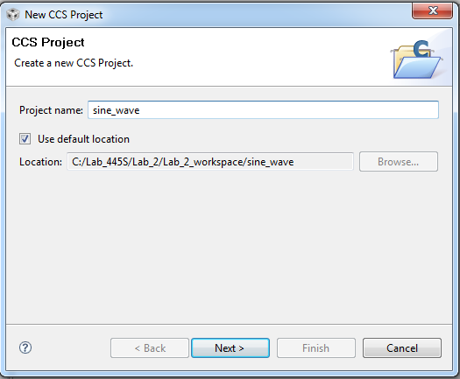

**4.** In the following screen, choose C6000 and ensure the Debug/Release build configurations are

checked:

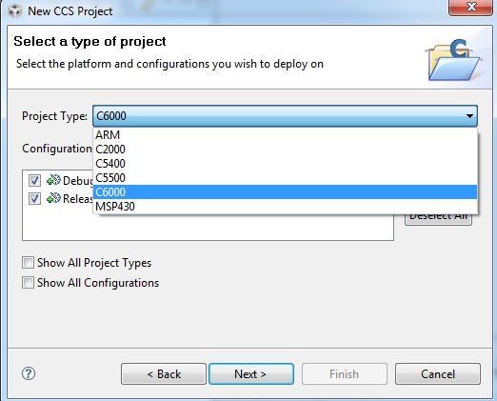

**5.**On the next screen, just click Next. There are no additional project settings.

**6.** We are now at one of the critical and most useful capabilities of CCSv4. We can apply these settings on a per-project basis vs. the older version of CCS which used the “Configuration Manager” to set these settings and they applied to all projects, not just one. When this screen appears, choose the settings as follows (choose the latest version of Code Gen tools in the dropdown box) :

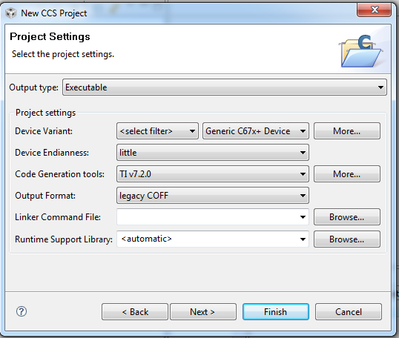

The Device Variant should be “Generic C674x Device”. This will either match the board or device you are building your application for. Codegen tools (CGT) v7.2.0 comes standard with CCSv4.2. However, we may have upgraded CCS since this screen capture – so choose the latest version available on your system. You could also choose a linker command file at this point, but we will simply add it to our project later. Click *Next*.

7. Expand the arrow beside DSP/BIOS v5.xx Examples and select “Empty Example”. Click “Finish”.

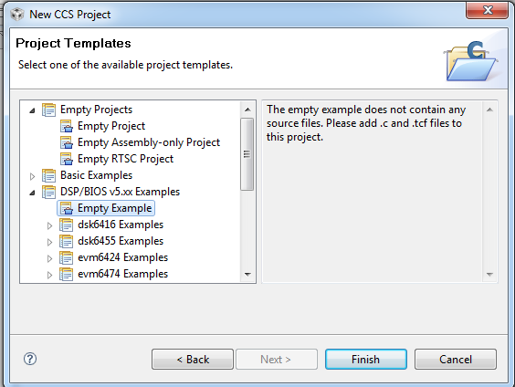

8. Right click on the created project and select “Add Files”. Go to the folder “C:\Lab_445S\Lab_2\Lab_2_files” and select the files highlighted in the screenshot:

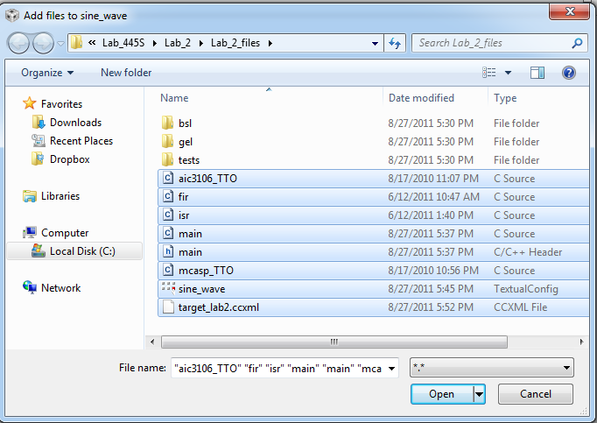

9. Right click on the created project and select “Link Files”. Go to the folder “C:\Lab_445S\Lab_2\Lab_2_files\bsl\lib\” and select the file evmc6748_bsl.lib:

10. Right click on the created project and select “Build properties”. Click on “Basic options”. You will find Target Processor Version (--silicon_version, -mv) to be “67p”. Change it to 6740. Next click on Include options as shown: Click on the + sign as highlighted in the screenshot:

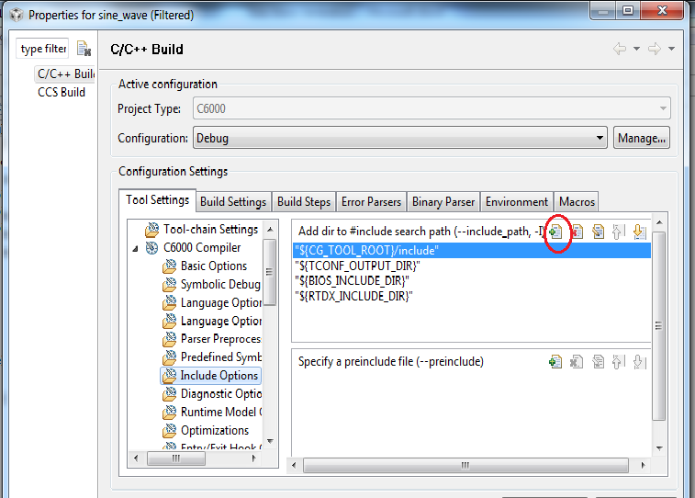

In the dialogue that opens, type C:\Lab_445S\Lab_2\Lab_2_files\bsl\inc under directory. Click on “Ok”. Next, click on “Ok” to close the “Build Properties” screen.

11. Your Code Composer screen should look like:

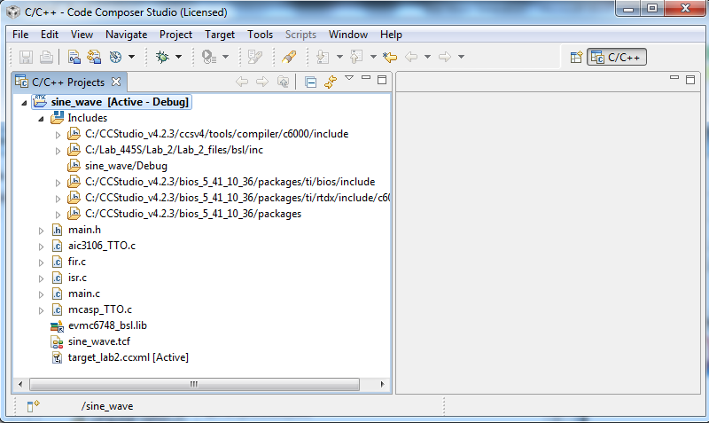

12. Open the different files and examine their contents. Connect an oscilloscope to the line out of the DSP board with BNC cables.

13. Near the top right-hand corner of CCS, you will see two build buttons: 

The button on the left is the “*Build Active Project*” button. This will only build the source files that have changed since the last build (kind of like an “incremental” build). The button on the right is “*Rebuild Active Project*”. This button will clean all intermediate files and start over from scratch and then build your project. Click the “*Build Active Project*” button (on the left) and watch the progress in the console window.

**14.** To the right of the build buttons, you’ll see the following:  Click on the symbol of the bug.

Now change the perspective to Debug perspective. To the top right corner, you will find: 

Now, click on Debug. Near the top of the screen, locate the ACTION buttons:

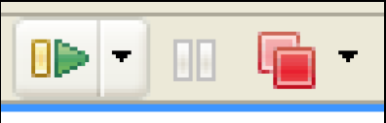

Hit the green button to play.

Chek with the TA what you find in the console window (The window which opnes up at the bottom.) and the oscilloscope.

15. Go to the file AIC3106_TTO.c. Scroll down to the macro definitions and change the sampling frequency from 48 to 8 KHZ. Also, in the file isr.c, change fs to 8000 from 48000 in order to generate the sine wave. You will learn more about sine wave generation in Lab 2. This lab will give you an idea about how to run a CCS project.