% Tune-Up #5 October 15, 2024
% The tuneup is to solve homework problem 5.1.

% Intro. A step function u[n] is a function
% that turns at the origin and stays on. This
% can model turning on a switch and leaving it
% on indefinitely. Mathematically, u[n] is
% 1 when n >= 0
% 0 otherwise.
% In Matlab, one can implement u[n] as ( n >= 0 ).
% The logical operator >= returns 1 if true and
% 0 if false.
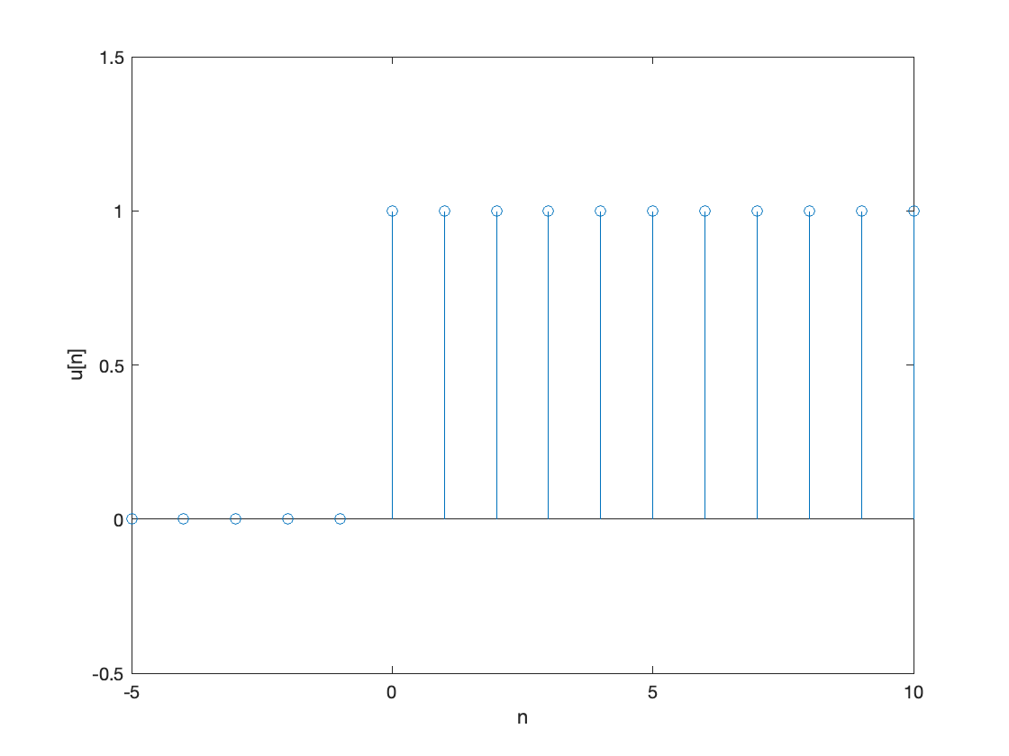
% Part (a). Make a plot of u[n] for -5 <= n <= 10.
% Describe what you see.
n = -5 : 10;
unitstep = ( n >= 0 );
figure;
stem(n, unitstep);
xlabel('n');
ylabel('u[n]');
ylim([-0.5 1.5]);
% In the plot, the signal is zero/off when
% n < 0 and one/on when n >= 0. This is a
% step function -- the signal takes a step up
% at n = 0 from amplitude 0 to amplitude 1.
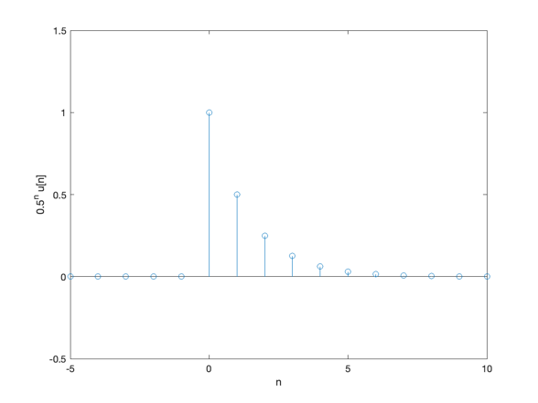
% Part (b). We can use the unit-step sequence
% to represent other sequences that are zero
% for n < 0. Plot x[n] = (0.5)^n u[n]
% for -5 <= n <= 10. Describe what you see.
n = -5:10;
unitstep = ( n >= 0 );
x = (0.5 .^ n ) .* unitstep;
figure;
stem(n, x);
xlabel('n');
ylabel('0.5^n u[n]');
ylim([-0.5 1.5]);
% In the plot, signal is zero when n < 0 and a
% a decaying exponential sequence when n >= 0.
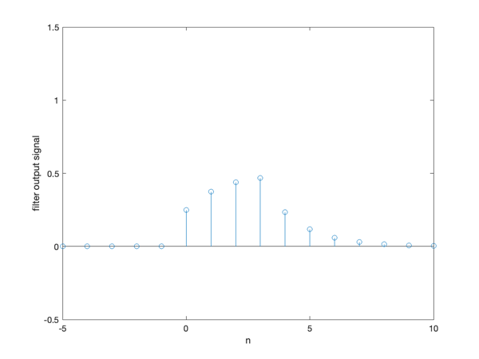
% Part (c). Apply a four-point averaging
% filter to x[n] and plot the result

% Solution #1: Using the filter command
averagingFilterCoeffs = [ 1/4, 1/4, 1/4, 1/4 ];
y = filter(averagingFilterCoeffs, 1, x);
figure;
stem(n, y);
xlabel('n');
ylabel('Output signal using the filter command');
ylim([-0.5 1.5]);
% In the plot, the output signal is zero when
% n < 0. The output signal for 0 <= n <= 2
% corresponds to a partial response by the filter
% to the change in the input signal at the origin
% Once we reach n = 3, the sliding window of input
% samples would be filled.

% Solution #2: Using the convolution command, conv.
% When the input signal and the impulse response
% are finite length, convolution will produce a signal
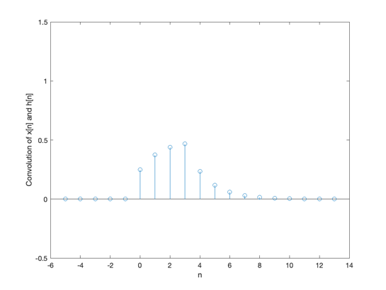
% whose length is the length of the input signal plus
% the length of the impulse response minus one.
averagingFilterCoeffs = [ 1/4, 1/4, 1/4, 1/4 ];
y = conv(averagingFilterCoeffs, x);
numberExtraSamples = length(averagingFilterCoeffs) - 1;
n = -5 : 10 + numberExtraSamples;
figure;
stem(n, y);
xlabel('n');
ylabel('Convolution of x[n] and h[n]');
ylim([-0.5 1.5]);
% In the plot, the output signal is zero when n < 0. The output
% signal for 0 <= n <= 2 corresponds to a partial response by the
% filter to the change in the input signal at the origin. Once
% we reach n = 3, the sliding window of input samples would be
% filled. We also see the trailing response from convolution.
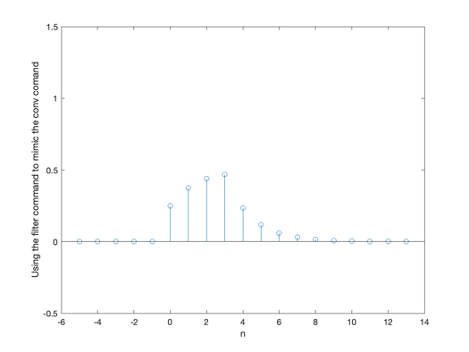
% Solution #3: Using filter command to perform convolution
averagingFilterCoeffs = [ 1/4, 1/4, 1/4, 1/4 ];
numberExtraSamples = length(averagingFilterCoeffs) - 1;
xZeroPadded = [x zeros(1, numberExtraSamples)];
y = filter(averagingFilterCoeffs, 1, xZeroPadded);
n = -5 : 10 + numberExtraSamples;
figure;
stem(n, y);
xlabel('n');
ylabel('Using the filter command to mimic the conv comand');
ylim([-0.5 1.5]);
% In the plot, the output signal is zero when n < 0. The output
% signal for 0 <= n <= 2 corresponds to a partial response by the
% filter to the change in the input signal at the origin. Once
% we reach n = 3, the sliding window of input samples would be
% filled. We also see the trailing response from convolution.

