Tune-Up Tuesday #3 Version 1.0
Written by: Alice Liu (TA)
% Tuneup Tuesday #3 for September 15, 2026
% Copy this file into a Matlab script window, add your code and answers to the
% questions as Matlab comments, hit "Publish", and upload the resulting PDF file
% to this page for the tune-up assignment. Please do not submit a link to a file
% but instead upload the file itself.
% Late penalty: 2 points per minute late.

% The following code clears the Matlab workspace
clear all; % clears all Matlab variables
close all; % closes all figures
clc; % clears the command window of text

% In this in-lecture assignment, we examine an audio effect, tremolo, onto
% a pure tone. We examine what happens when we apply amplitude modulation
% to a signal in the time domain and observe the effects in time and frequency.

%% Part 1
% Generate a cosine signal at frequency 440 Hz to play it as an audio
% signal at a sampling rate of 8000 Hz:

f0 = 440; % 440 Hz (A in the 4th octave, or A4)
fs = 8000; % sampling rate in Hz (a.k.a. samples per second)
Ts = 1/fs; % sampling time in seconds
t = 0 : Ts : 3;% sampling time, from 0s to 3s
x = cos(2*pi*f0*t);
sound(x, fs);
pause(3);

%% Part 2.
% Generate and apply a pulse-shaping signal p(t) for amplitude modulation
% p(t) = A*cos(2*pi*f_tau*t)
% You may choose any value of A and f_tau, and we recommend you try
% different values. Share the values of A and f_tau that you tested.
% (a) Try A = {0.1, 0.9} with f_tau = 0.5
% (b) Try f_tau = {0.5, 5} with A = 0.9

% (a1) A=0.1, f_tau = 0.5
A1 = 0.1;
f_tau1 = 0.5;
p1 = A1*cos(2*pi*f_tau1*t);
y1 = p1 .* x;

% (a2) A=0.9, f_tau = 0.5
A2 = 0.9;
f_tau2 = 0.5;
p2 = A2*cos(2*pi*f_tau2*t);
y2 = p2 .* x;

% (b1) A=0.9, f_tau = 0.5
A3 = 0.9;
f_tau3 = 0.5;
p3 = A3*cos(2*pi*f_tau3*t);
y3 = p3 .* x;

% (b2) A=0.9, f_tau = 5
A4 = 0.9;
f_tau4 = 5.0;
p4 = A4*cos(2*pi*f_tau4*t);
y4 = p4 .* x;

%% Part 3.
% Please play the audio signals in Part 2, and describe what you hear. How
% does the value of A and f_tau affect the audio signal you hear? (It may
% be helpful to play the initial signal, x, and compare against y.)

% Play a vector of amplitude values as an audio signal.
% Amplitude values less than -1 are clipped to -1.
% Amplitude values greater than 1 are clipped to 1.

% (a1) A=0.1, f_tau = 0.5
sound(y1,fs);
pause(3);

% (a2) A=0.9, f_tau = 0.5
sound(y2,fs);
pause(3);

% (b1) A=0.9, f_tau = 0.5
% (This is a repeat, it's ok if the repeat is not included in submission.)
sound(y3,fs);
pause(3);

% (b2) A=0.9, f_tau = 5
sound(y4,fs);
pause(3);

Discussion response for (3):
% Our initial signal, x, is a single tone at 440 Hz, with a maximum amplitude
% of 1. Compared to the initial signal, in our modified tremolo signals, we
% hear the initial signal, x, change in terms of volume (amplitude).

% We compare the audio signals of part (a), with constant f_tau and
% variable maximum signal amplitude, A.
% When A is small (A=0.1), the maximum volume of the signal is softer.
% When A is large (A=0.9), the maximum volume of the signal is louder.
% Since f_tau is the same, we hear the amplitude modulation occur at the
% same rate.

% We compare the audio signals of part (b), with constant maximum signal
% amplitude and variable f_tau.
% When f_tau is small (f_tau=0.5 Hz), we hear the volume change slowly.
% When f_tau is large (f_tau=5.0 Hz), we hear the volume change quickly.
% Since both f_tau values are relatively small compared to the initial
% frequency, f0, it sounds as though the tremolo signal is still at the
% same frequency of 440 Hz. Depending on how sensitive one's hearing is,
% one may either hear 2 frequencies, or just 1 frequency that sounds like
% the initial 440 Hz.
% Since the amplitude A is held constant, we should hear that the maximum
% volume of the signal remains the same.

% Food for thought (not graded for submission):
% When f_tau is very large (say, for f0 = 440 Hz, we choose f_tau = 110 Hz),
% we can start to distinguish 2 tones in the audio signal, like in the beat
% signals from Tune-up Tuesdays #2 last week. Thus, to ensure we create a
% tremolo effect, we must let f_tau remain relatively small when compared
% to the initial frequency, f0.

%% Part 4.
% Analyze the resulting tremolo signal in the time and frequency domain
% for f_tau = 5 with A = 0.9.
% Do the plots demonstrate the same behaviors you noticed in part 3?
% Why or why not?
% You may want to zoom in on the frequency domain and spectrogram
% plots for your analysis.
% Does the resulting tremolo signal share the same period with the
% original tone?

% For f_tau = 5, A = 0.9, this is option (b2), which is signal y4.
% Thus, we now plot the Time-domain analysis:
plot_timeDomainAnalysis(y4, fs);
% And the Frequency-domain and Spectrogram analysis:
plot_freqDomainAnalysis(y4, fs);

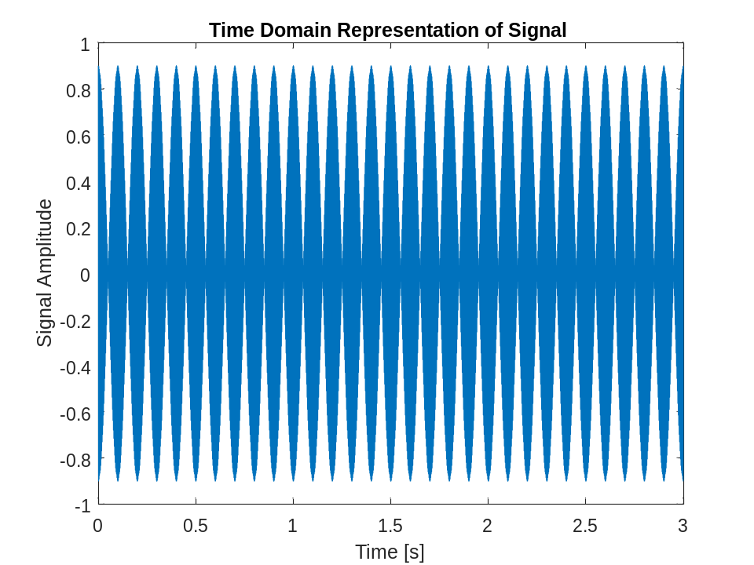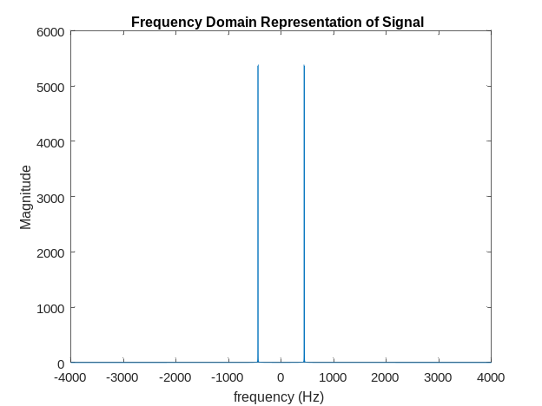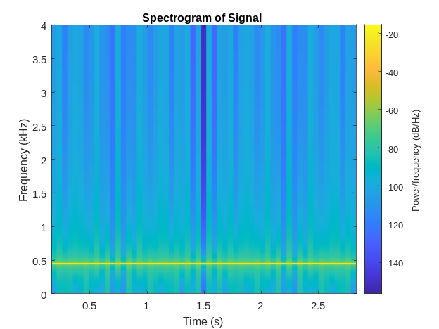

% Alternatively, we can specify the type of signal in the title of the plot:
plot_timeDomainAnalysis(y4, fs, "Tremolo");
plot_freqDomainAnalysis(y4, fs, "Tremolo");
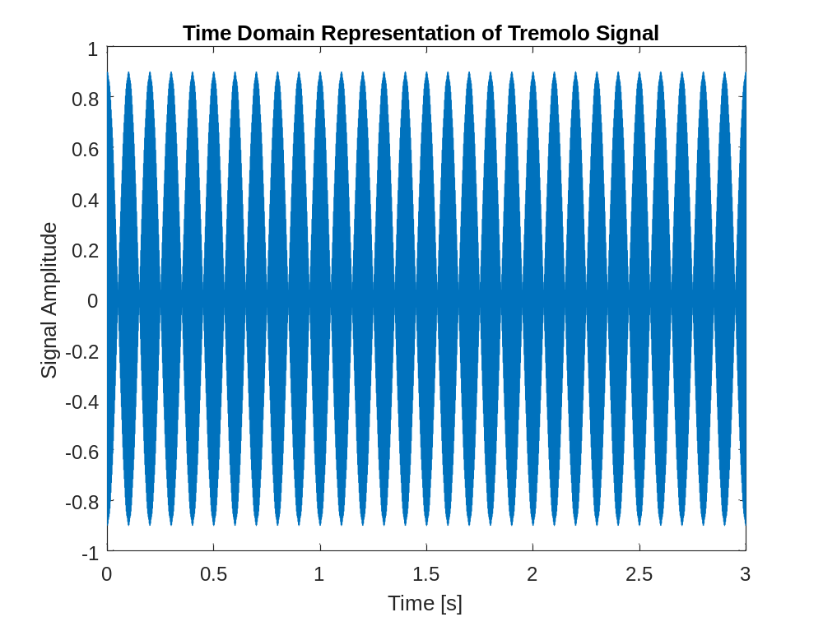
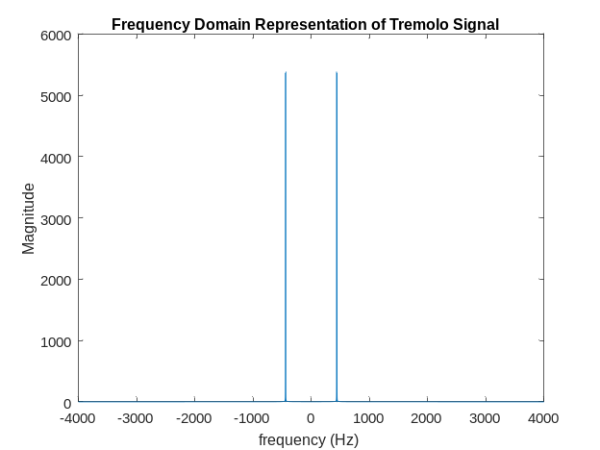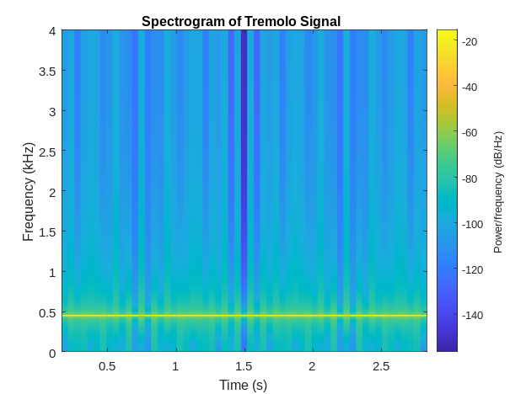

%% Discussion response for (4):
% Yes, the time-domain plot supports our observations from (3).
% The time-domain plot demonstrates the amplitude modulation of the
% original signal. We see that over time, the amplitude of the pure tone
% decreases to 0 before it increases to 0.9. If we were to plot option (a1)
% we would see that the amplitude only increases to 0.1 instead.

% At a glance, the frequency-domain representation of the signal shows the
% frequencies appearing at f0=440 Hz. However, if we zoom into the
% frequency-domain representation of the signal, we will notice that the
% frequency components present appear at +/-(f0+f_tau) and +/-(f0-f_tau).
% This is in line with what we hear and with what we understand. Because
% the f_tau used is relatively small, we don't expect to hear an audible
% difference in the pitch of the signal. But we understand based on the way
% we have generated the tremolo signal, that the actual frequencies present
% must the combination of the two cosines in the equation,
% y = cos(2*pi*f_tau*t).*cos(2*pi*f0*t).
% We see the same 2 frequencies in the spectrogram as well, if we zoom in to
% around 440 Hz.

% The resulting tremolo signal for option (b), signal y4, should have a
% period of Tfund = 1/ffund = 1/gcd(f0+f_tau,f0-f_tau) = 0.2 seconds;
% We see that this is also the case when we examine the time-domain plot.
% Notice that at these timestamps (0.04875s and 0.24875s), the signal
% amplitude y4(t) are exactly the same:
% y4(t=0.04875s) == y4(0.24875s) == -0.0336045
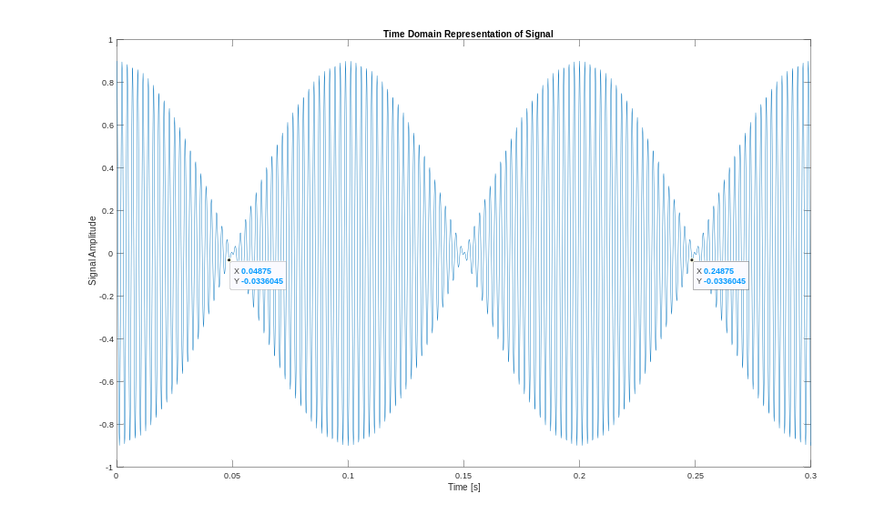
xlim([0 0.3]);
Tfundamental = 0.24875s-0.04875s = 0.2s

