Task 1836.133, Energy Efficient Signal processing techniques for smart grid heterogeneous communication networks
Naofal Al-dhahir, University of texas at dallas, aldhahir@utdallas.edu
brian l. evans, University of texas austin, bevans@ece.utexas.edu

sIGNIFICANCE AND OBJECTIVES
Within a smart grid (SG), we seek to enable reliable and high-speed communications for better monitoring and control of energy usage. We focus on “last mile” bi-directional communication from a concentrator to smart meters using orthogonal frequency division multiplexing (OFDM) based powerline communications in the 3-500 kHz band and wireless communications in the unlicensed 902-928 MHz band.

TECHNICAL APPROACH
Performance of narrowband PLC is limited by non-Gaussian interference dominated by periodic impulsive noise. We propose a time-frequency modulation diversity scheme at the transmitter and a diversity demodulator at the receiver robust to combat periodic impulsive noise in narrowband PLC, thus enhancing communication reliability without decreasing data rates.
To further enhance SG communications reliability, we propose PLC/wireless receive diversity combining schemes under the impulsive interference variations over the two links. Assuming OFDM transmissions for both links, we analyze the performance gains using simultaneous data transmission and diversity reception over the 3-500 kHz NB-PLC and the unlicensed 902-928 MHz wireless bands.

SUMMARY OF RESULTS
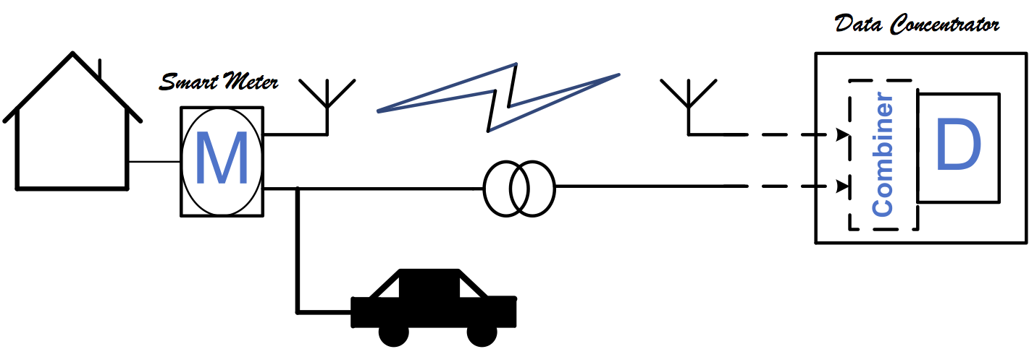
We investigated the maximal ratio-combining (MRC) scheme for combining the output signals of the NB-PLC and wireless links. The MRC scheme combines the log-likelihood ratios (LLRs) of the received bits over the two links by weighting each link with its SNR. We showed that, due to the impulsive interference on both links, using the instantaneous SNRs of the two links to compute the combining weights provides better bit error rate (BER) than using the average SNRs.
In addition, we proposed a time-frequency modulation diversity technique to improve transmission robustness in periodic impulsive noise without decreasing data rates. The time-frequency modulation diversity transmitter jointly encodes multiple bits to multiple PSK symbols, and allocates them to different subcarriers in various OFDM symbols (Figure 1). It can be embedded into existing narrowband PLC standards.
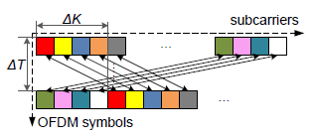
Figure 1: An example of time-frequency modulation diversity. Components of a length-2 modulation diversity code (marked in the same color) are allocated to 2 subcarriers separated in both time and frequency.
On the receiver, we derive a diversity combining demodulator that linearly combines signals received from corresponding sub-channels/OFDM symbols with weights inversely proportional to the sub-channel SNRs. The periodically varying noise power spectrum can be estimated offline based on noise measurements during no-transmission intervals. Alternatively, it can be estimated primarily during data transmission by exploiting its sparsity in frequency domain and applying sparse Bayesian learning algorithms. In simulations, our proposed transceiver methods achieve 100-1000x reduction in coded bit error rates, while maintaining the same data rates, compared to a conventional OFDM narrowband PLC system that uses BPSK, convolutional coding and block interleaving.
Keywords: smart grids, powerline and wireless communication, diversity, periodic impulsive noise.

INDUSTRY interactionS
Texas Instruments, Freescale Semiconductor

MAJOR PAPERS
[1] M. Sayed and N. Al-Dhahir, “Narrowband-PLC Wireless Diversity for Smart Grid Communications,” accepted in IEEE Globecom conference, December, 2014.
[2] J. Lin, T. Pande, I. H. Kim, A. Batra and B. L. Evans, “Time-Frequency Modulation Diversity To Combat Periodic Impulsive Noise In Narrowband Powerline Communications'', submitted to IEEE Trans. Comm.

